Annex IX

Field Manual
National Forest Inventories for FRELs/FRLs Uganda REDD+ Programme (draft)

November, 2015

Ministry of Water and Environments (MWE)
In cooperation with
Food and Agriculture Organization (FAO)

Adopted from the several Inventory guidelines namely;
- The FAO-Viet Nam National Forest Assessment (NFA) Project’s field manual, 2012,
- National Forest Authority PSP and IE manuals- Alder et al
- National Forest Authority National Biomass Technical Repots 1998 and 2002
- National Forest Authority Carbon Project PSP manual 2010

Complied by ; John Begumana Ayongyera, FAO MRV Expert REDD+

  - Table of contents
1 National Forest Inventory in Uganda, 5
1.1 National Biomass Study Inventory 5
1.2 Timber Stock Surveys (EI and ISSMI) 7
1.3 Permanent Sample Plots 8
1.4 Special Forest Inventories 9
1.5 Some of the Sampling designs in use 9
1.5.1 NBS Plot layout and sample design 9
1.5.2 Layout design of EI blocks and plots 10
1.5.3 Layout of PSPs 12
2 Overview of data collection process 14
2.1 Preparations for the fieldwork 15
2.1.1 Field crew composition 15
2.1.2 Preparations of tools and instruments 16
2.1.3 Preparation of the field forms and maps 16
2.1.4 Contacts and Introduction of the project to local people 17
2.1.5 Field equipment and Tools 18
3 Data collection in the field 21
3.1 Navigation to the Plot 21
3.2 Plot demarcation 21
4.4 Slope corrections 21
3.2.1 NBS Plot Layout 22
3.2.2 Change of the Biomass Sampling Design 23
3.2.3 EI and PSPS design 23
3.3 Tree measurements 23
4.4 Tree Positioning 23
3.3.1 Tree diameter measurements 24
3.3.2 Tree height measurements 30
3.3.3 Tree Crown Diameter Measurement 33
3.4 Dead wood measurements 33
4 REFERENCES 34
5 Appendix 1 Equipment by measurement types 36
6 Appendix II Tree and Stump Data Form 37
7 Appendix III. Slope Correction Table 40

List of figures
Figure 1. Overview of major forest inventories in Uganda (NBS and EI) 7
Figure 2. Systematic Stratified (based on population and Ecological zones) sampling- Source NBS 1995 10
Figure 3. EI Sampling Design Layout- lines are in blue, transects in red, plots in black/yellow 11
Figure 4. Spiral system of Quadrant Numbering of PSPs in THF 12
Figure 5. An example of a nested Circular plot 13
Figure 6. Data collection procedure 14
Figure 7. Distances on slope 21
Figure 8. Rectangular Biomass plot (Left) and the Proposed Circular Biomass Plot (right) 23
Figure 9. Positioning of calliper when measuring diameter 25
Figure 10. Diameter Measurement on Flat terrain -straight tree (left) and Leaning Tree (right) 26
Figure 11. Diameter measurement of tree on slope 26
Figure 12. Diameter measurement points for forked tree 27
Figure 13. Examples of forks’ intersection at the 1.3 m height 28
Figure 14. Diameter and stump height measurements of coppice tree 28
Figure 15. Diameter measurement of a tree with large buttress 29
Figure 16.Diameter measurement of a tree with aerial roots 29
Figure 17. Diameter measurement of deformed trees 30
Figure 18. Diameter measurement of damaged and broken stem 30
Figure 19. Point of measure of horizontal distance is middle of the base 31
Figure 20. Tree height measurements 31
Figure 21. Deadwood intersect the North - South line is enumerated 33
Figure 22. Measurement of Deadwood 34

list of PLATES
Plate 1. Tree Numbering with paint 24

list of tables
Table 1. Location of sample plots along a transect line 10
Table 2. Equipment per field crew team 18
Table 3. Equipment and tools for the base station (camp) 20
Table 4. Equipment by measurement types 36
Table 5. Stumps, Standing tree Live and Dead Tree Form 37
Table 6. Dead wood form 39
Table 7. Bamboo measurements form 39

DEFINTIONS
Abiotic: Pertaining to the non-living parts of an ecosystem, such as soil particles bedrock, air, and water.
Afforestation: The establishment of a forest or stand in areas where the preceding vegetation or land use was not forest.
Agroforestry: A collective name for land-use systems and practices in which trees and shrubs are deliberately integrated with non-woody crops and (or) animals on the same land area for ecological and economic purposes.
Biotic factor: Any environmental influence of living organisms (e.g., shading by trees, damage by animals) in contrast to inanimate (i.e., abiotic) influences.
Bole height: Bole height refers to merchantable height that is defined as the distance from the base of the tree to the first occurrence of the lowest point on the main stem, above the stump, where utilization of the stem is limited by branching or other defect.
Breast height: Breast height is the height of 1.3 m from the ground level, or if the ground level cannot be defined, from the seeding point. See more explanations and special cases in the section Tree diameter measurements.
Dead tree: A tree is regarded as dead tree if it does not have any living branches. Trees that are alive but so badly damaged that cannot grow in the next growing season (e.g. trees felled by storm) are regarded as dead trees.
Forked tree: If the forking point is below the breast height (1.3 m), the tree is recorded by giving a unique tree number for each fork. If the forking point is above the breast height, a tree is recorded as one stem.
Ground level: Ground level is described as in the following figure.
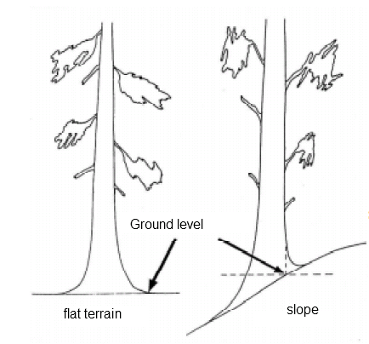
GPS: Global Positioning System receiver
Living tree: A live tree must have living branches. The tree must be able to survive at least to the next growing season/next year.
Permanent Sample Plot(s): Periodically re-measured sample plots. They provide data of changes in land use, forest stocking, volume and carbon. The locations of s are measured using high-precision GPS.
Plot radius, centre and boundary: as in the next figure.
Sample tree: A live tree selected for measurements of additional parameters.
Seeding point: Seeding point is usually at the ground level. Trees that grow on the top of a stone or old stump, the seeding point is the point where the seeds have started to grow.
Shrub: Shrubs are woody perennial plants, generally of more than 0.5 m and (usually) less than 4 m in height on maturity and with many stems and branches.
Stump height: Stump height is the level of the upper most root collar. If no root collars exist, stump height is expected to be 15 cm from the ground level.
Tally tree: Live or dead standing tree in the concentric circular plot above minimum DBH.
Tree: A tree is at least 1.35 m perennial wooded plant with distinct stem capable of reaching 4 meters height in situ. Plants that last for a few seasons e.g., acanthus, solanum spp are not considered as trees. Bamboos is considered as a special tree but its measurement is described is unique. Shrubs are not recorded as trees. Orchards of oranges, oil palms are considered under national circumstances but are not reported on under REDD+
Tree height: Tree height is measured as the distance from the ground level up to the highest point of the tree. If the seeding point is higher than the ground level (e.g. in case where a tree growing on the top of a stone), the tree height is measured from the seeding point. See more explanations and special cases in the section Tree height measurements.

Part I, Design of Forest Inventories in Uganda

National Forest Inventory in Uganda,
Forest inventories in Uganda can be grouped into four broad categories and these are:
- National Biomass Study (NBS)- intended for biomass energy assessment
- Timber Stock assessment inventories (Exploratory Inventory and Integrated Stock Survey
- Permanent Sample Plot (s) for monitor growth and yield monitoring. They also provide data on changes in land use, forest stocking, volume and carbon for a variety of purposes
- Special purpose inventories (e.g., biodiversity, carbon assessment and research studies).

Table 1. Main characteristics of forest inventory data
Inventory | Estimated Number of sample plots | Main habitat type | Plot design
National Biomass Study | 10,000- (includes re-measurement) | Subsistence Farmland (69%)  Grassland (18%)  Forests (mainly Woodland (13%) | 2,500 m² square
Exploratory Inventory | 16,512 | Tropical High Forest | 500 m² circular
PSPs Natural Forest | 116 | Tropical High Forest | 1 ha square
PSPs Plantation Forest | 125 | Forest Plantation | 400 m² square
Special purpose Plots | * | THF / woodlands | Varied
*Needs to be compiles

National Biomass Study Inventory
The purpose of this forest inventory was to assess biomass stock in Uganda. The project was carried out between 1995 – 2002. The inventory was funded by the Norwegian Government and it was implemented by the National Biomass Study under the Forest Department. The assessment mainly focused on areas outside gazetted areas (Figure 1) which were presumed to be sources of woody biomass mainly for energy purposes, i.e. wood fuel. This data may also be used for planning forest resource extraction including timber harvesting licensees on private lands by the Forestry Sector Support Department (FSDD).
All NBS data that was originally lost has been captured into a relational database. Basically, NBS data contains the plot data from 13 main strata (i.e. land cover/land use classes):
- Hardwood plantations,
- Conifer plantations,
- Tropical High Forests (THF) – normally stocked,
- Tropical High Forests - depleted,
- Woodlands - trees and shrubs (aver. height > 4 m),
- Bushland – bush, thickets, shrub (aver. height < 4 m),
- Grassland,
- Wetlands,
- Subsistence farmland,
- Large-scale commercial farmland,
- Built-up area,
- Water (lakes, rivers and ponds),
- Impediments (bare rock and soils).
Site type both at plot level and general surrounding is recorded on the NBS field forms.
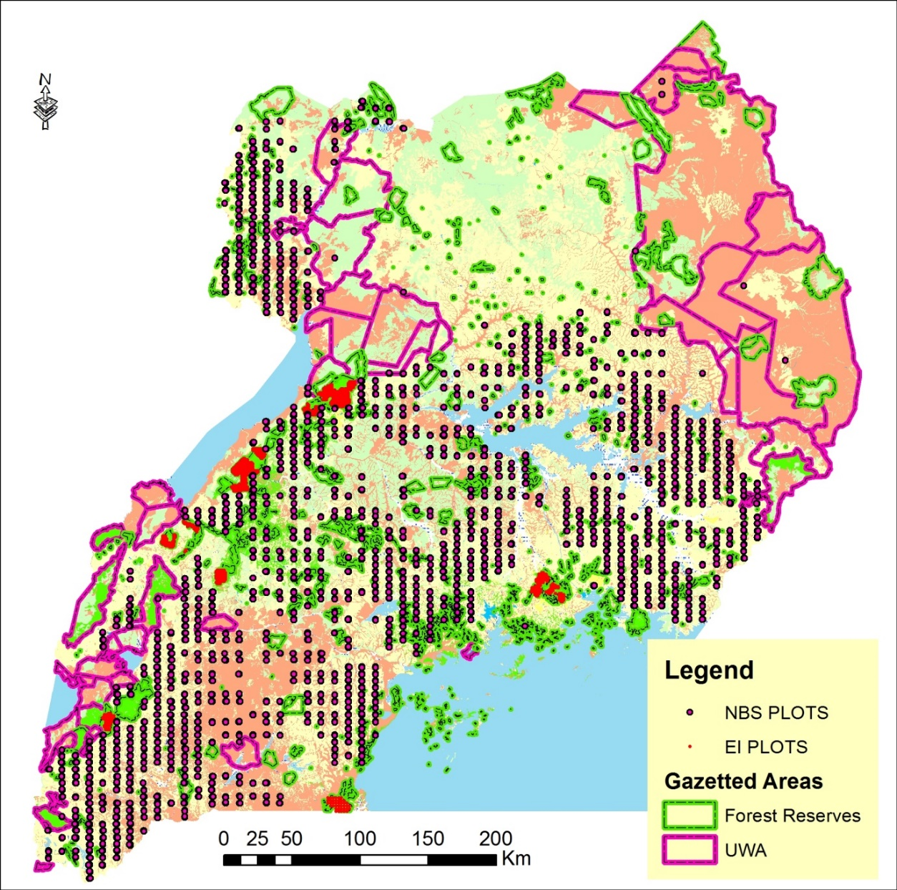
Figure 1. Overview of major forest inventories in Uganda (NBS and EI)

Timber Stock Surveys (EI and ISSMI)
Timber Stock surveys were carried out in Forest Production zones since the 1960s but digital data is only available from year 2000. These surveys specifically target generating information for timber harvesting purposes. These stock surveys are carried out at two levels. Level 1 is called Exploratory Inventory (EI). EI provides information on forest stocks in production zones. After EI, Integrated Stock Survey and Management Inventory (ISSMI) is carried out only in forest blocks that are found with sufficient stocks to warrant timber harvesting.
Apart from forest plantations data, site type (Plot Class) is not recorded in the field. For grouping of data similarly as in NBS, the site type needs to be taken from land use/land cover map based satellite image interpretation either from 2005 or 2010.

Permanent Sample Plots
There are two types of s established: plots in natural forests and in plantation forests. These data have different content and structure in the database. Plantation forest PSPs have been visited once (in 2006 or 2011) while natural forest PSPs have been visited 1 – 6 times between 1999 – 2015 and this varies amongst forest reserves and site.
Permanent sample plots (s) in Uganda started way back in the 1930s and have contributed substantially to scientific research in natural forests. For management purposes, they are generally intended to generate information on forest growth rates, biomass dynamics and yields. This information can be later used for e.g. for forest management planning. Together with other data sources (e.g., from ISSMI) information from PSPs may help in making decisions on level of timber extraction.
Current approach of PSPs are influenced by the Departmental Standing Orders (DSO) of the Forest Department. In the early 1960s DSOs had recommended a sampling intensity of 0.8% in Tropical High Forest. Originally, Budongo had the highest number of PSPS (120) and it was felt that this would lead to a biased sample that focuses entirely on one geographical area (Alder 1998). In the late 1990s’ it was decided that a sampling intensity of 0.08% about 100 PSPs of 1-ha well distributed by site and forest type (forest reserve) were fully adequate for constructing growth models suitable for informing Uganda’s standards of forest management (Alder 1998).
The plan was that within the five year EC project cycle, two biannual measurements would be achieved such that procedures, training programmes, and data processing methods would to be fully tested and evolved and probably produce a useful growth model. However, it should be noted that these PSPs were targeting highly productive (timber) areas as evidenced by the following guidelines;
- Only the more productive forest types should be sampled. Areas which are degraded, or have high concentrations of non-commercial species (eg. pure Cynometra stands) should be avoided.
- Small, fragmentary reserves, or localities under intense population pressure should be avoided (the PSPs are unlikely to survive for a long period).
- Likewise, areas within 500 m of public roads, external forest boundaries or settlements should be avoided.
- Subject to the above constraints, some plots should be located in each of following the forest reserves: Budongo, Bugoma, Kalinzu, Kayoha-Kitomi and Mabira.
- In Budongo (and elsewhere if applicable) use should be made of old PSPs to locate the new plots, subject to the above constraints.
- Plots established in each forest should not be unduly concentrated in any one compartment or locality.

Special Forest Inventories
A number of special forest inventories are carried out in Uganda and approaches and methodologies may differ from those described above. Notable among these are carbon stock inventories, biodiversity inventories and inventories done for academic purposes and a few are listed as follows:
- Carbon stock assessment PSPs by NFA in Rwoho and Mt Rwenzori Forest have been re-visited 1-6 times
- Carbon stock assessment PSPs by private companies have been re-visited 1-6 times.
- World Conservation Society (WCS) has been carrying out flora and fauna biodiversity inventories in Uganda Wildlife Authority (UWA) and Forest Reserves in Uganda.
- Biodiversity inventory that was carried out in 12 Major forest reserves by the Forest Department at around 1991.
- UWA face foundation Inventory in Mt Elgon and Kibale National parks (1992, 2003 and 2015).
- PhD student biomass assessment in Luwero- Nakasongola area (2003?).
- MSc student carbon stock assessment for Plan VIVO funding for local communities in Bushenyi, Western Uganda.
Some of these inventories are localised and their application in FREL/FRL for REDD+ will vary depending on circumstances. An overview of the plot design and Field Forms (including proposed changes) for the major forest Inventories in Uganda is provided.

Some of the Sampling designs in use
Sampling designs differ according to the purpose of the inventory. Habitat condition also influence the design. For example, the National Biomass Study which was carried on relatively open silvipastoral / agroforesty systems used large plots (2,500m²) as compared to the other inventories e.g. Exploratory Inventory in Tropical high Forest which use 500m². PSPs in Tropical High forest deploy 1 ha square nested plots as opposed EI which deploys 500 m² circular plots or to NBS (2,500m²).

NBS Plot layout and sample design
The NBS used a stratified systematic (5km by 10km grid) sampling with a random starting point. Every grid intersection had a cluster of three plots; one at the intersection point, one 300m north and one 300m south. Alternative plots were provided at 300m and 600m west or east of the intersection in case there was a sound reason that may hinder measurement of any of the three plots. Stratification was based on population density at a ratio of 3:2:1 in high (over 100 persons per Km²), Medium (50-100 persons per Km²) and low (below 50 persons per Km²). In addition, Uganda was stratified into 4 broad agro-ecological zones.

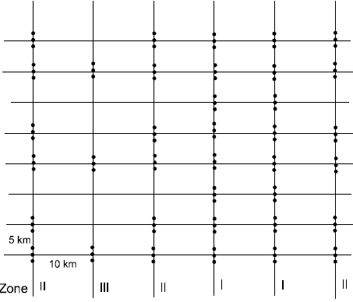
Figure 2. Systematic Stratified (based on population and Ecological zones) sampling- Source NBS 1995
In high population densities, plots were measured at every sample grid. In medium population densities, one grid interval would be skipped and samples taken at two subsequent ones while in the low population density two grid intervals would skipped between every cluster of plots (figure 2).

Layout design of EI blocks and plots
EI uses a stratified, partially-randomised sample design. Stratification is by square blocks, each normally of 1 km² (see Figure 3), oriented in a NS-EW direction. Within the block, two transects are laid at random in an EW direction. This randomisation is constrained to values that are integer multiples of 200 m in a NS direction (i.e., 200,400,600,800 or 1000 m for 1 km² blocks). The location of transects is usually determined in the field using a dice: Values 1-5 give possible transect positions, 6 is re-thrown.
Along the transect, plots are established at 100 m intervals, starting 50 m in from the beginning of the transect (table 1).

Table 1. Location of sample plots along a transect line
Plot No. | Location along the transect from West to East from the block line
1 | 50m
2 | 150m
3 | 250m
4 | 350m
5 | 450m
6 | 550m
7 | 650m
8 | 750m
9 | 850m
10 | 950m

Each block is assigned a number, usually in sequence of access, and is identified geographically by its co-ordinates relative to the base point. The base point used to be averaged at the edge of the forests before commencement of field work. With better GPS firmware, it is hoped that block coordinates will be inside the forest.

This design gives 20 plots of 0.05 ha on a block of 100 ha, or a sampling intensity of 1%. For Sango Bay, the design was modified to use a 2 x 2 km grid, with 20 plots on each transect, giving a sample intensity of 0.5% (2 ha sampled per 4 km² block).

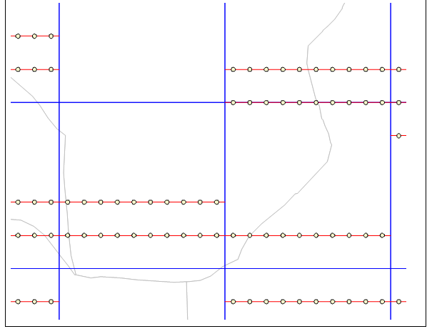
Figure 3. EI Sampling Design Layout- lines are in blue, transects in red, plots in black/yellow

In the field it is normal to have separate teams cutting lines and enumerating plots. Line cutting proceeds at about 800 m per day, whilst plots are measured at a rate of about 10 per day.

Layout of PSPs
The oldest PSPs (over 50 years) in Uganda can be found Tropical High Forests. NBS laid some PSPs in woodlands and non-forested that may generally be referred to as silvipastoral and agroforestry systems but the status of these PSPs is not known. Current PSP design in Tropical forests borrows from the old Departmental Standing Orders (DSOs) system that use spiral quadrat numbers (figure 4). The numbering is also derived from Alder & Synnott (1992).

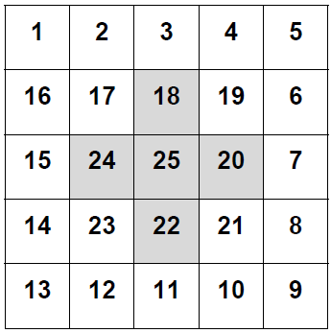
Figure 4. Spiral system of Quadrant Numbering of PSPs in THF

PSPs in forest plantations follow completely a different approach. In recognition of the rising demands for timber and also as a strategy to reduce pressure on the natural forests, a deliberate effort to encourage private sector investment into commercial forest plantations was initiated around year 2000. NFA supported this plan by allocating land for tree planting in production forest reserve or degraded forest reserves. The Saw Log Production Grant Scheme (SPGS) provides incentives and technical support in form of improved silvicultural practices. In addition to private sector, NFA embarked establishing new forest plantations and replanting harvested areas. Some of these are under target generation of carbon revenues and follow CDM procedures.
The need to monitor growth and performance of forest plantation lead to the establishment of Permanent Sample Plots (PSPs). NFA targets a sampling intensity of 0.16% to 0.2% i.e., 1 plot of 400m² to 500 m² to for every 25 ha. The sampling intensity in private forest varies greatly but many seek services to NFA inventory team. Stratification in forest plantations is mainly by species and age class. Site class might also be a consideration.
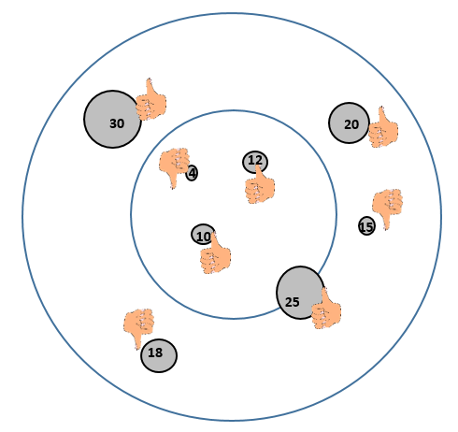
Figure 5. An example of a nested Circular plot

PSPs in forest plantations generally use nested circular plots whereby the measurable size limit in the inner circle is lower (e.g., 10cm) than in the outer circle (e.g., 20cm). Nested plots may be designed differently e.g., measurable size limit in a quarter of a plot being lower than in the rest of the plot. This approach is common rectangular plots.

Part II, Preparation for Field work

Overview of data collection process
Data is collected by the field crews from sample plots. The main information sources for the assessment are:
- Preparation of fieldwork which include planning for personnel, tools and equipment plus contacting local government leaders and village leaders
- Field measurements which include navigation to the plot, plot demarcation, observations in sample plots (tree cover, slope, activities in the plot neighbourhood and very important tree measurement
- Information on land tenue, attitudes of people and leaders is also important especially in guiding subsequent visits
- Data on deadwood is collected in Tropical High Forests
- Data on soil carbon may as well be collected
The process for data collection is summarized in the next figure.
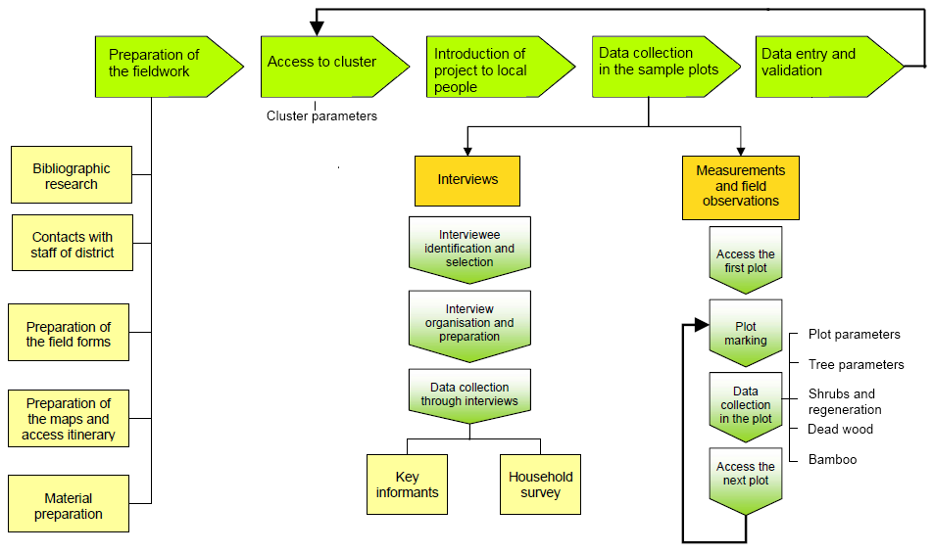
Figure 6. Data collection procedure

Preparations for the fieldwork
This part includes recommendations to prepare and carry out fieldwork activities. The fieldwork is described step by step which includes manpower requirements, tools and equipment plus community engagement.

Field crew composition
A recommended field crew consists of the following members:
- Crew leader;
- 2 Technicians (biophysical field measurements -enumerators);
- At least 1Local council member
- 3 temporary helpers (Casual Workers)

One Technician is nominated to act as assistant crew leader. Technicians are experienced tree identifies and enumerators. One or two graduate may be attached to understudy the technicians. . It is desirable that local councils are hired locally and act as guides in the field. They also provide local names of the trees..
The responsibilities of each crew member must be clearly defined and their tasks are proposed as follows below.
The crew leader is responsible for
- Organizing all the phases of the fieldwork, from the preparation to the data collection. He/she has the responsibility of contacting and maintaining good relationships with the community and the informants and has a good overview of the progress achieved in the fieldwork; he/she has the responsibility of maintaining harmony and good working spirit within the crew;
- Specifically preparing the fieldwork: carry out the bibliographic research, prepare field forms and collect the maps;
- Planning the work for the crew;
- Contacting local forestry officers, authorities and the community. Introduce the survey objectives and the work plan to the local forestry staff and authorities, and request their assistance to contact the local people, identify informants, guides and workers;
- Administer the location and access itinerary of clusters and plots;
- Taking care of logistics of the crew: organize and obtain information on accommodation facilities; recruit local workers; organize access to the clusters;
- Interviewing external informants and local people;
- Filling in the forms and take notes;
- Ensuring that field forms are properly filled in and that collected data are reliable;
- Organizing meetings after fieldwork in order to sum up daily activities;
- Organizing the fieldworks safety;
- Submitting data for entry into the computer.

The assistant of the crew leader will:
- Help the crew leader to carry out his/her tasks;
- Take necessary measurements and observations;
- Make sure that the equipment of the crew is always complete and operational;
- Supervise and orient the workers;
- Filling in the forms and take notes as required;
- Take over in the team leader's absence.

The enumerators will carry out the field measurements.
The temporary helpers are assigned the following tasks, according to their skills and knowledge of local species, language and practices:
- Help to measure distances;
- Open ways to facilitate access and visibility to technicians;
- Provide the common/local name of forest species;
- Inform about access to the plots;
- Provide information about the forest uses and management;
- Carry the equipment.

Training of the crews on the survey methodology is undertaken in theoretical and practical sessions in the beginning of the fieldwork where techniques of different forest and tree measurements, and tally of data will be explained and practiced. The names and contact details of the crew members and key persons must be written down in field form (Annex 1) for communication in case of emergencies and queries that may arise in the field.
The crew leader is responsible for planning the work schedule in an efficient way. In the field, crew leader locates the subplot, defines the surrounding area, records time for time study, determines slope corrections on sloping areas and records tree measurements. The crew leader is responsible for the quality of the work of crew members.
The crew members measure slope percentage, tally and sample trees, dead wood (where applicable like in THF), and stumps. They also take tree measurements.

Preparations of tools and instruments
The preparation of fieldwork consists of the following phases:
- Preparation of the field forms and maps;
- Contacts to Forest Range Managers, Local Authorities and District Forest Officers who in turn contact local communities;
- Field equipment (maintenance, checking). A check list is provided in Appendix I

Preparation of the field forms and maps
The Inventory Coordinator will ensure all secondary data sources, particularly maps and existing management plans, with administrative centres, accessibility and forest ownership is availed to the crew team.
Maps (stratified land cover /use covering the study area should be prepared in advance to help the orientation in the field. These may be enlarged and reproduced, if necessary. Plot locations should be over layered on the available maps to ease navigation in the field. Reference objects (roads, rivers, houses) that contribute to the better orientation of the crew in the field should be identified during the planning phase.
Order for data collection may vary according to conditions of accessibility. It is determined during the preparation phase.
Prior to the field visit, each crew must plan the itinerary to access the cluster or a transect depending on the sampling design. NBS uses clusters on a 2Km x 2km grid while EI uses transects in 1Km x 1KM block. Where inventory is on private land like under NBS, consultations with local forestry staff are usually valuable and help saving time in searching the best option to access the cluster.

Contacts and Introduction of the project to local people
Especially for those inventories that are carried out on private land, the Inventory coordinator should liaise with Forestry Sector Support Department (FSSD) at least three weeks before commencement of field work. If the sample area is inhabited, the Inventory coordinator and FSSD must establish contact with local government officials, local staff and local leaders in advance. The local staff may also provide information about access conditions to the target area and about the people who can be locally recruited as guides or workers. They may also inform the local people about the project.
On arrival to the site, the crew should meet with contacted persons who in turn should introduce them to the village leaders and owners the land. In many cases, it will be necessary for the village leaders to introduce the inventory crew to the local population and request permission to access the area. An introductory meeting may also be organized.
The crew must briefly introduce and explain the aim of the visit and study. A map or an aerial photograph/satellite image, showing the target inventory area, may be very useful to facilitate the discussion. It is important to ensure that both local people and the field crew understand which area will be studied. The aim of the inventory must also be clearly introduced to avoid misunderstandings or raise false expectations. Cooperation and support from local people are essential to carry out the fieldwork. It is easier to achieve this support if the first impression is good. Nevertheless, it must be stressed that the fieldwork consists only of data collection and not local development or law enforcement project. Some key points about the project introduction are mentioned below.
Key points to be stressed during the presentation of the project to the local people are as follows:
- An objective of this study is to collect data on land uses to support national decision making by interacting with the local users. The collected land use information will be used by the country and the international community. The objective is to generate reliable information for improved land use policies that takes into account people’s reality and needs. Hopefully, this can lead to natural resources being managed in a sound and sustainable way. The intervention resulting out of the data collection, analysis and project write up could help not only in the mitigation of Green House Gases but of poverty.
- The data are collected from two sources:
(1) Measurements of the forests and trees (may include trees on non-forested land); Measurement examples to be mentioned may be: tree diameter and height, as well as forest species composition.
(2) Interviews with local communities using land including forest users and other people who are knowledgeable of the area. The field crew should equally be interested in the local people’s perception on land use changes, the main products extracted from land, land use related problems, and will therefore interview land users.
- It could also be mentioned that country wide NFI is planned but some areas have been selected as starting points using a pre- defined criteria.

Field equipment and Tools
Equipment and tools needed by each field crew are described in table 2. Equipment and tools required at the base station are listed in table 3.

Table 2. Equipment per field crew team
Equipment needed | Number required | Comments
Measurement tools
Compass (360°) | 1 | In degrees, Water proof model
GPS receiver + extra batteries + charger | 1
Measuring tape, 20 m | 2 | Metric
Measuring tape, 50 m | 1 | Metric
Diameter tape | 1 | mm scale
Tree height and land slope measuring equipment | 1 | Haglöf Vertex hypsometer or Suunto hypsometer with 15m, 20m and % scales to measure both tree height, in meters; and slopes, in percent.
Spherical densitometer | 1 | Canopy coverage measuring equipment. Concave model.
Coloured flagging ribbon | Several rolls
Waterproof bags to protect measurement instruments and forms | As necessary
Soil auger | 1
Plastic packs for soil samples | As necessary | For soil samples in clusters/plots only
Plastic tarp, 100 cm x 100 cm | 1 | For collecting and mixing the soil samples in clusters/plots only
Spade | 1
Digital camera, extra memory card, extra batteries, and charger | 1 | Not necessary of GPS has camera
Machete / Bush-knife | As necessary
Pocket knife and Machete | 1
Colour spray | 1 | For marking of fixed points in PSPs
Tools that will help mark centre point, stick or metal | As necessary
Clothing
Boots and waterproof outfits | For permanent team members
Helmet | For permanent team members |  | Optional, for area where there is risk for branches to fall
Rain coats | As necessary |  | Optional
Documents, papers
Tablet uploaded with appropriate forms | 1
Power bank for tablet
Backup Field forms (water proof better) | As necessary
Hand calculator | 1
Clipboard | 2 | To take notes
Code check list with slope correction table | As necessary | Needs to be laminated
Field manual (Brief) | As necessary
Flora and species check list | As necessary
Munsell Soil Colour Chart | 1
Field Maps (Topographic, LUC, aerial photo/satellite image | As necessary
Pens and markers | As necessary
Supporting board / writing tablet | 1 | To take notes
File | 1
Newspapers | As necessary | For collection of samples (plants/ leaves)
Other equipment (camping, security, communication…)
Mobile phone | At least 1
First aid kit | 1 | With phone numbers of hospitals / emergency
Flashlight and batteries | As necessary

Table 3. Equipment and tools for the base station (camp)
Laptop PC (at base station) | 4 | Data validation, QA/QC control, Access reference material, Data capture etc
Camping equipment and cooking utensils | As necessary | Vary according to field teams
Rucksack | As necessary
Water and food | As necessary

The list of equipment is specified by measurement type in the following table.
The condition of the inventory equipments needs to be verified prior to field work and missing or damaged items are replaced with new or fixed tools.

Part III Field Measurements

Data collection in the field

Navigation to the Plot
Field preparation stage helps plan for the most appropriate route to the cluster and or plot. Coordinates are preloaded on to the GPS for easy navigation. With the help of the maps and information from the local staff and village leader each Crew team leader is expected to choose the most appropriate route to access a cluster or plot.

Plot demarcation
All measurements start by plot demarcation. Plots or quadrants may vary in size and shape but the most important is consistence. Consistence is needed to ensure that the plot size is the same for the plots where the terrain is not flat slope correction should be applied. For PSPs it is important that tree positions are marked in manner that they can be identified on subsequent visits. Tree position is increasingly becoming of help in Quality control and quality assurance procedures.

Slope corrections
All reference distances, such as a tree distance from subplot centre point, are expressed as horizontal distances. Thus, plot areas are also computed upon horizontal plane. When the terrain is flat, distances can be measured directly. But on sloping terrain the horizontal distances differ from direct distances (see figure 7). A corrected distance may be taken from a slope correction table (Appendix III) or may be computed (see equation 1 below) and the distance are applied at all slopes above or equal to 5 percents.
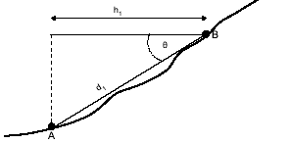
Figure 7. Distances on slope

Note: The distance between two points, measured along slope (d₁) is always longer than an equivalent horizontal distance (h₁). On slope terrain, the horizontal distance must be multiplied by a factor that corresponds to the inclination, in order to obtain a corrected distance.

Slope is measured using a Haglöf Vertex hypsometer, TruePulse, clinometer or Suunto hypsometer. The unit in this inventory is percent. Where distances are measured using a measuring tape on sloping ground, slope distance will need to be corrected back to horizontal using the following equation:
Equation 1. Calculating Horizontal distance
Horizontal distance = Slope distance × Cos(σ)
Where σ = slope angle in degrees.
The equation can be written in the following form when slope angle is in percentages:
Horizontal distance = Slope distance × Cos(Atan(α/100))
Where α = slope angle in percentages (%).
The slope correction table for distances is presented in Annex xx.
Note: The points recorded by the GPS will reflect horizontal distance. No corrections for distances on slope are required.

NBS Plot Layout
From 1993 to 2005, the NBS has been using 50m by 50m square plots in all land units except in forest plantations where the size was reduced to (20m by 20m). These plot sizes were arrived at through research during the development of the biomass monitoring program (Knut, 1997; Forest Department 1994 and 1995). The south western corner of the plot would be located on the ground using differential GPSs. A plot would be subdivided into five 10-meter wide strips running in the east-west direction and tree measurement done systematically from one strip to another. Tree numbering was based on the location of the tree in the strip (figure 8 left). This was intended to make tree re-identification easier during subsequent visits.
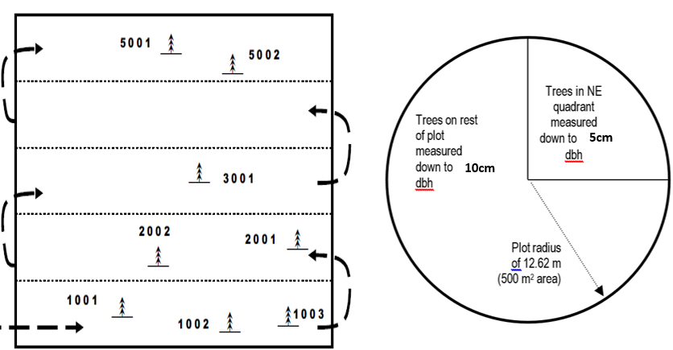
Figure 8. Rectangular Biomass plot (Left) and the Proposed Circular Biomass Plot (right)

Change of the Biomass Sampling Design
It is proposed that starting with late 2015 or early 2016, the Biomass Assessment Inventory changes from a cluster of three rectangular plots (2,500m² each) on 10Km x 5Km grid to a cluster of five circular plots on 2Km by 2Km grid. The circular plot has a nested quadrant in the first 90 degrees (NE part) of the plot (figure 8 right) where trees up to 5cm diameter are measured. The minimum diameter in the rest of the plot is 10cm. The plot size will be determined after carrying pre survey tests in the woodlands but will most likely be having a radius of 12.6 m (the same as the EI has circular plots of 500 m²⁾).

EI and PSPS design
EI and PSPs in the natural forests maintain the same sampling design and plot size as before. PSPs in forest plantations also maintain that same sampling design and plot size.

Tree measurements
All live trees that have the minimum diameter as specified in each inventory plan (ie., NBS, EI, PSP) are enumerated. Trees which are totally dead and clearly decaying but retain a standing bole are recorded as dead trees. However, any tree which shows any signs of life, including those with broken tops, should recorded as live tree. Coded notes are proved in table 5 under Appendix II. In PSPs, large stranglers which have assumed tree form should also be included.

Tree Positioning
All trees that qualify to be measured are identified and given unique numbers in clockwise direction starting from the North direction. Numbers could be temporarily assigned using flagging tapes or trees could be permanently market e.g., in PSPS (plate 1).
It is recommended that four photos are taken in the North, East, South and western direction using either a tablet or GPS or both. Photos are important in documenting plot characteristics such as vegetation type, when taken after tree numbering may ease the relocation of trees in the future reassessments. On private lands close to human settlements the crew should ask a permission to take a photo. Taking photos with GPS or tablets ensure that the photos are geotagged and thus associated with plot data.

Plate 1. Tree Numbering with paint

Tree diameter measurements
Tree diameter is measured over bark, at 1.3 m breast height above the ground with the exception of particular cases mentioned below. Measurement may be carried out using preferably the diameter tape or with the use of the caliper. Both devices should have metric scale and the smallest unit in millimeters. Diameter is recorded in centimeters with one decimal digit (i.e. as millimeter). If a caliper is used, the measurement is always carried out at right angles to centre point (figure 9). If a tree is leaning in flat terrain, the measurement point is at that side where tree leans (figure 10). Make sure the caliper tightly holds the stem, in order to prevent the caliper clasps from grasping without compressing the bark.
If the diameter tape is used, make sure it is not twisted and is well stretched around the tree in a perpendicular position to the stem. Nothing must prevent a direct contact between the tape and the bark of the tree to be measured.

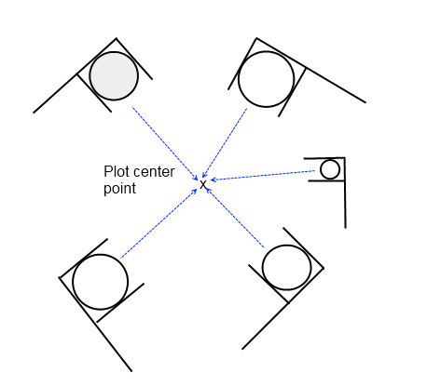
Figure 9. Positioning of calliper when measuring diameter

Note about Permanent Sample Plot measurements:
- All tree diameters on the permanent sample plots should be recorded only using the diameter tape;
- A 1.3 m stick must be used when determining the breast height up from the ground level.

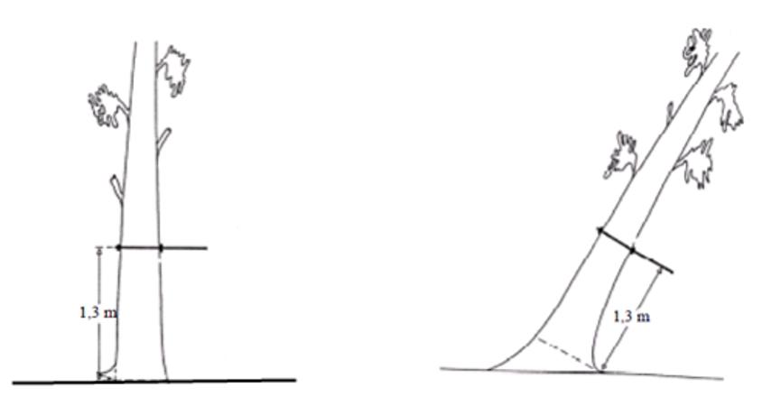
Figure 10. Diameter Measurement on Flat terrain -straight tree (left) and Leaning Tree (right)

When a tree is growing on slope, the measurement point is located at the upper side of slope (figure 11).

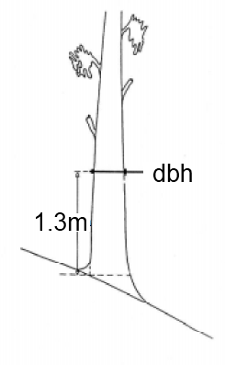
Figure 11. Diameter measurement of tree on slope

There are several cases where a forked tree exists. The first thing is to determine the point where the tree forks. If the fork originates (the point where the core is divided) below 1.3 m height, each stem reaching the required diameter limit will be considered as a stem to be measured, and the diameters is measured at 1.3 m height (figure 12).
A living stem can be a sample tree. For a forked sample tree record the stump diameter at the default stump height level (15 cm above ground). This stump diameter usually refers to the stump diameter of the whole tree. If a forked sample tree originates below 15 cm, then write a remark to that stem as ‘fork below 15 cm’.
A fork can be dead or alive. Record this information into Health status.

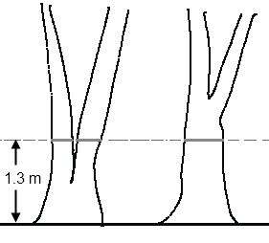
Figure 12. Diameter measurement points for forked tree

If a fork originates at 1.3 m or a higher, the tree will be counted as a single tree. The diameter measurement is thus carried out below the forks’ intersection point, just below the bulge that could influence the DBH (figure 13).

Figure 13. Examples of forks’ intersection at the 1.3 m height

Coppice tree: Coppice shoots considered similarly as forked trees. The measuring height is 1.3 m above the seedling point (figure 14). Record also the stump height (cm) for each coppice shoot. This is the height of the estimated level where the shoot originates.
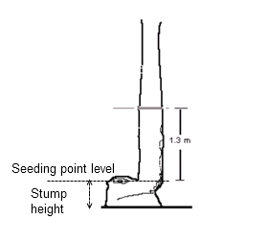
Figure 14. Diameter and stump height measurements of coppice tree

Trees with an enlarged stem base or buttressed tree: diameter measurement is made at 30 cm above the enlargement or main width of buttress, if the buttress/enlargement reaches more than 90 cm height above the ground (figure 15).

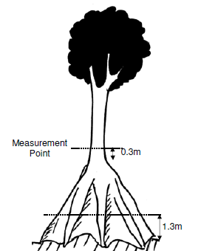
Figure 15. Diameter measurement of a tree with large buttress

Trees with aerial roots exceeding 130 cm from the ground: diameter is measured 30 cm above the upper root (figure 16). Among Rhizophora genus (mangrove) there are some species of which usually contain prop roots above 130 cm from the ground. Some upper roots are well established in the mangrove mud, while others have just started forming, or are formed from within the canopy. Therefore only roots originating from the central stem and touching the mangrove soil or permanent water body are considered, when pointing out the ‘upper root’.

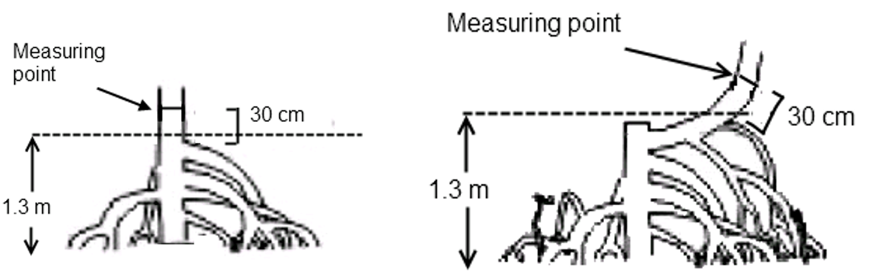
Figure 16.Diameter measurement of a tree with aerial roots

a) Growing mangrove stem b) Cut mangrove stem

Trees with irregular shape at 1.3m level: Trees with bulges, wounds, hollows and branches, or other reasons causing irregular shape at the breast height, are to be measured above and beneath the deformation, and the average of both is the calculated as DBH of the tree (figure 17).

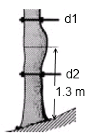
DBH = (d1 + d2)/2
Figure 17. Diameter measurement of deformed trees

Other special cases: The diameter of a tree with a horizontally protruding stem should be measured 130 cm along the stem, even if this is less than 130 cm above the floor. A case of damaged and broken stem where the DBH measurement is done below 1.3 m is presented in (figure 18).
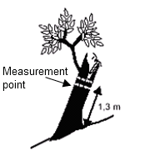
Figure 18. Diameter measurement of damaged and broken stem

Tree height measurements
Tree height measurement may be carried out by means of several instruments (as Blume-Leiss, Suunto, Haga, electronic range finders). Suunto hypsometers and some Haglöf Vertex hypsometers are in use for the field teams.

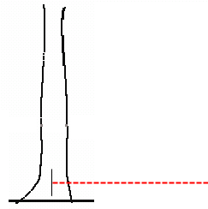
A height measurement using Suunto is done in the following stages:
Figure 19. Point of measure of horizontal distance is middle of the base
- Measure 20 meters horizontal distance to the tree:
- If tree top is at the same vertical line with the base of the tree, measure the distance from the middle of the tree base (figure 19 and 20 a).
- Observation to the top of the tree;
- Observation to the base of the tree;
- Addition or subtraction of the results of these two observations as follows:
  - -addition if the operator is focusing downwards to the base of the tree (20 a)
  - -subtraction if the operator is focusing upwards to the base of the tree (20 b)

If the tree leans, follow the rule presented in figure 20 c

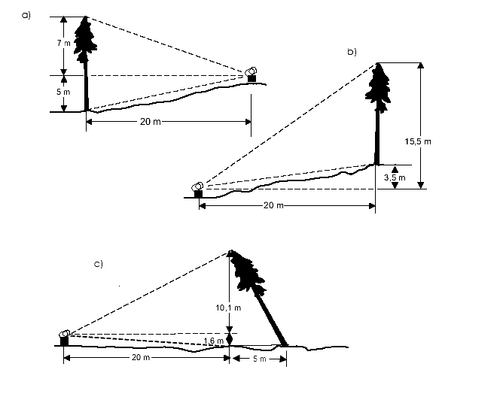
H = 7.0+5.0 = 12.0
H = 15.5-3.5 = 12.0
Figure 20. Tree height measurements
H = √(11.7²+5²) = 12.7 m
Summary of Tree Height measurements provided in figure 20a, 20b and 20 c
- By adding the results above and below the horizontal measurement (7.0+5.0);
- By subtracting from the total the difference between the base of the tree and the horizontal line (15.5-3.5);
- By applying the Pythagorean theorem. Measure first the height of the tree top, then measure the horizontal distance from the stump point to the top point projected on the horizontal level. Apply equation: H= √(Height²+Distance²).

Tree Crown Diameter Measurement
Tree Crown diameters is the distance on the ground covered by the crown of a tree. It is measured by a distance-tape and readings made to the nearest meter. Since trees normally have irregular crown shapes, two diagonal readings are normally taken and the average mean recorded as the crown width.

Dead wood measurements
Dead wood are tree parts that are lying on the ground. Dead wood measurements are taken only in Tropical High Forests. The field crew determines dead wood of 10cm diameter and above that are intersected by transect line that runs North to south across the plot (figure 21 and figure 22).
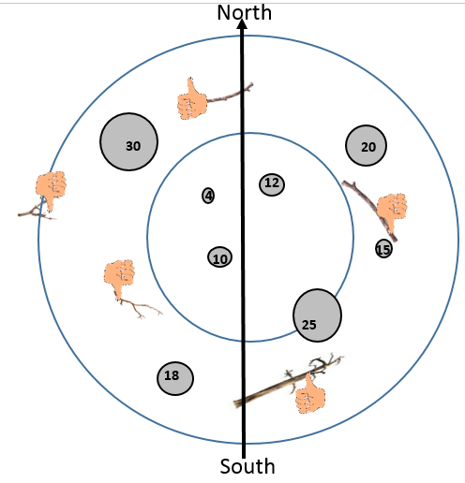
Figure 21. Deadwood intersect the North - South line is enumerated

Diameter (perpendicular to log length) at the point of intersection is recorded. The diameters are measured over bark if bark still exists; otherwise without bark. The total length of the dead wood is also recorded (figure 22).
The dead wood is assigned to one of the three density states (sound, intermediate and rotten) using the ‘machete test’, as recommended by IPCC Good Practice Guidance for LULUCF (2003). Decay class is used when we compute dead wood biomass and carbon: rotten coarse woody debris has lower density value than a solid wood. A sample of deadwood data form is provided in table 6 in appendix II.

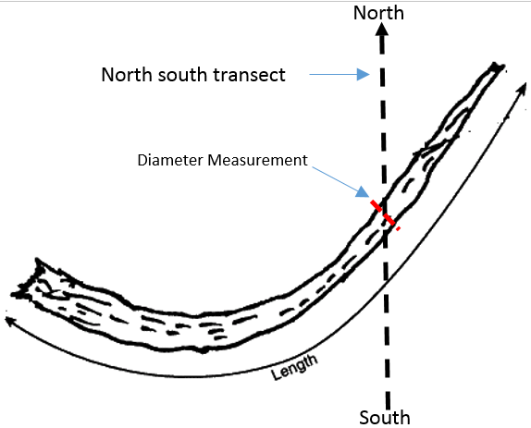
Figure 22. Measurement of Deadwood

REFERENCES
- British Columbia Ministry of Forests 2008. Glossary of Forestry Terms in British Columbia. Province of British Columbia, Canada. Available at: http://www.for.gov.bc.ca/hfd/library/documents/glossary/
- Commonwealth of Australia. 2002. Field measurement procedures for carbon accounting. Bush for Greenhouse Report 2. Australian Greenhouse Office.
- ETFRN. 2000. Developing Needs-Based Inventory Methods for Non-Timber Forest Products Application and Development of Current Research to Identify Practical Solutions for Developing Countries. Workshop 4–5 May 2000. FAO, Rome, Italy. 95 p. At: http://www.etfrn.org/ETFRN/workshop/ntfp/
- FAO. 2006. Guidelines for Soil Description. 4th Edition. Rome. 97 p.
- FAO. 2007. Global Forest Resources Assessment 2010 – Specification of National Reporting Tables for FRA 2010. FRA Working Paper No 135. Rome. 51 p.
- FAO. 2008. Technical Review of FAO’s Approach and Methods for National Forest Monitoring and Assessment (NFMA). By Erkki Tomppo and Krister Andersson. National Forest Monitoring and Assessment Working Paper NFMA 38. Rome
- FAO. 2009. National Forest Monitoring and Assessment – Manual for integrated field data collection. Version 2.3. National Forest Monitoring and Assessment Working Paper NFMA 37/E. Rome.
- Forest Survey of India. 2002. Manual of Instructions for Field Inventory. Forest Survey of India (FSI), Dehradun, India.
- Holechek, J. & Galt, D. 2000. Grazing intensity guidelines. Rangeland 22(3):11–14.
- IPCC 2008. 2006 IPCC Guidelines for National Greenhouse Gas Inventories – A primer. Prepared by the National Greenhouse Gas Inventories Programme, Eggleston H.S., Miwa K., Srivastava N. and Tanabe K. (eds). Publisher: IGES, Japan.
- JICA. 2012. The Study on Potential Forests and Land Related to “Climate Change and Forests” in the Socialist Republic of Viet Nam. Draft Final Report. 208 p.
- METLA 2006. VMI10 Maastotyöohje. Field Manual for NFI-10 in Finland. Finnish Forest Research Institute. Helsinki, Finland. (in Finnish).
- Michalak, R. 2008. Comparison of the scope, terms, definitions and classifications applied for the FAO Global Forest Resources Assessment 2010 and the MCPFE/UNECE/FAO Report on State of Europe’s Forests 2007. Part I - Definitions and classifications structured according to FRA reporting tables. UNECE/FAO Timber Section, Geneva. 38 p.
- National Forest Authority Carbon Project PSP manual 2010
- National Forest Authority National Biomass Technical Repots 1998 and 2002
- National Forest Authority PSP and IE manuals- Alder et al 2003
- Raae, K. Christensen, P., Phuong, V.T. and Dien, V.T. 2010. Technical Report on Technical Assistance in the Development of the National REDD Programme of Vietnam: Component of Collecting Information and Analyzing Trends of Forest Resources and Forest Carbon Stock for Establishment of the Interim Baseline Reference Scenarios. Vietnam Administration of Forestry, Hanoi. 38 p.
- Setje-Eilers, U. 2008. Forest Resource Inventory Field Manual (province level). Forest for Livelihood Improvement in the Central Highlands (FLITCH) Project. Technical Report. 28 p. + annexes.
- Setje-Eilers, U. 2012. Proposal on Information Standard for Forest Resource Inventory. Development of Management Information System for Forestry Sector (FORMIS) Project. Version February 2012. 29 p.
- Tomppo, E., Olsson, H., Ståhl, G., Nilsson, M., Hagner, O. & Katila, M. 2008. Combining national forest inventory field plots and remote sensing data for forest databases. Remote Sensing of Environment 112: 1982-1999.
- Woodall, C.W., Rondeux, J., Verkerk, P.J. & Ståhl, G. 2006. Estimating Dead Wood During National Forest Inventories: A Review of Inventory. Methodologies and Suggestions for Harmonization. Proceedings of the Eighth Annual Forest Inventory and Analysis Symposium.

Appendix 1 Equipment by measurement types

Table 4. Equipment by measurement types
Measurement type | Equipment required
SUBPLOT
Plot locations | GPS, maps, list of cluster /Plot coordinates
Tree location determination | 20m measuring tape, slope correction table
Plot border marking | Coloured flagging ribbon, metal/wooden poles
Slope | Haglöf Vertex hypsometer, TruePulse or Suunto hypsometer with clinometer
Photo documentation | GPS camera or Tablet
Canopy coverage (Trees) | Spherical densiometer
Soil depth | Spade
Soil colour | Munsell Soil Colour Chart
Soil texture | guidelines still being developed.
Soil sample | Plastic packs, marker pen
TREES
Species code and name | Species check list
Tree diameter | 1.3 m stick; Diameter tape (mm scale)
Stump diameter | Diameter tape
Tree height | Clinometer, 20/50m measuring tape
Bole height | Clinometer, 20/50m measuring tape
Stump height | Measuring tape
Marking of fixed points (as trees) | Spray paint
DEAD WOOD
Species code and name | Species check list
Dead wood diameters (2) | Diameter tape or caliper
Dead wood length | 20/50m measuring tape
Decay class | Machete
BAMBOO
Species code and name | Species check list
Bamboo average diameter | Diameter tape or caliper
Bamboo average height | Haglöf Vertex hypsometer or Suunto hypsometer

Appendix II Tree and Stump Data Form

Table 5. Stumps, Standing tree Live and Dead Tree Form

26. Subplot measurement? (y/n) | 27. Tree /Stump N° | 28..Stump (mark “x” if stump) | 29.Height at which diameter is taken if stump | 30. Number of Year(s) since tree was cut | 31.Species name |  | 32. Dbh¹ | 33. Total height | 34 Bole height | 35. Crown diameter | Health
 |  |  |  |  | 31a. Common/local name | 31b. Scientific name |  |  |  |  | 36. Crown Condition  (healthy =1, declining health = 2, unhealthy=3, dying =4, dead =5) | 37. Overall tree condition  (healthy =1, declining health = 2, unhealthy=3, dying =4, dead =5) | 38. Causative agents² (N/A=0, insects=1, disease/fungi=2, fires=3, animals=4, humans=5, climate=6, other*=99)
26. Subplot measurement? (y/n) | 27. Tree /Stump N° | 28..Stump (mark “x” if stump) | m | 30. Number of Year(s) since tree was cut | 31a. Common/local name | 31b. Scientific name | cm | m | m | m | C | C | C

Codded Notes for site factors | Codded Notes for Tree Condition
AG; Agriculture (current or recent)  CT; Climber tangle impeding regeneration  FI; Forest fire indicators (burnt bark etc.)  GA; Gap from natural tree fall  GF; Gap caused by recent felling  LG; Mechanised logging  PL; Plantation or enrichment planting  RK; Rock outcrop  RS; River, stream or lake  SW; Pit sawing or mobile sawmills  UN; Unstocked – no measurable trees | 1)Tree form and measurement quality  DU; Diameter unreliable - measurement cannot be made accurately.  FB; Fluted bole – bole is fluted and cannot be well measured.  MF; Malformed – tree very crooked, bent over, twisted  MS; Multiple stems – forked above pom  OD; Optical diameter measurement – large high buttress trees measured by Relascope  2)Damage and health indicators  BS; Broken stump – tree broken off in mid or lower bole  BT; Broken top – crown completely broken off  CD; Crown damage – major branches broken, crown partially lost  CI; Climber infestation – competing with tree crown  DB; Dead bark – areas of bark loss exposing dead cambium  EX; Excrescences – large bumps or woody growths from bole of tree.  FD; Fire damage – charred wood or bark.  FU; Fungi – fruiting bodies of fungi on stem or buttress.  LD; Logging damage – tree has been damaged during logging.  LT; Leaning tree – tree partially uprooted or leaning from the vertical  RB; Rotten buttress – Base of tree largely rotten  RT; Rotten timber – rotten branches, hollows etc. on main bole  ST; Strangled tree – Tree largely dominated by strangler  DF; Defoliation – tree has no foliage  3)Dead or missing tree indicators  DT; Dead tree – tree clearly dead, but standing  LS; Logged stump – sawn or axe-cut stump  NT; No tree – Tree completely missing  TF; Tree fallen and on ground.  4)Other factors  DC; Diameter change – new POM adopted  FW; Flowering – tree is in flower  IN; In growth – a recruit tree not previously measured.  US; Uncertain species – identification given is best guess.

Table 6. Dead wood form
Forest Floor wood Information; Status =1, 2 or 3

Log No | Diameter | Decomposition status

Bamboo data is recorded on Forest, Woodland, and Bushland vegetation types, whenever applicable.
This form contains information related to bamboo clumps (all bamboo shoots taller than 1.3 m) within a plot. The average diameter is at the breast height (1.3 m above ground). Dead and alive bamboos are recorded separately, when possible. The parameters for bamboo measurements are listed in table 7.

Table 7. Bamboo measurements form
Bamboo parameters
Object | Definition | Source | Format | Notes
Cluster number | Cluster ID | Inventory plan | Number

Appendix III. Slope Correction Table

 |  | Length (m)
slope % | slope, degrees | 2 | 10 | 12 | 15 | 20 | 50
5 | 2.9 | 2.00 | 10.01 | 12.01 | 15.02 | 20.02 | 50.06
10 | 5.7 | 2.01 | 10.05 | 12.06 | 15.07 | 20.10 | 50.25
15 | 8.5 | 2.02 | 10.11 | 12.13 | 15.17 | 20.22 | 50.56
20 | 11.3 | 2.04 | 10.20 | 12.24 | 15.30 | 20.40 | 50.99
25 | 14.0 | 2.06 | 10.31 | 12.37 | 15.46 | 20.62 | 51.54
30 | 16.7 | 2.09 | 10.44 | 12.53 | 15.66 | 20.88 | 52.20
35 | 19.3 | 2.12 | 10.59 | 12.71 | 15.89 | 21.19 | 52.97
40 | 21.8 | 2.15 | 10.77 | 12.92 | 16.16 | 21.54 | 53.85
45 | 24.2 | 2.19 | 10.97 | 13.16 | 16.45 | 21.93 | 54.83
50 | 26.6 | 2.24 | 11.18 | 13.42 | 16.77 | 22.36 | 55.90
55 | 28.8 | 2.28 | 11.41 | 13.70 | 17.12 | 22.83 | 57.06
60 | 31.0 | 2.33 | 11.66 | 13.99 | 17.49 | 23.32 | 58.31
65 | 33.0 | 2.39 | 11.93 | 14.31 | 17.89 | 23.85 | 59.63
70 | 35.0 | 2.44 | 12.21 | 14.65 | 18.31 | 24.41 | 61.03
75 | 36.9 | 2.50 | 12.50 | 15.00 | 18.75 | 25.00 | 62.50
80 | 38.7 | 2.56 | 12.81 | 15.37 | 19.21 | 25.61 | 64.03
85 | 40.4 | 2.62 | 13.12 | 15.75 | 19.69 | 26.25 | 65.62
90 | 42.0 | 2.69 | 13.45 | 16.14 | 20.18 | 26.91 | 67.27
95 | 43.5 | 2.76 | 13.79 | 16.55 | 20.69 | 27.59 | 68.97
100 | 45.0 | 2.83 | 14.14 | 16.97 | 21.21 | 28.28 | 70.71
105 | 46.4 | 2.90 | 14.50 | 17.40 | 21.75 | 29.00 | 72.50
110 | 47.7 | 2.97 | 14.87 | 17.84 | 22.30 | 29.73 | 74.33
115 | 49.0 | 3.05 | 15.24 | 18.29 | 22.86 | 30.48 | 76.20
120 | 50.2 | 3.12 | 15.62 | 18.74 | 23.43 | 31.24 | 78.10
125 | 51.3 | 3.20 | 16.01 | 19.21 | 24.01 | 32.02 | 80.04
130 | 52.4 | 3.28 | 16.40 | 19.68 | 24.60 | 32.80 | 82.01

Some areas of Forest Reserves may be put under conservation, as nature reserves, where harvesting is not allowed.

