

Agricultural Sector Development Programme - Livestock (ASDP-L) and Agriculture Service Support Programme (ASSP)
Impact Evaluation
Household Questionnaire
November 2017

ADMINISTRATIVE INFORMATION
Questionnaire number:
Time of interview:  (24 hour clock) | Start HH MM |  |  | Stop HH MM
Name of interviewer:
Number of visits (max. of 3)
Reason for call back |  | Number of visits
 |  | 1 | 2 |  | 3
Refused to be interviewed |  |  | 1 |  | 1
Target respondent not at home/reachable |  |  | 2 |  | 2
Target respondent requested for a call back
No one in the household |  |  | 3 |  | 3
Respondent not able to be interviewed due to medical reasons (very sick, dumb, etc.) |  |  | 4 |  | 4
No adult member in the household |  |  | 5 |  | 5
Language barrier |  |  | 6 |  | 6
Not applicable |  |  | 99 |  | 99
Outcome of final visit |  | Successful | Incomplete |  | Replaced

Field quality control checks
Activity | Activity undertaken by
Activity | Interviewer | Supervisor | RSA Field Manager
Reviewed
Accompanied
Back checked
Called back

INFORMED CONSENT FOR WOMEN’S EMPOWERMENT IN AGRICULTURE INDEX
Enumerator: Leave the printed consent form with the household.
Informed Consent: Before beginning the interview, it is necessary to introduce the household to the survey and obtain their consent to participate. Make it clear to them that their participation in the survey is voluntary. Please read the following statement:
Thank you for the opportunity to speak with you. We are a research team from [XXXX] working in collaboration with [XXXX]. We are conducting a survey to learn about agriculture, food security and wellbeing of households in this area. You have been selected to participate in an interview which includes questions on topics such as your family background, dwelling characteristics, asset ownership and income earning activities. The survey includes both a section to be asked about the household generally, in addition to sections which will be asked to a primary adult male and female in your household if applicable. These questions in total will take approximately 4 hours to complete and your participation is entirely voluntary. Your answers will be completely confidential; we will not share information that identifies you with anyone. After entering the questionnaire into a data base, we will destroy all information such as your name which will link these responses to you.
We will also interview other households in your community and in other parts of Zanzibar. After we collect all the information we will use the data to make a study about how various programs can be most helpful to the people in this area. Do you have any questions about the study or what I have said? We will leave one copy of this form for you so that you will have record of this contact information and about the study.
Please ask the participants (male and female) if they consent to the participation in the study (check one box):
Participant 1: YES NO | Participant 2: YES NO
Participant 3: YES NO

I ____________________________, the enumerator responsible for the interview taking place on __________________, 2017 certify that I have read the above statement to the participant and they have consented to the interview. I pledge to conduct this interview as indicated on instructions and inform my supervisor of any problems encountered during the interview process.

If the household does not give consent to all of the data collection, stop the interview and inform your team leader. Team leaders will discuss the reason for this refusal and decide whether a partial data collection is possible for this household.

LISTING OF SURVEY MODULES
Household Level Questionnaire |  | Individual Level Questionnaire
Module 1 | Household Identification Cover Sheet | Module 4 | Cognitive Skill
Module 2 | Household Roster (Demographics) | Module 16 | FFS
Module 3 | Housing Characteristics | Module 17a | FFS Vegetables
Module 5 | Assets | Module 15b | FFS Cassava
Module 6 | Livestock | Module 15c | FFS Banana
Module 7 | Agriculture | Module 15d | FFS Rice
Module 9.1 | Off-Farm Employment | Module 15e | FFS Goat
Module 9.2 | Self-employment | Module 15f | FFS Chicken
Module 10 | Shocks and Resilience | Module 15g | FFS Cows
Module 11 | Access to Assistance Programs | Module 18 | FFS Spillovers
Module 12 | Capacity-Building Support | Module 19 | Women’s Empowerment in Agriculture Index
Module 13 | Food Consumption
Module 14 | Network
Module 15 | Market Access
Definition Of Household And Respondents (Required)
A household is a group of people who live together and take food from the “same pot.” In our survey, a household member is someone who has lived in the household at least 6 months, and at least half of the week in each week in those months. Even those persons who are not blood relations (such as servants, lodgers, or agricultural laborers) are members of the household if they have stayed in the household at least 3 months of the past 6 months and take food from the “same pot.” If someone stays in the same household but does not bear any costs for food or does not take food from the same pot, they are not considered household members. For example, if two brothers stay in the same house with their families but they do not share food costs and they cook separately, then they are considered two separate households. Generally, if one person stays more than 3 months out of the last 6 months outside the household, they are not considered household members. We do not include them even if other household members consider them as household members.
Exceptions to these rules should be made for:

Consider as household member:
- A newborn child less than 3 months old.
- Someone who has joined the household through marriage less than 3 months ago.
- Servants, lodgers, and agricultural laborers currently in the household and will be staying in the household for a longer period but arrived less than 3 months ago.

Do not consider as household member:
- A person who died very recently though stayed more than 3 months in last 6 months.
- Someone who has left the household through marriage less than 3 months ago.
- Servants, lodgers, and agricultural laborers who stayed more than 3 months in last 6 months but left permanently.
This definition of the household is very important. The criteria could be different from other studies you may be familiar with, but you should keep in mind that you should not include those people who do not meet these criteria. Please discuss any questions with your supervisor.
The primary and secondary respondents are those which are self-identified as the primary members responsible for the decision making, both social and economic, within the household. They are usually husband and wife, however can also be another member as long as there is one male and one female aged 18 and over. It may also be the case that there is only a primary respondent if that person is a female and there is no adult male present in the household.

MODULE 1: HOUSEHOLD IDENTIFICATION COVER SHEET
Q101  District | Q102  Shehia | Q103  Village | Q104  HH No. |  | Q1005 Household Location (GPS Coordinate) |  |  |  |  |  |  |  | Q106  Enumer.  Code |  | Q107  Super.  Code
 |  |  |  |  | a. WP |  | b. Elevation | c. Latitude |  | d. Longitude
Q108 Name of Self-identified Household Head and ID (from Module 2) |  |  |  |  |  | Q109 Name of FFS participant and ID (from Module 2) (Relevant only for households that are direct beneficiaries of FFS) |  |  |  |  |  |  | Q110 Date of survey dd/mm/year
Q111 Primary Respondent Name and ID (from Module 2) |  |  |  |  |  | Q112 Secondary Respondent Name and ID (from Module 2)
Primary and secondary respondents are those who self-identify as the primary male and female (or female only) members responsible for the decision making, both social and economic, within the household.
In Male and Female Adult Households, they are usually the husband and wife; however they can also be other household members as long as they are aged 18 and over.
In Female Adult Only households, there will only be a primary respondent -- the principal female decision-maker aged 18 or older.
Primary and secondary respondents do not need to be noted for Male Adult Only and Child Only Households, and Module G WEAI should not be applied in Male Adult Only and Child Only Households.
Q113 Household Type
Male and female adult - household contains at least one male and one female adult ≥ 18 years old 1
Female adult only - household contains at least one female adult and no male adults ≥ 18 years old 2
Male adult only - household contains at least one male adult and no female adults ≥ 18 years old 3
Child only - household contains no adults ≥ 18 years old 4
Q114 Beneficiary Status of the Household
(To be filled by the enumerator himself)
Direct Beneficiary Participating households in a FFS (Direct Treatment Households) 1 Ask question Q115 and Q117
Non-beneficiary Households not affected by FFS 2 Ask question Q122.
Q115 Were you the one in the household who participated in the FFS (household head and FFS participant is the same member of the household)? (Relevant only for households that are direct beneficiaries of FFS)
Yes 1 Interview the household head for module 1 to 18.
No 2 Interview the household head for module 1 to 3 and 5 to 15 and interview the FFS participant for module 4 and 16 to18
Q116 How many FFS did the household participate in?
Unit (count)
If the answer is 0, then end of the interview. We need to interview a household who participated in the FFS.
Q117 Did the household participate in at least one of the following FFS type: poultry, banana, cassava, vegetables, cow, goat, rice?
Yes 1
No 2 End of the interview. We need to interview a household that participated in these types of FFS.
Q118 Did the household participate in additional FFS activity types other than poultry, banana, cassava, vegetables, cow, goat, rice?
Yes 1 Ask question Q119
No 2
Q119 What was the additional FFS activity type that the household additionally attained?
1=Bata, 2=Bee keeping, 3=Citrus, 4=Clove nursery, 5=Cocoyam, 6=Cowpeas, 7=Crabs farming, 8=Finger Millet, 9=Fish farming, 10=Forestry 11=Whisky pines, 12=Groundnuts, 13=Local goats, 14=Magimbi, 15=Maize, 16=Mangroove conservation, 17=Millet, 18=Pigeon peas, 19=Pineapples, 20=Sea weeds, 21=Sorghum, 22=Spices, 23=farming, 24Sunflower, 25=Sweet potatoes, 26=Tree Nursery, 27=Turmeric/ginger, 28=Yams
Q120 Why did you or any other member of your household not attend a Farmer Field School?
Select up to two
1=None available, 2=Did not know it was happening in time to attend, 3=Travel too far / Expensive,
4=Already knew about topics covered,5=Not interested in topics covered,
6=Do not believe information given is reliable, 96=Other, please specify
Q121 Does the household produce the following crops and livestock: banana, cassava, vegetables, rice, poultry, cow, goat?
Yes 1 Ask question Q122
No 2
Q122 If yes, Which crop or livestock did you produce? (Multiple answer allowed)
1= Vegetables, 2= Cassava, 3= Goat, 4= Chicken, 5= Banana, 6= Rice, 7= Cow

MODULE 2.1: HOUSEHOLD ROSTER (DEMOGRAPHICS)
HH Member ID |  | Name of Household  Member | Age in completed years | Sex | Relationship to household head |  |  | Disability | Years of education completed | Marital status |  | If married, when did [NAME] get married? |  | If divorced or separated, when did [NAME] get divorced or separated? | If divorced or separated, what was the reasons for the divorce or separation of [NAME]? |  |  | Primary Occupation now |  | Secondary occupation now | Primary Occupation 10 years ago | Secondary occupation 10 years ago | Ethnicity | Religion
 |  |  |  |  |  |  |  |  | For ages above 5 |  |  |  |  | For ages above 10
 |  | (Start with household head) | Enter ‘0’ for < 1 year | 0= Female  1= Male | Enter codes  from list |  |  | Enter codes from  list | Enter codes from  list | Enter codes from list |  | Year |  | Year |  | 1=Migration  2=Adultery  3=Health reasons  5=FFS participation related reasons  96=Other, please specify |  | Enter codes  from  list |  | Enter codes  from  list | Enter codes  from  list | Enter codes  from  list | Enter codes from list | Enter codes from list
Q2101 |  | Q2102 | Q2103 | Q2104 | Q2105 |  |  | Q2106 | Q2107 | Q2108 |  | Q2109 |  | Q2110 |  | Q2111 |  | Q2112 |  | Q2113 | Q2112a | Q2113a | Q2114 | Q2115
02

03

04

05

06

07

08

09

Q2105 |  |  |  |  |  | Q2106 |  |  |  |  | Q2107 |  |  |  |  |  | Q2112/Q2113
Relationship with household head |  |  |  |  |  | Disability |  |  |  |  | Education |  |  |  |  |  | Occupation
1= | Head |  |  |  |  | 0= | None |  |  |  | 0= |  | Never attended school |  |  |  | 1= |  | Engaged in farming (unpaid work on own farm)
2= | Spouse |  |  |  |  | 1= | Partial visual impairment |  |  |  | 1= |  | Primary school incomplete |  |  |  | 2= |  | Large livestock raising (cattle, donkeys)
3= | Son/daughter of head and spouse |  |  |  |  | 2= | Total visual impairment |  |  |  | 2= |  | Attending primary school |  |  |  | 3= |  | Small livestock raising (sheep, goats, pigs)
4= | Son /daughter of head |  |  |  |  | 3= | Partial hearing impairment |  |  |  | 3= |  | Primary school complete |  |  |  | 4= |  | Poultry and other small animals raising
5= | Son/daughter of spouse |  |  |  |  | 4= | Total hearing impairment |  |  |  | 4= |  | Secondary school incomplete |  |  |  | 5= |  | Fishing and aquaculture
6= | Mother/father of head/ spouse |  |  |  |  | 5= | Mobility and orthopedic impairment |  |  |  | 5= |  | Attending secondary school |  |  |  | 6= |  | Non-farm self-employed (Trading/business)
7= | Sister/brother of head/spouse |  |  |  |  | 96= | Other, please specify |  |  |  | 6= |  | D6Secondary school complete |  |  |  | 7= |  | Casual off-farm labour in agriculture (paid)
8= | Foster child |  |  |  |  |  |  |  |  |  | 7= |  | University student |  |  |  | 8= |  | Casual labour in non-agriculture (paid)
9= | God child |  |  |  |  |  |  |  |  |  | 8= |  | University graduate |  |  |  | 9= |  | Permanently employed in agriculture (paid)
10= | Grandchild |  |  |  |  |  |  |  |  |  | 96= |  | Other, please specify |  |  |  | 10= |  | Permanently employed in non-agriculture (paid)
11= | Other relatives |  |  |  |  |  |  |  |  |  |  |  |  |  |  |  | 11= |  | Civil service/Government official
12= | Non-relatives |  |  |  |  | Q2112 |  |  |  |  | Q2113 |  |  |  |  |  | 12= |  | Chief/village elder or leader
 |  |  |  |  |  | Ethnicity |  |  |  |  | Religion |  |  |  |  |  | 13= |  | domestic/housewife (unpaid)
Q2108 |  |  |  |  |  | 1= | Hadimu |  |  |  | 1= |  | Orthodox |  |  |  | 14= |  | Student
Marital status |  |  |  |  |  | 2= | Tumbatu |  |  |  | 2= |  | Protestant |  |  |  | 15= |  | Unemployed
1= | Never married |  |  |  |  | 3= | Arab |  |  |  | 3= |  | Catholic |  |  |  | 16= |  | Unable to work due to illness/ disability
2= | Married (monogamous) |  |  |  |  | 4 = | Persian |  |  |  | 4= |  | Muslim |  |  |  | 17= |  | Retired/elderly
3= | Married (polygamous) |  |  |  |  | 5= | Sukuma |  |  |  | 5= |  | Hindu |  |  |  | 18= |  | No secondary occupation (only for Q2113)
4= | Divorced |  |  |  |  | 6= | Haya |  |  |  | 6= |  | Traditional worship |  |  |  | 96= |  | Other, please specify
5= | Separated |  |  |  |  | 7= | Nyakyusa |  |  |  | 7= |  | Pagan worship
6= | Widowed |  |  |  |  | 8= | Nyamwezi |  |  |  | 96= |  | Other, please specify
96= | Other, please specify |  |  |  |  | 9= | Chaga
 |  |  |  |  |  | 10= | Shirazi
 |  |  |  |  |  | 11= | Zaramo
 |  |  |  |  |  | 12= | Makonde
 |  |  |  |  |  | 96= | Other, please specify

MODULE 2.2: HOUSEHOLD ROSTER (Education)
 |  | NOTE TO ENUMERATOR: Ask only if individual is >=5 years
Q2201 | How many children currently go to school? (If 0, >> Q301)
Q2202 | How many children go to residential school?
Q2203 | Primarily, In this household who decides whether or not a child goes to school? Enter codes from list
Member ID | [Copy the Names of the members from the Household Roster in the same order] |  | Can [Name] write and/or read in any language? | Has [Name] ever attended school (Including adult education, vocational, or technical)? | What is the highest education level [NAME] completed? | Is [Name] currently attending school? (Don't include adult education, vocational, technical) | In the past 12 months, how many days was [Name] absent from school? | Why was [Name] absent from school? (Main reason) | How much was spent on [Name's] education in the last 12 months? (Ask this only if Q2209==1) |  |  |  | Primarily, who decides how much to invest in NAME's education?
 | Name  [FIRST, LAST NAME] |  | 0 = No  1 = Yes, Read only  2 = Yes, Write only  3= Yes, Read and Write | 1 =Yes  2 = No >> Next member | Enter codes from list | 1 = Yes  2 = No >> Next member  (The last member skips to next section) | If 0 >> Q2212 | Enter codes from list | Stationary, book, supplies [Tshs] | School uniform [Tshs] | Tuition, fees [Tshs] | Other costs , tutoring | Enter codes from list
Q2204 | Q2205 |  | Q2206 | Q2207 | Q2208 | Q2209 | Q2210 | Q2211 | Q2212 | Q2213 | Q2214 | Q2215 | Q2216
1
2
3
4
5
6
7
8
9
10

Q2208 | Q2211 | Q2216
0= Studying class1/pre-school | 1= Sickness | 1=Household Head
1= Completed class 1 | 2= Needed to help in household activities | 2=Spouse of the head
2= Completed class 2 | 3= Needed to participate in wage labor | 3= Head and the spouse jointly
3= Completed class 3 | 4= Could not afford expenses | 4=Other adult male (s)
4= Completed class 4 | 5= School too far | 5=Other adult female (s)
5= Completed class 5 | 6= Not interested | 6=Other Male and other female jointly
6= Completed class 6 | 7= School closed | 96=Other, please specify
7= Completed class 7 | 96= Other, please specify
8= Completed class 8
9= Completed class 9
10= Completed class 10
11= Completed class 11
12= Completed class 12
13=Completed Form 6
14= BA/BS or equivalent (Incomplete)
15= BA/BS or equivalent (Complete)
16= Post-graduate or equivalent
17= Vocational/Technical
18= Adult education
99= Never attended school

MODULE 3: HOUSING CHARACTERISTICS
Q3001 | How long has the household been living in your main dwelling? | […] Years  Minimum 0.
Q3002a | In what circumstance does the household live in your main dwelling? | 1= Owned, 2= Free of rent, 3= Rented, 96= Other , please  specify
Q3002b | In what circumstance did the household live in the main dwelling 10 years ago? | 1= Owned, 2= Free of rent, 3= Rented, 96= Other , please  specify
Q3003a | What is the main construction material of the walls of your main dwelling unit? | 1= Corrugated iron, 2= Cement, 3= Thatch, 4= Wood/ mud,  5= Reed/bamboo, 6= Plastic sheeting, 7= Cloth, 8= Asbestos,  9= Bricks, 96= Other, please
Q3003b | What was the main construction material of the walls of your main dwelling unit 10 years ago? | 1= Corrugated iron, 2= Cement, 3= Thatch, 4= Wood/ mud,  5= Reed/bamboo, 6= Plastic sheeting, 7= Cloth, 8= Asbestos,  9= Bricks, 96= Other, please
Q3004a | What is the main material used to construct the roof of your main dwelling? | 1= Corrugated iron, 2= Cement, 3= Thatch, 4= Wood/ mud,  5= Reed/bamboo, 6= Plastic sheeting, 7= Cloth, 8= Asbestos,  9= Bricks, 96= Other, please specify
Q3004b | What was the main material used to construct the roof of your main dwelling 10 years ago? | 1= Corrugated iron, 2= Cement, 3= Thatch, 4= Wood/ mud,  5= Reed/bamboo, 6= Plastic sheeting, 7= Cloth, 8= Asbestos,  9= Bricks, 96= Other, please specify
Q3005a | What is the main material used to construct the floor of your main dwelling? | 1= Mud/dung, 2= Reed/bamboo, 3= Wood, 4= Cement,  5= Plastic sheeting, 6= Brick tiles, 7= Ceramic/marble tiles,  96= Other, please specify
Q3005b | What was the main material used to construct the floor of your main dwelling 10 years ago? | 1= Mud/dung, 2= Reed/bamboo, 3= Wood, 4= Cement,  5= Plastic sheeting, 6= Brick tiles, 7= Ceramic/marble tiles,  96= Other, please specify
Q3006a | What type of kitchen does your main dwelling have? | 1= No kitchen, 2= Traditional kitchen – outside,  3= Traditional kitchen – inside, 4= Modern kitchen – outside,  5= Modern kitchen – inside, 96= Other, please specify
Q3006b | What type of kitchen did your main dwelling have 10 years ago? | 1= No kitchen, 2= Traditional kitchen – outside,  3= Traditional kitchen – inside, 4= Modern kitchen – outside,  5= Modern kitchen – inside, 96= Other, please specify
Q3007a | How many rooms does your main dwelling have? | […] Number of rooms  Minimum1.
Q3007b | How many rooms did your main dwelling have 10 years ago? | […] Number of rooms  Minimum1.
Q3008a | What is the total size of the household? | Sq. meters
Q3008b | What was the total size of the household 10 years ago? | Sq. meters
Q3009a | What type is the bathing facility that people in your main dwelling mainly use throughout the year? | 1= Tub – private, 2= Tub – shared, 3= Shower – private,  4= Shower – shared, 5= Room for shower – private,  6= Room for shower – shared, 7= No fixed location for bathing,  96= Other, please specify
Q3009b | What type was the bathing facility that people in your main dwelling mainly used 10 years ago? | 1= Tub – private, 2= Tub – shared, 3= Shower – private,  4= Shower – shared, 5= Room for shower – private,  6= Room for shower – shared, 7= No fixed location for bathing,  96= Other, please specify
Q3010a | What type is the toilet facility that people in your main dwelling mainly use?
  1= Flush toilet - private, 2= Flush toilet - shared,
  3= Pit - private, 4= Pit – shared, 5= Bucket, 6= Field/forest,
  96= Other, please specify
Q3010b | What type was the toilet facility that people in your main dwelling mainly use 10 years ago?
  1= Flush toilet - private, 2= Flush toilet - shared,
  3= Pit - private, 4= Pit – shared, 5= Bucket, 6= Field/forest,
  96= Other, please specify
Q3011a | What is the distance from your household to the nearest toilet facility? | Meters  Minimum 0.
Q3011b | What was the distance from your household to the nearest toilet facility 10 years ago? | Meters  Minimum 0.
Q3012a | How long does it take to travel from your household to the nearest toilet facility (round trip, waiting time included)? | Minutes  Minimum 0.
Q3012b | How long did it take to travel from your household to the nearest toilet facility (round trip, waiting time included) 10 years ago? | Minutes  Minimum 0.
Q3013a | What type of solid waste disposal facility does your main dwelling mainly use? | 1= Waste disposal container/vehicle, 2= Dug-out,  3= Throw away, 4= Use as fertilizer, 5= Burning the waste,  6= Public (community) dump, 96= Other, please specify
Q3013b | What type of solid waste disposal facility did your main dwelling mainly use10 years ago? | 1= Waste disposal container/vehicle, 2= Dug-out,  3= Throw away, 4= Use as fertilizer, 5= Burning the waste,  6= Public (community) dump, 96= Other, please specify
Q3014a | What is the main source of lighting that your main dwelling use? | 1= Electric meter, 2= Electric generator, 3= Solar energy,  4= Biogas, 5= Electric battery, 6= Lantern,  7= Light from dry cell with switch, 8= Imported kerosene lamp,  9= Traditional kerosene lamp, 10= Candle/wax,  11= Firewood, 96= Other, please specify
Q3014b | What was the main source of lighting that your main dwelling used 10 years ago? | 1= Electric meter, 2= Electric generator, 3= Solar energy,  4= Biogas, 5= Electric battery, 6= Lantern,  7= Light from dry cell with switch, 8= Imported kerosene lamp,  9= Traditional kerosene lamp, 10= Candle/wax,  11= Firewood, 96= Other, please specify
Q3015a | What is the main source of cooking fuel that your main dwelling use? | 1= Firewood, 2= Charcoal, 3= Crop residue/leaves, 4= Manure,  5= Saw dust, 6= Kerosene, 7= Butane gas, 8= Electricity,  9= Solar energy, 10= Biogas, 11= Nothing, 96= Other, please  specify
Q3015b | What was the main source of cooking fuel that your main dwelling used 10 years ago? | 1= Firewood, 2= Charcoal, 3= Crop residue/leaves, 4= Manure,  5= Saw dust, 6= Kerosene, 7= Butane gas, 8= Electricity,  9= Solar energy, 10= Biogas, 11= Nothing, 96= Other, please  specify
Q3016a | What is the main source of drinking water for the household during the long rainy season? (record the most important source) | 1= Pond, 2= Hand dug well, 3= Shallow tube well,  4= Deep tube well, 5= Borehole, 6= Excavated water  reservoir,  7= River, 8= Water trucked to settlements with permanent  water source, 9= Pipe/tap water, 10= Spring water,  11= Bottled water, 96= Other, please specify
Q3016b | What was the main source of drinking water for the household during the long rainy season 10 years ago? (record the most important source) | 1= Pond, 2= Hand dug well, 3= Shallow tube well,  4= Deep tube well, 5= Borehole, 6= Excavated water  reservoir,  7= River, 8= Water trucked to settlements with permanent  water source, 9= Pipe/tap water, 10= Spring water,  11= Bottled water, 96= Other, please specify
Q3017a | How long does it take you to fetch drinking water from the source during the long rainy season (round trip, waiting time included)? | […] Minutes (record 0 if drinking water comes directly into the house)  Minimum 0.
Q3017b | How long did it take you to fetch drinking water from the source during the long rainy season (round trip, waiting time included) 10 years ago? | […] Minutes (record 0 if drinking water comes directly into the house)  Minimum 0.
Q3018a | What is the main source of drinking water for the household during the short rainy season? (record the most important source) | 1= Pond, 2= Hand dug well, 3= Shallow tube well,  4= Deep tube well, 5= Borehole, 6= Excavated water  reservoir,  7= River, 8= Water trucked to settlements with permanent  water source, 9= Pipe/tap water, 10= Spring water,  11= Bottled water, 96= Other, please specify
Q3018b | What was the main source of drinking water for the household during the short rainy season 10 years ago? (record the most important source) | 1= Pond, 2= Hand dug well, 3= Shallow tube well,  4= Deep tube well, 5= Borehole, 6= Excavated water  reservoir,  7= River, 8= Water trucked to settlements with permanent  water source, 9= Pipe/tap water, 10= Spring water,  11= Bottled water, 96= Other, please specify
Q3019a | How long does it take you to fetch drinking water from the source during the short rainy season (round trip, waiting time included)? | […] Minutes (record 0 if drinking water comes directly into the house)  Minimum 0.
Q3019b | How long did it take you to fetch drinking water from the source during the short rainy season (round trip, waiting time included) 10 years ago? | […] Minutes (record 0 if drinking water comes directly into the house)  Minimum 0.
Long rainy (Masika): February to August.
Short rainy (Vuli): October to February.

MODULE 5.1: DURABLE ASSETS
Do you currently own any of the following items?  1= Yes  2=No >> Next item | Number owned currently  Number  Minimum 0. | Number owned 10 years ago  Number  Minimum 0. | Estimated current value of asset (current) on average  Per Unit, […] Tshs  Minimum 0.
Q5101 | Q5102 | Q5103 | Q5104
- Kerosene stove
- Cylinder gas stove
- Electric stove
- Blanket
- Mattress and/or bed
- Wrist watch/clock
- Fixed line phone
- Mobile phone
- Radio/tape recorder
- Television
- CD/VCD/DVD/video deck
- Satellite dish
- Sofa set
- Bicycle
- Motorcycle
- Cart (hand pushed or animal drawn)
- Sewing machine
- Weaving equipment
- Energy saving stove
- Refrigerator
- Private car
- Gold/silver (in grams)
- Wardrobe
- Biogas stove (pit)
- Water storage pit
- Chairs
- Tables
- Lanterns
- Computer
- Cooking pots, Cups, other kitchen utencils
- Mosquito net
- Iron (Charcoal or electric)
- Books (not school books)
- Fan/Airconditioner
- Dish antena/decoder
- Boat/canoe

MODULE 5.2: PRODUCTIVE ASSETS
Do you currently own any of the following items?  1= Yes  2=No >> Next item | Number owned currently  Number  Minimum 0. | Number owned 10 years ago  Number  Minimum 0. | Estimated current value of asset  (current) on average  Per Unit, […] Tshs  Minimum 0.
Q5201 | Q5202 | Q5203 | Q5204
- Hand hoe
- Hand-powered sprayer
- Spraying machine
- Ox plough
- Ox seed planter
- Ox cart
- Tractor
- Sheller/thresher
- Hand mill/grinder

- Milking machine
- Harvesting and threshing machine
- Hand milling machine
- Reapers
- Watering can
- Water pumping set
- Farm building/storage facilities
- Geri cans/drums
- Coffee pulping machine
- Fertilizer distributor
- Other, specify

MODULE 6.1: LIVESTOCK (OWNERSHIP AND DECISION MAKING)
Type of livestock  1= Yes  2=No >> Next item | How many [livestock] does the household own and are present on farm now? | How many [livestock] did the household own 10 years ago? | Who in the household owns the [livestock]? |  |  | How many of the [livestock] is owned by [HH memberID]? |  |  | Who in the household takes care of the [livestock]? |  |  | Total born in the last 12 months | Out of this quantity in Q6101, how many are an improved breeds? | Out of this quantity in Q6101, how many are an exotic breeds? | Estimated current value of livestock  (current) on average
 | Quant.  (count)  Minimum 0. | Quant.  (count)  Minimum 0. | [If HH member, list IDs, with primary owner first. If outside individual enter code from list] |  |  | Quant.  (count) |  |  | [If HH member, list IDs, with primary owner first. If outside individual enter code from list] |  |  | Quant.  (count)  Minimum 0. | Quant.  (count)  Minimum 0. | Quant.  (count)  Minimum 0. | Per Unit, […] Tshs  Minimum 0.
Q6000 | Q6101 | Q6101a | Q6102a | Q6102b | Q6102c | Q6102d | Q6102e | Q6102f | Q6103a | Q6103b | Q6103c | Q6104 | Q6105 | Q6106 | Q6107
- Bulls
- Cows
- Steers
- Heifers
- Male calves
- Female calves
- Goats
- Sheep
- Pigs
- Chickens
- Turkeys
- Rabbits
- Donkeys
- Dogs
- Other, specify
Q6102/ Q6103
Decision making
29= Household jointly, 30= Outside household male, 31= Outside household female, 32= Government or other institution, 98= Not applicable

MODULE 6.1: LIVESTOCK (PURCHASE AND DECISION MAKING)
Type of livestock  1= Yes  2=No >> Next item | Has anyone in the household purchased any [livestock] in the last 12 months? |  | Who in the household decided to buy the [livestock]? |  |  | Main point of purchase | Total travel time to point of purchase | Is this market seasonal?
 | Quantity  (count)  Minimum 0. | Total value (all bought in Tshs)  Minimum 0 | [If HH member, list IDs, with primary decision maker first. If outside individual enter code from list] |  |  | Enter code from list | […]  Return trip, mins.  Minimum 0. | 1= Yes  2=No
Q6000 | Q6108a | Q6108b | Q6109a | Q6109b | Q6109c | Q6110 | Q6111 | Q6112
- Bulls
- Cows
- Steers
- Heifers
- Male calves
- Female calves
- Goats
- Sheep
- Pigs
- Chickens
- Turkeys
- Rabbits
- Donkeys
- Dogs
- Other, specify
Q6110
1= On farm, 2= This village, 3= Another village in this shehia, 4= Another village outside this shehia, 5= Local market town in this shehia, 6= Local market town outside this shehia, 7= District market, 8= Regional center (Muana Kwerekwe/ Darajani), 9= Zanzibar Town, 96= Other, please specify

Q6109
Decision making
29= Household jointly, 30= Outside household male, 31= Outside household female, 32= Government or other institution, 98= Not applicable

MODULE 6.1: LIVESTOCK (SALES)
Type of livestock  1= Yes  2=No >> Next item | Has the household sold any of these [livestock] in the last 12 months? |  | Who in the household decided to sell [livestock]? |  |  | Who controls the money from the sale of the [livestock] ? |  |  | Main point of sale | Total travel time to point of sale | Is this market seasonal?
Type of livestock  1= Yes  2=No >> Next item | Quantity  (count)  Minimum 0.  If 0, skip to next item. | Total value (all sold)  Minimum 0. | [If HH member, list IDs, with primary decision maker first. If outside individual enter code from list] |  |  | [If HH member, list IDs, with primary decision maker first. If outside individual enter code from list] |  |  | Enter code from list | […]  One way trip, mins.  Minimum 0. | 1= Yes  2=No
Q6000 | Q6113a | Q6113b | Q6114a | Q6114b | Q6114c | Q6115a | Q6115b | Q6115c | Q6116 | Q6117 | Q6118
- Bulls
- Cows
- Steers
- Heifers
- Male calves
- Female calves
- Goats
- Sheep
- Pigs
- Chickens
- Turkeys
- Rabbits
- Donkeys
- Dogs
- Other, specify
Q6116
1= On farm, 2= This village, 3= Another village in this shehia, 4= Another village outside this shehia, 5= Local market town in this shehia, 6= Local market town outside this shehia, 7= District market, 8= Regional center (Muana Kwerekwe/ Darajani), 9= Zanzibar Town, 96= Other, please specify

Q6114/ Q6115
Decision making
29= Household jointly, 30= Outside household male, 31= Outside household female, 32= Government or other institution, 98= Not applicable

MODULE 6.1: LIVESTOCK (HEALTH)
Type of livestock  1= Yes  2=No >> Next item | How many animals have die from sicknesses over the last 12 months? | What sickness affected over the last 12 months? | How much did your household spend on vaccines for …. in the last 12 months? | How much did your household spend on veterinary services for …. in the last 12 months? | Has the household received subsidy for animal vaccines or veterinary services from IFADs Agricultural Sector Development Programme - Livestock (ASDP-L) and Agriculture Service Support Programme (ASSP)?
Type of livestock  1= Yes  2=No >> Next item | Number (count)  If 0, move to next item  Minimum 0. | Enter codes from list | TSH  Minimum 0. | TSH  Minimum 0. | 1= Yes  2=No
Q6000 | Q6119 | Q6120 | Q6121 | Q6122 | Q6123
- Bulls
- Cows
- Steers
- Heifers
- Male calves
- Female calves
- Goats
- Sheep
- Pigs
- Chickens
- Turkeys
- Rabbits
- Donkeys
- Dogs
- Other, specify
Q6120
1= pneumonia, 2=worm infestation , 3= bloody diarrhea disease, 4= mahepe/kideli/gombolo (herpes virus), 5= small pox (variola), 6= discuose fever (DCF), 7= foot and mouse disease, 8= lapas, 9= plasmiosis, 10= diseases from ticks or bucks, 99= Other, please specify

Q6124 | Which animal services are available for your livestock in this shehia? | 1= Vaccination, dipping inoculation  2=Treatment for diseases  3=Animal de-worming  4 Breeding services  5=Commercial feed supply  6=Veterinary store with vaccines  7=Veterinary store with de-worming supplies  8=Veterinary store with antibiotics  9=Veterinary store with salt licks/mineral supplements
Q6125 | Was there a time in the last 12 months when you needed any of these animal services for your livestock but were not able to get them? | 2=No>>skip to next module  1=Yes
Q6126 | If yes, why were you not able to get the animal services that you needed?  (Multiple responses possible) | 1=No veterinary center  2=No staff in the center  3=Veterinary center was far away  4=Veterinary center was destroyed/burnt  5=Security problems  6=No transportation  7=No road/road condition poor  8=No veterinary store  9=Veterinary store did not have supplies needed  10= No money to pay for what I needed  96=Others, please specify ___________________________________
Q6127 | What other strategies do you use to control livestock pests and diseases? | 1=Biological control e.g paracitic wasps and nematode-trapping fungi  2=Cultural pest control e.g maintaining overall good health of the animals, providing a well balanced diet to the animals at consistent intervals and in appropriate portions, providing adequate ventilation for animals kept indoors, Providing shelter for animals kept outdoors,  3=Mechanical control e.g using trapping rodents and grooming combs, brushes and flea  combs with closely spaced teeth to monitor for insects and ticks  4=Physical control e.g sticky fly paper, separating sick animals from healthy animals and  5=Sanitation e.g keeping the barnyards, stables, kennels, exercise areas and surrounding areas as clean as possible  6=Quarantines e.g isolating new animals to observe it for a period of time to confirm that it is  pest free before grouping it with other animals  96=Others, please specify

MODULE 6.1: LIVESTOCK (INPUTS)
Type of livestock | How much did your household purchase feed for …. over the last 12 months? | How long in minutes walking do you travel to get fodder/pasture for your livestock? |  | How many days of household labour were allocated to maintaining …. over the last 12 months? | Has the household hired any labourers to maintaining …. over the last 12 months? | How many labourers did the household hire to maintain … over the last 12 months? | How much has the household spent on wages of these labourers hired to take care of …. over the last 12 months? |  | Where do you get the water for your animals? | Do you use this animal to supply manure?
1= Yes  2=No >> Next item | TSH  Minimum 0. | Hours  And minutes  Round trip |  | Days  Minimum 0. | 1= Yes  2=No >> skip Q6132 | Number of labourers  Minimum 0. | If in-kind  Convert to TSH  Minimum 0. | In cash  TSH  Minimum 0. | 1=River. 2=Stream, 3=Spring, 4=Pond, 5=Borehole well, 6=Hand dug well, 7=Delivered by water tanker  8=Others, please specify | 1= Yes  2=No
Q6000 | Q6128 | Q6129a | Q6129b | Q6130 | Q6131 | Q6132 | Q6133a | Q6133b | Q6134a | Q6134b
- Bulls
- Cows
- Steers
- Heifers
- Male calves
- Female calves
- Goats
- Sheep
- Pigs
- Chickens
- Turkeys
- Rabbits
- Donkeys
- Dogs
- Other, specify

MODULE 6.2: LIVESTOCK (INCOME)
During the past 12 months, did you make any income from selling any of the following items? | How much did you sell of this product? |  | Total revenue | Who controls the money from the sale of the [livestock] products? |  |  | Main point of sale | Total travel time to point of sale | Is this market seasonal?
1= Yes  2=No >> Next item | Quantity  (count)  Minimum 0. | Unit  1=kg,  2=liter, 3=milliliters, 96= other, specify | […] Tshs  Minimum 0. | [If HH member, list IDs, with primary decision maker first. If outside individual enter code from list] |  |  | See code | […]  One way trip to the sale point, in minutes .  Minimum 0. | 1= Yes  2=No
Q6200 | Q6201a | Q6201b | Q6203c | Q6204a | Q6204b | Q6204c | Q6205 | Q6206 | Q6207
- Cow milk (traditional)
- Cow milk (improved)
- Chicken eggs (traditional)
- Chicken eggs (improved)
- Ghee/butter
- Cheese/yogurt
- Honey
- Skins and hides
- Manure
- Other, specify
Q6204
Decision making
29= Household jointly, 30= Outside household male, 31= Outside household female, 32= Government or other institution, 98= Not applicable

MODULE 7.1: MAP OF LAND AREA (PRINTED OUT FOR THE RESPONDENT TO SKETCH)
NOTE TO ENUMERATOR: In the space below, ask the respondent sketch out all the parcels he owns, rents, or sharecrops, and cultivated on during the past 12 months, how those parcels are shaped, the relative size of those parcels, where they are relative to the household, and approximate distance in minutes (return trip) to the household. Also, ask the respondent clearly indicate any key landmarks (e.g., roads, rivers, wells, caves, markets, religious shrines etc.) located near each parcel. All parcels should be numbered. A parcel is defined as a contiguous piece of land. Sharecropping is a system of agriculture in which a household who owns land allows another household to use the land for agricultural production in return for a given share of the crops produced on the land.
Parcel and Plot Map and Parcel Roster
 |  |  |  | North
 |  |  |  | 
West
West |  |  |  |  |  |  |  | East
 |  |  |  | South

Cultivating season | Parcel | Plot | Crop
MASIKA SEASON

VULI SEASON

MULTI-SEASON

MODULE 7.2: DETAILS OF LAND AREA: PARCEL ROSTER
Q7201: How many parcels did the household cultivate on or have access to, even if they did not cultivate in the last 12 months? _____
A PARCEL IS A CONTINUOUS PIECE OF LAND THAT IS NOT DIVIDED BY A PATH > 1 METER WIDE
Parcel id |  | Parcel Area |  |  |  |  |  | Parcel tenure |  |  | Renting in
Numerical roster whose size is defined by the number of parcels identified in Q7201 | What is the name of the parcel?  USE A SHORT DESCRIPTIVE PHRASE THAT WILL HELP THE RESPONDENT REMEMBER THE PARCEL BEING DISCUSSED. | What is the area of [PARCEL NAME]?  Unit Codes  1=Hectare  2=Sq Meter  3=Acre  4=Other, Specify |  |  | GPS area of [PARCEL NAME] | GPS coordinates from where [PARCEL NAME] area measurement started. |  | How did your household acquire [PARCEL NAME]? | What document do you have to show how you acquired [PARCEL NAME]? |  | How much did you pay to rent [PARCEL NAME] in the last 12 months?  QUESTIONS ARE ONLY ACTIVE IF Q7205=5, 6 |  | Who in the household owns [PARCEL NAME]?  List up to two. If more than two, list the most important two.  QUESTION IS ONLY ACTIVE IF Q7205= 1-4, 8, 9
 |  | Quantity | Unit |  | Hectares | Latitude | Longitude | 1=Inherited  2=Purchased or leased  3=Granted / Allocated by Government  4=Granted / Allocated by Local Leader  5=Rented in  6=Share-cropped  7=Borrowed for Free  8=Cleared and occupied  9=Other, Specify | 1=None  2=Title/Deed issued by government  3=Certificate issued by non-government  4=Rental Agreement  5=Other, specify |  | Cash  [Tshs] | Value of in-kind payments  EXCLUDE PAYMENTS MADE WITH CROPS HARVESTED FROM [PARCEL NAME] | Members from roster
Q7202 | Q7203 | Q7204a | Q7204b |  | Q7204c | Q7204d | Q7204e | Q7205 | Q7206 |  | Q7207a | Q7207b | Q7208a |  | Q7208b
1
2
3

MODULE 7.2: DETAILS OF LAND AREA: PARCEL ROSTER
Parcel id |  | Plot Roster Season 1 |  |  | Plot Roster Season 2
 |  |  | plotid1 | PLOT NAME 1 |  | plotid2 | PLOT NAME 2
Numerical roster whose size is defined by the number of parcels identified in Q7201 | What is the name of the parcel?  USE A SHORT DESCRIPTIVE PHRASE THAT WILL HELP THE RESPONDENT REMEMBER THE PARCEL BEING DISCUSSED. | For [PARCEL NAME], how many plots did the household cultivate on or have access to even if they did not cultivate in the period between [February and August 2017] [MASIKA]? | Numerical roster whose size is defined by the number of plots identified in Q7209 | Plot name for each plot on [PARCEL NAME] that the household cultivated or had access to in the period between [February and August 2017] [MASIKA]? | For [PARCEL NAME], how many plots did the household cultivate on or have access to even if they did not cultivate in the period between [October 2016 and February 2017] [VULI]? | Numerical roster whose size is defined by the number of plots identified in Q7212 | Plot name for each plot on [PARCEL NAME] that the household cultivated or had access to in the period between [October 2016 and February 2017] [VULI]?
 |  | A PLOT IS A CONTINUOUS PIECE OF LAND ON WHICH A UNIQUE CROP OR MIXTURE OF CROPS IS GROWN UNDER A UNIFORM, CONSISTENT CROP MANAGEMENT SYSTEM |  | USE A SHORT DESCRIPTIVE PHRASE THAT WILL HELP THE RESPONDENT REMEMBER THE PLOT BEING DISCUSSED. | A PLOT IS A CONTINUOUS PIECE OF LAND ON WHICH A UNIQUE CROP OR MIXTURE OF CROPS IS GROWN UNDER A UNIFORM, CONSISTENT CROP MANAGEMENT SYSTEM |  | USE A SHORT DESCRIPTIVE PHRASE THAT WILL HELP THE RESPONDENT REMEMBER THE PLOT BEING DISCUSSED.
Q7202 | Q7203 | Q7209 | Q7210 | Q7211 | Q7212 | Q7213 | Q7214
1
2
3

MODULE 7.2: DETAILS OF LAND AREA: PARCEL ROSTER (Tree/Permanent Crop Plot Roster)
 |  | plotid TP | PLOT NAME TP
For [PARCEL NAME], did you harvest any tree crops or other multiple-season crops such as cassava in the last 12 months? | For [PARCEL NAME], how many plots did the household harvest tree crops or other multiple-season crops in the last 12 months?  INCLUDE AS A PLOT IF CROP(S) ARE DISBURSED THROUGHOUT [PARCEL NAME], OR INTERCROPPED WITH SINGLE-SEASON CROPS | Numerical roster whose size is defined by the number of plots identified in Q7225 | Plot name for each plot on [PARCEL NAME] that the household harvested tree crops or other multiple-season crops from in the last 12 months.
1=Yes  2=No - NEXT PARCEL | A PLOT IS A CONTINUOUS PIECE OF LAND ON WHICH A UNIQUE CROP OR MIXTURE OF CROPS IS GROWN UNDER A UNIFORM, CONSISTENT CROP MANAGEMENT SYSTEM |  | USE A SHORT DESCRIPTIVE PHRASE THAT WILL HELP THE RESPONDENT REMEMBER THE PLOT BEING DISCUSSED.
Q7224 | Q7225 | Q7226 | Q7227

MODULE 7.3: DETAILS OF LAND AREA: PLOT ROSTER
Season id | Plot id [season id] | Plot Area |  | Plot Characteristics
IF PLOT WAS CULTIVATED IN MORE THAN ONE SEASON, AS IDENTIFED IN PLOT LINK YN? _?, SKIP ALL BUT Q7302FOR ALL BUT FIRST INSTANCE. |  | What is the area of [PLOT NAME [seasonid]]?  Unit Codes  1=Hectare  2=Sq Meter  3=Acre  4=Other, Specify |  | How long does it take to travel to [PLOT NAME [seasonid]] during [SEASON]?  One-way trip by usual method of transport. | What is the color of the soil of [PLOT NAME [seasonid]]? | What is the texture of the soil of [PLOT NAME [seasonid]]? | What is the extent of erosion on [PLOT NAME [seasonid]]?  READ ANSWERS | What erosion structures are on [PLOT NAME [seasonid]] currently?  READ ANSWERS  Select up to three. If more than three, select three most important. None cannot be selected in conjunction with any other type |  |  | What is the slope of [PLOT NAME [seasonid]]?  READ ANSWERS | Is [PLOT NAME [seasonid]] swamp / wetland?
 |  | Quantity | Unit | Minutes | 1=Black  2=Red  3=White/Light  4=Yellow  5=Other, Specify | 1=Very Fine  2=Fine  3=Between Coarse and Fine  4=Coarse  5=Very Coarse | 1=None  2=Mild  3=Moderate  4=Severe | 1=None  2=Terraces  3=Bunds  4=Gabions/Sandbags  5=Drainage Ditches  6=Trees  7=Grass Strips  8=Other, Specify |  |  | 1=Flat  2=Moderate 3=Steep/Hilly | 1=Yes  2=No
Q7234 | Q7235 | Q7301a | Q7301b | Q7302 | Q7303 | Q7304 | Q7305 | Q7306a | Q7306b | Q7306c | Q7307 | Q7308
1 | 1
1 | 2
1 | 3
2 | 2
2 | 3

MODULE 7.3: DETAILS OF LAND AREA: PLOT ROSTER
Season id | Plot id [season id] | Plot use | Renting Out
IF PLOT WAS CULTIVATED IN MORE THAN ONE SEASON, AS IDENTIFED IN PLOT LINK YN? _?, SKIP ALL BUT Q7302 FOR ALL BUT FIRST INSTANCE |  | During [SEASON], how was [PLOT NAME [seasonid]] used?  Select only one. Select 2 only if 1 does not apply. | How much did you receive from renting out [PLOT NAME [seasonid]] during [SEASON]?  THEN NEXT PLOT
 |  | Use Codes  1=Cultivated w/ Single Season Crops -> Q7401a  2=Cultivated w/ Multiple-Season Crops Only -> NEXT PLOT  3=Rented Out  4=Loaned Out -> NEXT PLOT  5=Grazing Land / Pasture -> NEXT PLOT  6=Left Fallow -> NEXT PLOT  7=Virgin Land -> NEXT PLOT  8=Other, Specify | Cash  [Tshs] | Value of In-Kind Payments  [Tshs]
Q7234 | Q7235 | Q7309 | Q7310 | Q7311
1 | 1
1 | 2
1 | 3
2 | 2
2 | 3

MODULE 7.4: CROP PRODUCTION: Annuals Production Inputs (Plot by Season Module)
Season id | Plot id [season id] | Decision-Maker |  | Land Preparation |  |  |  | Crop Roster
Mod 7.4 to be asked through one season, then proceed to 7.5 before returning to 7.4 mod for next season. |  | Who in the household makes the decisions concerning crops to be planted, input use and the timing of cropping activities on [PLOT NAME [seasonid]] during [SEASON]?  Select up to two |  | What main crop or use was on [PLOT NAME [seasonid]] before preparing the soil during [SEASON]? | How was crop residue on [PLOT NAME [seasonid]] from previous planting season mainly used / disposed of? | How did you prepare the soil for planting on [PLOT NAME [seasonid]] during [SEASON]? | What was the main source of power used to prepare the soil for planting on [PLOT NAME [seasonid]] during [SEASON]? | Which crops were planted on [PLOT NAME [seasonid]] during [SEASON]?
 |  | [If HH member, list IDs, with primary decision maker first. If outside individual enter code from list] |  | Crop Codes +  Use Codes 2-7 from Q7309  IF USE CODE 3-7 -> Q7404 | 1=Burned on field  2=Left in field then tilled / incorporated into field  4=Cut and removed from field for fodder or other use  5=Grazed by animals  6=Other, Specify -> | 1=Hand Hoeing  2=Plowing - Moldboard  3=Plowing - Disc  4=Zero / Minimum Tillage  5=Paddy  6=Other, Specify | 1=Own / Free Manual Labor  2=Hired Manual Labor  3=Own / Free Animal  4=Hired Animal  5=Own / Free Mechanical  6=Hired Mechanical | Crop Codes
Q7234 | Q7235 | Q7401a | Q7401b | Q7402 | Q7403 | Q7404 | Q7405 | Q7406a | Q7406b | Q7406c | Q7406d
1 | 1
1 | 2
1 | 3
2 | 2
2 | 3
Q7401
Decision making
29= Household jointly, 30= Outside household male, 31= Outside household female, 32= Government or other institution, 98= Not applicable

MODULE 7.4: CROP PRODUCTION: Annuals Production Inputs (Plot by Season Module)
Season id | Plot id [season id] | Irrigation |  |  | Organic Fertilizer
Mod 7.4 to be asked through one season, then proceed to 7.5 before returning to 7.4 mod for next season. |  | During [SEASON], was [PLOT NAME [seasonid]] irrigated? | What is the primary source of water for irrigation on [PLOT NAME [seasonid]]? | What is the primary method for distributing water for irrigation on [PLOT NAME [seasonid]]? | Did you use any organic fertilizer on [PLOT NAME [seasonid]] during [SEASON]? | How much organic fertilizer was applied on [PLOT NAME [seasonid]] during [SEASON]?  1=Kg  2=Bucket  3=Wheelbarrow  4=Cart  5=Other, Specify -> Q7411b _os ESTIMATE KGS FOR UNITS OTHER THAN KG |  |  | What is the total cost of the [ORGANIC FERTILIZER CODE] applied on [PLOT NAME [seasonid]] during [SEASON]? | Provenance | How long did it take to transport the [ORGANIC FERTILIZER CODE] applied on [PLOT NAME [seasonid]] during [SEASON]?
 |  | 1=Yes  2=No -> Q7410 | 1=Canal  2=Borehole  3=Well  4=River/Stream  5=Pond/Lake  6=Other, Specify -> Q7408_os | 1=Hand/Bucket  2=Hand Pump  3=Motorized / Electrical Pump  4=Flooding  5=Other, Specify -> Q7409_os | 1=Yes  2=No -> Q7415 | Quantity | unit | Estimate # Kgs per Unit | Value (TSH) | Provenance code | One way trip from the market in minutes
Q7234 | Q7235 | Q7407 | Q7408 | Q7409 | Q7410 | Q7411a | Q7411b | Q7411c | Q7412 | Q7413 | Q7414
1 | 1
1 | 2
1 | 3
2 | 2
2 | 3

MODULE 7.4: CROP PRODUCTION: Annuals Production Inputs (Plot by Season Module)
Season id | Plot id [season id] | Inorganic Fertilizer |  |  |  |  |  |  |  | Weeding
Mod 7.4 to be asked through one season, then proceed to 7.5 before returning to 7.4 mod for next season. |  | Did you use any inorganic fertilizer on [PLOT NAME [seasonid]] during [SEASON]? | What types of inorganic fertilizer did you apply on [PLOT NAME [seasonid]] during [SEASON]?  MULTIPLE RESPONSE ALLOWED | How much [INORGANIC FERTILIZER TYPE] was applied on [PLOT NAME] during [SEASON]?  1=Kg  2=Liter  3=Bucket  4=Wheelbarrow  5=Cart  6=Other, Specify  ESTIMATE KGS FOR UNITS OTHER THAN KG AND LITER. IF MIXED WITH WATER FOR APPLICATION, ESTIMATE WEIGHT BEFORE MIXING |  |  | What is the total cost of the [INORGANIC FERTILIZER CODE] applied on [PLOT NAME [seasonid]] during [SEASON]? | Provenance | How long did it take to transport the [INORGANIC FERTILIZER CODE] applied on [PLOT NAME [seasonid]] during [SEASON]? | How many complete weedings did you do on [PLOT NAME [seasonid]] during [SEASON]?
 |  | 1=Yes  2=No -> Q7421 | Inorganic Fertilizer Type Codes | Quantity | Unit | Estimate # Kgs per Unit | Value (TSH) | Provenance code | One way trip from the market in minutes | Number of times
Q7234 | Q7235 | Q7415 | Q7416 | Q7417a | Q7417b | Q7417c | Q7418 | Q7419 | Q7420 | Q7421
1 | 1
1 | 2
1 | 3
2 | 2
2 | 3

MODULE 7.4: CROP PRODUCTION: Annuals Production Inputs (Plot by Season Module)
Season id | Plot id [season id] | Pesticide/Herbicide
Mod 7.4 to be asked through one season, then proceed to 7.5 before returning to 7.4 mod for next season. |  | Did you use any pesticides / herbicides on this [PLOT NAME [seasonid]] during [SEASON]? | What type(s) of pesticide / herbicide did you apply on [PLOT NAME [seasonid]] during [SEASON]?  MULTIPLE RESPONSE ALLOWED | How much [PESTICIDE/HERBICIDE TYPE] applied on [PLOT NAME [seasonid]] during [SEASON]?  1=Kg  2=Liter  3=Bucket  4=Wheelbarrow  5=Cart  6=Other, Specify -> Q7424b_os  ESTIMATE KGS FOR UNITS OTHER THAN KG AND LITER. IF MIXED WITH WATER FOR APPLICATION, ESTIMATE WEIGHT BEFORE MIXING |  |  | What is the total cost of the [PESTICIDE/HERBICIDE] applied on [PLOT NAME [seasonid]] during [SEASON]? | Provenance |  | How long did it take to transport the [PESTICIDE/HERBICIDE] applied on [PLOT NAME [seasonid]] during [SEASON]? | Did you use traps to control pests on this [PLOT NAME [seasonid]] during [SEASON]? | How many traps did you use on this [PLOT NAME [seasonid]] during [SEASON]?
 |  | 1=Yes  2=No  -> Q7428 | Pest./Herb. Type Codes  1=Insecticide  2=Herbicide  3=Curative Fungicide  4= Preventive Fungicide  5=Other, Specify | Quantity | Unit | Estimate # Kgs per Unit | Value (TSH) | Provenance code |  | one way trip from the market in minutes | 1=Yes  2=No -> Q7430 | Number  (count)
Q7234 | Q7235 | Q7422 | Q7423 | Q7424a | Q7424b | Q7424c | Q7425 | Q7426 |  | Q7427 | Q7428 | Q7429
1 | 1
1 | 2
1 | 3
2 | 2
2 | 3

MODULE 7.4: CROP PRODUCTION: Annuals Production Inputs (Plot by Season Module)
Season id | Plot id [season id] |  | Labor (intermediate)
Mod 7.4 to be asked through one season, then proceed to 7.5 before returning to 7.4 mod for next season. |  |  | How many days of family labor were worked on land preparation / planting on [PLOT NAME] during [SEASON]? | How many days of exchange / free labor were worked on land preparation / planting on [PLOT NAME] during [SEASON]? | How many days of hired labor were worked on land preparation / planting on [PLOT NAME] during [SEASON]? | What was the total cost, in cash and in kind, for the days of hired labor on land preparation / planting on [PLOT NAME] during [SEASON]? | How many days of family labor were worked on harvest on [PLOT NAME] during [SEASON]? | How many days of exchange / free labor were worked on harvest on [PLOT NAME] during [SEASON]? | How many days of hired labor were worked on harvest on [PLOT NAME] during [SEASON]? | What was the total cost, in cash and in kind, for the days of hired labor on harvest on [PLOT NAME] during [SEASON]? | How many days of family labor were worked on any other activity on [PLOT NAME] during [SEASON]? | How many days of exchange / free labor were worked on any other activity on [PLOT NAME] during [SEASON]? | How many days of hired labor were worked on any other activity on [PLOT NAME] during [SEASON]? | What was the total cost, in cash and in kind, for the days of hired labor on any other activity on [PLOT NAME] during [SEASON]?
 |  |  | Days | Days | Days | Value (TSH) | Days | Days | Days | Value (TSH) | Days | Days | Days | Value (TSH)
Q7234 |  | Q7235 | Q7430a | Q7430b | Q7430c | Q7430d | Q7431a | Q7431b | Q7431c | Q7431d | Q7432a | Q7432b | Q732c | Q7432d
1 | 1
1 | 2
1 | 3
2 | 2
2 | 3

MODULE 7.5: CROP PRODUCTION: Annuals Harvest (Crop by Plot and Season)
Season id |  | Plot id | Crop id | Planting
Module 7.5 to be asked through one season, then proceed to 7.6 |  |  | This will be populated from the list of crops identified on [PLOT NAME] during [SEASON]. | Was the planting material for [CROP CODE] local / recycled, or hybrid / improved? | How much seed did you plant for [CROP CODE] on [PLOT NAME [seasonid]] during [SEASON]?  1=Kg  2=Seedlings  3=Bucket  4=Other, Specify  ESTIMATE KGS FOR UNITS OTHER THAN KG AND SEEDLINGS |  |  | When did you finish planting for [CROP CODE] on [PLOT NAME [seasonid]] during [SEASON]? |  | If seed/ seedling was purchased, what was the total cost for [CROP CODE] on [PLOT NAME [seasonid]] during [SEASON]? | Provenance | How long did it take to transport the seeds purchased for [CROP CODE] on [PLOT NAME [seasonid]] during [SEASON]?
 |  |  |  | 1= Local / Recycled  2= Hybrid / Improved  3= Mix  4=Don't Know | Quantity | Unit | Estimate # Kgs per Unit | Month | 1=First Half  2=Second Half | If in-kind convert to Tshs | Provenance code | one way trip from the market in minutes
Q7234 | Q7235 |  | Q7406 | Q7501 | Q7502a | Q7502b | Q7502c | Q7503a | Q7503b | Q7504 | Q7505 | Q7506
1 | 1 |  | 1
1 | 2 |  | 1
1 | 2 |  | 2
1 | 3 |  | 3
2 | 2 |  | 4
2 | 3 |  | 1

MODULE 7.5: CROP PRODUCTION: Annuals Harvest (Crop by Plot and Season)
Season id | Plot id | Crop id | Harvest
Module 7.5 to be asked through one season, then proceed to 7.6 |  | This will be populated from the list of crops identified on [PLOT NAME] during [SEASON]. | How much [CROP CODE] did you harvest from [PLOT NAME [seasonid]] during [SEASON]?  1=Kg  2=Ton  3=Piece  4=Sack  5=Bucket  6=Cart  7=Other, Specify -> Q7509b  ESTIMATE KGS FOR UNITS OTHER THAN KG AND TON |  |  |  | Was the area harvested less than the area planted? | Why was the area harvested less than the area planted? | When did you finish harvesting [CROP CODE] from [PLOT NAME [seasonid]] during [SEASON]? |  |  | Who in the household makes the decision concerning the use of [CROP CODE] harvested from [PLOT NAME [seasonid]] during [SEASON]?  Select up to two
 |  |  | Quantity | Unit | Estimate # Kgs per Unit | Condition  1=Shelled  2=Unshelled  3=Not Applicable | 1=Yes  2=No -> Q7510 | 1=Drought  2=Floods  3=Landslides  4=Fire  5=Insects  6=Animals  7=Disease  8=Theft  9=Other, Specify | Month |  | 1=First Half  2=Second Half | [If HH member, list IDs, with primary owner first. If outside individual enter code from list]
Q7234 | Q7235 | Q7406 | Q7507a | Q7507b | Q7507c | Q7507d | Q7508 | Q7509 | Q7510 |  | Q7511 | Q7512a | Q7512b
1 | 1 | 1
1 | 1 | 2
1 | 2 | 2
1 | 3 | 3
2 | 2 | 4
2 | 3 | 1
Q7512
Decision making
29= Household jointly, 30= Outside household male, 31= Outside household female, 32= Government or other institution, 98= Not applicable

MODULE 7.6: CROP PRODUCTION: Annuals Disposition (Crop by Season)
seasonid |  | cropid | Sales
Module 7.6 to be asked through one season entirely and then return to module 7.4 for the next season |  |  | Did you sell any of the [CROP CODE] harvested during [SEASON]? | How much of the [CROP CODE] harvested during [SEASON] was sold in total?  1=Kg  2=Ton  3=Piece  4=Sack  5=Bucket  6=Cart  7=Other, Specify  ESTIMATE KGS FOR UNITS OTHER THAN KG AND TON |  |  |  |  |  | What was the total value of all sales of [CROP CODE] harvesetd during [SEASON]? |  |  | Who in your household kept / decided what to do with these earnings?  Select up to two |  | What type of buyer made the purchase in the largest transaction of [CROP CODE] harvested during [SEASON]? | Who in your household is responsible for negotiating the sale of [CROP CODE] harvested during [SEASON] in the largest transaction? |  | Where did the largest transaction of [CROP CODE] harvested during [SEASON] take place? | How long did it take to transport the [CROP CODE] sold in the largest transaction of [CROP CODE] harvested during [SEASON]?
 |  |  | 1=Yes  2=No -> Q7609 | Quantity | Unit | Estimate # Kgs per Unit |  | Condition  1=Shelled  2=Unshelled  3=Not Applicable |  | Value (TSH) |  |  | [If HH member, list IDs, with primary decision maker first. If outside individual enter code from list] |  | Buyer Type Code | [If HH member, list IDs, with primary owner first. If outside individual enter code from list] |  | Sale Location Code | one way trip to the market in minutes
Q7234 | Q7406 |  | Q7601 | Q7602a | Q7602b | Q7602c |  | Q7602d |  | Q7603 |  |  | Q7604a | Q7604b | Q7605 | Q7606a | Q7606b | Q7607 | Q7608
1 | 1
1 | 2
1 | 3
2 | 1
2 | 4
Q7604
Decision making
29= Household jointly, 30= Outside household male, 31= Outside household female, 32= Government or other institution, 98= Not applicable

MODULE 7.6: CROP PRODUCTION: Annuals Disposition (Crop by Season)
Additional Uses
How much of the [CROP CODE] harvested during [SEASON] was given out as payment for land, labor? | How much of the [CROP CODE] harvested during [SEASON] was given out as payment for inputs borrowed or acquired on credit? |  |  | How much of the [CROP CODE] harvested during [SEASON] was used for animal feed? |  | How much of the [CROP CODE] harvested during [SEASON] was used as input for [CROP CODE] by-products that your household sold, if any, for cash/in-kind goods/ services? |  | How much of the [CROP CODE] harvested during [SEASON] was saved for seed? |  | How much of the [CROP CODE] harvested during [SEASON] was lost to rotting, insects, rodents, theft, etc in the post-harvest period? | What was the reason for loss?  Select up to two |  |  | Do you have any of the [CROP CODE] harvested during [SEASON] in storage now? | How much of the [CROP CODE] harvested during [SEASON] is being stored by your household?  FILL IN ZERO IF NONE AND CONTINUE ON
Quantity, unit, estimate, condition  FILL IN ZERO IF NONE AND CONTINUE ON |  |  |  |  |  |  |  |  |  |  | 1=Rotting  2=Insects  3=Animal Damage  4=Flood / waterlogging  5=Theft  6=Other, specify |  |  | 1=Yes  2=No | Quantity | unit | condition
Q7609abcd |  | Q7610abcd | Q7611abcd |  | Q7612abcd |  | Q7613abcd |  | Q7614abcd |  | Q7615a |  | Q7615b | Q7616 | Q7617a | Q7617b | Q7617c

MODULE 7.7: CROP PRODUCTION: Perennial Harvest (Crop by Plot Module)
plotid tp | Plot Area |  |  | Crop Roster
 | What is the area of [PLOT NAME TP]?  Unit Codes  1=Hectare  2=Sq Meter  3=Acre  4=Other, Specify  QUESTION IS ONLY ACTIVE IF PLOT IS NOT CULTIVATED IN ANOTHER SEASON AND SO HAS AREA FROM Q7301a, b |  |  | Which trees / permanent crops were harvested from [PLOT NAME TP] during the last 12 months? |  |  |  |  |  |  | "Who in the household makes the decision concerning the use of [T/P CROP] harvested from [PLOT NAME TP] during the last 12 months?  Select up to two |  |  | What main variety of cassava was planted in this field?  ASK ONLY IF [T/P CROP] IS CASSAVA
 | Quantity | Unit |  | Tree / Permanent Crop Codes |  |  |  |  |  |  | [If HH member, list IDs, with primary owner first. If outside individual enter code from list] |  |  | 1=Kizimbani  2=Machui,  3= Mahonda,  4=Kama  5=Boma  6= Mzungu  7= Kaniki  8=Mwari  96=others, specify
Q7226 | Q7701a | Q7701b |  | Q7702a | Q7702b | Q7702c | Q7702d | Q7702e |  |  | Q7703a |  | Q7703b | Q7704
1
2
3
Q7703
Decision making
29= Household jointly, 30= Outside household male, 31= Outside household female, 32= Government or other institution, 98= Not applicable

MODULE 7.7: CROP PRODUCTION: Perennial Harvest (Crop by Plot Module)
plotid tp | tpcropid | Planting information
 |  | Is the [T/P CROP] planted in a dedicated area, or spread throughout [PLOT NAME TP]? | Approximately how much of [PLOT NAME TP] was planted with [T/P CROP] ? | How many [T/P CROP] do you own on [PLOT NAME TP]? | In what year were most of these [T/P CROP] planted on [PLOT NAME TP]? | When did you plant most of this  [PLOT NAME TP] with cassava?  ASK ONLY IF [T/P CROP] IS CASSAVA |  | How many [T/P CROP] were planted on [PLOT NAME TP] during the last 12 months?  IF [T/P CROP] IS CASSAVA, ASK FOR ROOTS/ SEEDS
 |  | 1=Dedicated Area  2=Spread Throughout -> Q7707 | 1=Less than 1/4  2= 1/4  3= 1/2  4= 3/4  5= More than 3/4 | Quantity | Year | Year | Month  (Month code) | Integer
Q7226 | Q7227 | Q7705 | Q7706 | Q7707 | Q7708 | Q7709a | Q7709b | Q7710
1 | 2
1 | 3
1 | 4
2 | 33
3 | 1
3 | 3

MODULE 7.7: CROP PRODUCTION: Perennial Harvest (Crop by Plot Module)
plotid tp | tpcropid | Production Period |  |  |  |  | Harvest information
 |  | What was the last completed production period for [T/P CROP] from [PLOT NAME TP]? |  |  |  |  | How much [T/P CROP] did you harvest from [PLOT NAME TP] during the last 12 months?  1=Kg  2=Ton  3=Piece  4=Sack  5=Bucket  6=Cart  7=Other, Specify  ESTIMATE KGS FOR UNITS OTHER THAN KG AND TON |  |  |  |  | Was the area harvested less than the area planted? | Why was the area harvested less than the area planted? | Who in the household makes the decision concerning the use of [T/P CROP] harvested from [PLOT NAME TP] during the last 12 months?  Select up to two
 |  | Begin Month | Begin Year | End Month | End Year |  | Quantity | Unit | Estimate # Kgs per Unit | Condition  1=Shelled  2=Unshelled  3=Not Applicable |  | 1=Yes  2=No -> Q7712a | 1=Drought  2=Floods  3=Landslides  4=Fire  5=Insects  6=Animals  7=Disease  8=Theft  9=Other, Specify | [If HH member, list IDs, with primary owner first. If outside individual enter code from list]
Q7226 | Q7227 | Q77011a | Q77011b | Q77011c | Q77011d |  | Q7712a | Q7712b | Q7712c | Q7712d |  | Q7713 | Q7714 | Q7715a | Q7715b
1 | 2
1 | 3
1 | 4
2 | 33
3 | 1
3 | 3
Q7715
Decision making
29= Household jointly, 30= Outside household male, 31= Outside household female, 32= Government or other institution, 98= Not applicable

MODULE 7.8: CROP PRODUCTION: Perennial Disposition (By Crop)
tpcropid | Sales
T/P Crop Code | Did you sell any of the [T/P CROP] harvested during the last 12 months? | How much [T/P CROP] did you sell from what was harvested during the last 12 months?  1=Kg  2=Ton  3=Piece  4=Sack  5=Bucket  6=Cart  7=Other, Specify  ESTIMATE KGS FOR UNITS OTHER THAN KG AND TON |  |  |  |  |  |  | What was the total value of all sales of [T/P CROP] harvested during the last 12 months? | Who in your household kept / decided what to do with these earnings?  Select up to two |  | What type of buyer made the purchase in the largest transaction of [CROP CODE] harvested during the last 12 months? | Who in your household is responsible for negotiating the sale of [CROP] in the largest transaction? |  | Where did the largest transaction of [CROP CODE] harvested during the last 12 months take place? | How long did it take to transport the [CROP CODE] purchased in the transaction of [CROP CODE] harvested during the last 12 months?
 | 1=Yes  2=No -> Q7809 | Quantity | Unit |  | Estimate # Kgs per Unit |  | Condition  1=Shelled  2=Unshelled  3=Not Applicable |  | Value (TSH) | [If HH member, list IDs, with primary decision maker first. If outside individual enter code from list] |  | Buyer Type Code | [If HH member, list IDs, with primary owner first. If outside individual enter code from list] |  | Sale Location Code | one way trip to the market in minutes
Q7227 | Q7801 | Q7802a | Q7802b |  | Q7802c |  | Q7802d |  | Q7803 | Q7804a | Q7804b | Q7805 | Q7806a | Q7806b | Q7807 | Q7808
Q7804
Decision making
29= Household jointly, 30= Outside household male, 31= Outside household female, 32= Government or other institution, 98= Not applicable

MODULE 7.8: CROP PRODUCTION: Perennial Disposition (By Crop)
tpcropid |  | Additional Uses
T/P Crop Code |  | How much of the [T/P CROP] harvested during the last 12 months was given out as gifts or reimbursements for land, labor?  EXCLUDE REIMBURSEMENTS FOR INPUTS BORROWED/ACQUIRED FOR CREDIT. | How much of the [T/P CROP] harvested during the last 12 months was given out as reimbursements for inputs borrowed or acquired on credit? | How much of the [T/P CROP] harvested during the last 12 months was used for animal feed? | How much of the [T/P CROP] harvested during the last 12 months was used as input for [T/P CROP] by-products that your household sold, if any, for cash/in-kind goods/ services? |  | How much of the [T/P CROP] harvested during the last 12 months was saved for seed? | How much of the [T/P CROP] harvested during the last 12 months was lost to rotting, insects, rodents, theft, etc in the post-harvest period?  IF ZERO -> Q7816 |  | What was the reason for loss? |  |  | Do you have any of the [T/P CROP] harvested during the last 12 months in storage now? |  | What is your main method of storage for [T/P CROP]?  READ RESPONSE OPTIONS | How much of the [T/P CROP] harvested during the last 12 months is being stored by your household?  FILL IN ZERO IF NONE AND CONTINUE ON
 |  | Quantity, unit, estimate, condition  FILL IN ZERO IF NONE AND CONTINUE ON |  |  |  |  |  |  |  | 1=Rotting  2=Insects  3=Rodents / Pests  4=Flood / waterlogging  5=Theft  6=Other, specify |  |  | 1=Yes  2=No -> Next T/P Crop |  | 1=Unprotected pile  2=Heaped in house  3=Bags in house  4=Traditional Granary  5=Improved Granary | Quantity | unit | estimate, condition
Q7227 |  | Q7809abcd | Q7810abcd | Q7811abcd | Q7812abcd |  | Q7813abcd | Q7814abcd |  | Q7815a | Q7815b |  | Q7816 |  | Q7817 | Q7818a | Q7818b | Q7818c
 | Crop Codes  1=Maize  2=Wheat  3=Rice (paddy)  4=Rice (upland)  5=Sorghum  6=Millet  7=Barley  10=Other Grain, Specify  11=Soybean  12=Chick Pea  13=Pigeon Pea  14=Bean  15=Pea  16=Lentil  20=Other Pulse, Specify  21=Groundnut  22=Sesame  23=Rape Seed  30=Other Nut / Oil Seed, Specify  31=Sweet Potato  32=Orange Flesh Sweet Potato  33=Irish Potato  34=Yam  35=Cocoyams  40=Other Tuber, Specify  41=Tomato  42=Onion  43=Pepper  44=Eggplant  45=Cucumber  46=Carrot  47=Radish  48=Turnip  49=Cabbage  50=Leafy Greens  51=Pumpkin |  | Crop Codes (continued)  52=Gourd / Squash  53=Cauliflower  54=Green / French Beans  60=Other Vegetable, Specify  61=Tobacco  62=Cotton  63=Sugar Cane  64=Paprika  70=Other Cash Crop, Specify  Tree / Permanent Crop Codes  1=Cassava  2=Asparagus  3=Sisal  10=Other Perennial Tuber / Vegetable, specify  11=Coffee  12=Tea  13=Rubber  20=Other perennial non-food cash crop, specify  21=Banana  22=Plantain  23=Mango  24=Pineapple  25=Jack fruit  26=Papaya  27=Guava  28=Orange  29=Lemon  30=Lime  31=Apple  32=Coconut  33=Passion fruit  34=Pomegranate  35=Avocado  36= Grapefruit  37=Grapes |  |  | Tree / Permanent Crop Codes (continued)  38=Mandarin  39=plums  40=pear  41=peaches  42=pomelo  43=Durian  44= Bilimbi  45= Rambutan  46=Pineapple  47= Breadfruit  48= Malay apple  49= Star fruit  50=Cocoa  51= Wattle  52=Kapok  53=Palm Oil  60=Other Perennial Fruit, specify  61=Macadamia Nut  62=Cashew Nut  63=Bambara nuts  70=Other Perennial Nuts, specify  Inorg. Fert. Type Codes  1=DAP (di-Ammonium Phosphate)  2=Urea  3=CAN (Calcium Ammonium Nitrate)  4=TSP (Triple Super Phosphate)  5=Lime  6=Foliar  7=Ammonium Sulphate  8=Other, Specify |  |  | Provenance  1= from own farm  2= Purchase on farm  3= Purchase in this village,  4= Purchase in another village in this shehia  5= Purchase in another village outside this shehia  6= Purchase in local market town in this shehia  7= Purchase in local market town outside this shehia  8= Purchase in district market  9= Purchase in Zanzibar town  10= Other, please specify  Buyer Type Codes  1=Other households for their own use  2= Small-scale trader  3=Large-scale trader / wholesaler  5=Miller / Processor  4=Direct retailer  6=Restaurant  7=Institution (Church, Hospital, School, other)  8=NGO  9=Government Agency  10=Other, Specify  Sale Location Codes  1= On farm, 2= This village, 3= Another village in this shehia, 4= Another village outside this shehia, 5= Local market town in this shehia, 6= Local market town outside this shehia, 7= District market, 8= Regional center (Muana Kwerekwe/ Darajani), 9= Zanzibar Town, 96= Other, please specify  Months Code  1=January 7=July  2=February 8=August  3=March 9=September  4=April 10=October  5=May 11= November  6=June 12=December

MODULE 13: FOOD CONSUMPTION ITEMS
NOTE TO ENUMERATOR: Please ask the respondent to describe the meals (both foods and drinks) that you and other household members ate or drank yesterday (in 24 hours) during the day and night, whether at home or outside home. Start with the first food or drink of the morning.
Breakfast | Snack | Lunch | Snack | Dinner | Snack

MODULE 13: DIETARY DIVERSITY
NOTE TO ENUMERATOR: Based on what the respondent described in Module 17.1, please record whether yesterday the respondent or other household members consumed any food items in the following categories or not.
 | Did you or other members of the households consume any food items in the following category?  1= Yes  2=No>> Next Food Category | Number
  Yesterday, how many times did you or others in your household eat any of the following food items mentioned in?
 | Q1301 | Q1302
- Cereals (rice, wheat, barley, maize, sorghum, millet, maize, etc., and including cereal products like noodles, breads, congee, porridge, soup, etc.)
- White root and tuber items (potato, cassava, yam, taro, etc.)
- Vitamin A-rich vegetable and tuber items (pumpkin, carrot, squash, sweet potato, etc.)
- Dark green leafy vegetables (amaranth, cassava leaves, spinach, kale, etc.)
- Other vegetables (tomatoes, onions, eggplants, etc.)
- Vitamin A-rich fruits (mangoes, melons, apricots, papayas, peaches, etc., and either fresh, dried, or juices)
- Other fruits (either fresh, dried, or juices)
- Organ meats (liver, kidney, heart, other organ meats, blood-based foods, etc.)
- Flesh meats (beef, pork, lamb, goat, rabbit, game, chicken, duck, other birds, insects, etc.)
- Eggs (from chicken, duck, guinea fowl or any other eggs from animals)
- Fish, shrimp or other seafood (both fresh and dried)
- Legumes, nuts, and seeds (dried beans, dried peas, lentils, nuts, seeds, or foods made from these including soybean paste and tofu)
- Dairy products (milk, yogurt, cheese, or other dairy products)
- Oil and fats (oil, fats, butter, margarine, or other oil and fat products used for cooking)
- Sweets (sugar, honey, sweetened soda or sweetened juice drinks, sugary foods such as chocolates, candies, cookies, and cakes)
- Condiments (spices, salt, pepper, MSG, chili sauce, tea, coffee, alcoholic drinks, etc.)

MODULE 13: FOOD SECURITY
Over the past seven days, if there have been times when you did not have enough food or money to buy food, how many days has you or others in your household had to do the following:  1= Yes  2=No >>Next item | Over the past seven days, how many days did you or others in your household had to … ?
Q1303 | Q1304  […] Days  (up to 7 days)  Ranges between 0 and 7.
- Rely on less preferred and less expensive foods?
- Borrow food, or rely on help from a friend or relative?
- Purchase food on credit?
- Gather wild food, hunt, or harvest immature crops?
- Consume seed stock held for next season?
- Send household members to eat elsewhere?
- Send household members to beg?
- Limit portion size at mealtimes?
- Restrict consumption by adults in order for small children to eat?
- Feed working members of household at the expense of non-working members?
- Reduce number of meals eaten in a day?
- Skip entire days without eating?
In the last 12 months, did you have enough food to feed the household?  1= Yes  2=No >>Next module | In which months of the last 12 months did you experience this?  Ranges between 0 and 12.
Q1305 | Q1306

MODULE 9.1: Off-Farm Employment
Q9101 |  |  |  |  |  |  | Has anyone of your household members worked as a wage-employee in the last 12 months?  1=Yes  2=No -> Next section
Q9102 |  |  |  |  |  |  | How many members of your household have worked as a wage-employee in the last 12 months? |  |  |  |  |  |  |  |  |  |  |  |  |  |  |  | person (s)
 |  |  |  |  | Interviewer: Use separate rows for each off-farm occupation for each household member.
Occupation I.D. | HH Member I.D. |  |  | Occupation No. |  | Describe the type of Occupation in words (for example: production worker in canning factory) |  |  | Since when is [Name] working in this job? |  | Where is [Name] working? | How many days in the last 7 days did [Name] work in this type of employment? | Is this a regular employment or occasional? | How many days per month, does [Name] work in this type of employment? | How many months in the past 12 months has [Name] worked in this type of employment? | On average, what was the wage per month? | How much did [Name] earn over the past 12 months? [Convert in-kind to Tsh at current market price] |  | Primarily, who decides whether to take this employment? |  |  | Primarily, who decides on use of income earned from this work?
 |  |  |  |  |  |  |  |  | if less than 1 year ago give month (1-12) |  | Enter codes from list |  | 1. Regular, 2. Occasional >> Q9113 |  |  | On average, what was the wage per month? |  |  | [If HH member, list IDs, with primary decision maker first. If outside individual enter code from list]
 |  |  |  |  |  |  |  |  |  |  |  |  |  |  | Response must be in Response must be in [0, 12] | On average, what was the wage per month?
Occupation I.D. |  |  |  |  |  |  |  | Enter codes from list | Month  (1-12) | Year (YYYY) |  | Response must be in [0, 7] |  | Response must be in [0, 31] | Response must be in Response must be in [0, 12] | [Tshs] | [Tshs] | If in-kind convert to Tshs]
Q9103 | Q9104 |  |  | Q9105 |  | Q9106a |  | Q9106b | Q9107a | Q9107b | Q9108 | Q9109 | Q9110 | Q9111 | Q9112 | Q9113 | Q9114a | Q9114b | Q9115a | Q9115b |  | c |  | Q9115d
1
2
3
4
5
6
7
8

Q9106b |  |  | Q9106b (continued)
Agriculture |  | 32= | Other service worker
1= | Agricultural wage labourer |  | Public Sector
2= | Logger | 33 | Nurse (public clinic)
3= | Fisher | 34 | Nurse (private clinic)
Industry worker |  | 35 | Policeman
4= | Food processing | 36 | Teacher
5= | Textile, Apparel | 37 | Soldier
6= | Electronics | 38 | Central governmental administration
7= | Wood Products | 39 | Local government administration
8= | Furniture | 40 | Other civil servant
9= | Metal Products and Machinery | 96 | Other, please specify
10= | rubber production
11= | brickyard |  | Q9108
12= | other industry | 1= | On farm
13= | Miner, Quarryman | 2= | This village
14= | Construction worker | 3= | Another village in this shehia
 | Service | 4= | Another village outside this shehia
15= | Watchman | 5= | Local market town in this shehia
16= | Carwasher | 6= | Local market town outside this shehia
17= | Shoemaker | 7= | District market
18= | Barber | 8= | Regional center (Muana Kwerekwe/ Darajani)
19= | Tailor | 9= | Zanzibar Town
20= | Vendor / Salesman | 96= | Other, please specify
21= | Cook
22= | Waiter |  | Q9115
23= | Cleaner | 29= | Household jointly
24= | Housemaid | 30= | Outside household male
25= | Driver | 21= | Outside household female
26= | Carpenter | 32= | Government or other institution
27= | Mechanic | 98= | Not applicable
28= | Electrician
29= | Plumber
30= | accountant / bank clerk
31= | Tourist guide

MODULE 9.2: Self Employment
Q9201 | Has any of this household's members been engaged in non-farm self-employment in the last 12 months?  1=Yes  2=No>> Next Section
Q9202 | How many household members were engaged in non-farm self-employment in the last 12 months? | person (s)
Business I.D. |  | HH Member I.D. (head of business) |  | Business No. | Describe the Type of Business in words |  | When did [member] start with this [Business]? | Where is the [Business] located? | Did you receive a credit/loan to operate or expand this [Business] in last 12 months? |  |  | What was the major source of loan/credit for [Business]? | How many members of the family work in [Business]? | In the past 12 months, how many people from outside were hired to manage [Business]? |  | In the past 12 months, how many months did the [Business] operate? |  | In the past 12 months, How much was the… from this [Business] (in Tshs)? |  | Primarily, who controls the revenue from [Business]?
 |  |  |  | Business No. |  | Enter codes from list | if less than 1 year ago give month (1-12)  Year (YYYY) | Enter codes from list | 1=Yes  2=No >> Q9211 |  |  | Enter codes from list | Number | Number |  | Response must be in [0,12] |  | Total gross revenue  Tsh | Total cost  Tsh | [If HH member, list IDs, with primary decision maker first. If outside individual enter code from list]
Q9203 |  | Q9204 |  | Q9205 | Q9206a | Q9206b | Q9207 | Q9208 | Q9209 |  |  | Q9210 | Q9211 | Q9212 |  | Q9213 |  | Q9214a | Q9214b | Q9215a |  | Q9215b
1
2
3
4
5
6
7
8
9
10
 | Q9206b |  |  |  |  |  |  |  |  | Q9206b(Continued) |  |  |  |  | Q9215
 | Agriculture related |  |  |  |  |  |  |  |  | Crafts and Services |  |  |  |  | 29= |  | Household jointly
 | 1= |  | Agricultural services |  |  |  |  |  |  | 30= | Doctor |  |  |  | 30= |  | Outside household male
 | 2= |  | Livestock trader |  |  |  |  |  |  | 31= | Funeral and wedding service |  |  |  | 31= |  | Outside household female
 | 3= |  | Fish trader |  |  |  |  |  |  | 32= | Construction |  |  |  | 32= |  | Government or other institution
 |  |  | Production |  |  |  |  |  |  | 33= | Cement tile yard |  |  |  | 98= |  | Not applicable
 | 4= |  | Mill |  |  |  |  |  |  | 34= | Carver
 | 5= |  | Spinnery/weaving |  |  |  |  |  |  | 35= | Mining
 | 6= |  | Mat and Basket making |  |  |  |  |  |  | 96= | Other, Please specify
 | 7= |  | Brickyard |  |  |  |  |  |  | Q9208
 | 8= |  | Pottery |  |  |  |  |  |  | 1= | At house premises
 | Trade, Transport and Communication |  |  |  |  |  |  |  |  | 2= | This village
 | 9= |  | Retail-Shop (sales store) |  |  |  |  |  |  | 3= | Another village in this shehia
 | 10= |  | Petty trader (sales on street) |  |  |  |  |  |  | 4= | Another village outside this shehia
 | 11= |  | Wholesale |  |  |  |  |  |  | 5= | Local market town in this shehia
 | 12= |  | Taxi and transport |  |  |  |  |  |  | 6= | Local market town outside this shehia
 | 13= |  | Internet-shop |  |  |  |  |  |  | 7= | District market
 | Hotel and Food |  |  |  |  |  |  |  |  | 8= | Regional center (Muana Kwerekwe/ Darajani)
 | 14= |  | Hotel / guesthouse |  |  |  |  |  |  | 9= | Zanzibar Town
 | 15= |  | Restaurant/ Bar |  |  |  |  |  |  | 96= | Other, please specify
 | 16= |  | Foodstall operator
 | 17= |  | Butchery |  |  |  |  |  |  | Q9210
 | 18= |  | Other small scale food processing incl. alcohol production |  |  |  |  |  |  | 1= | Commercial Bank
 | Crafts and Services |  |  |  |  |  |  |  |  | 2= | Micro-finance
 | 19= |  | Hair salon / barber |  |  |  |  |  |  | 3= | cooperatives
 | 20= |  | Repair shop |  |  |  |  |  |  | 4= | Money lender
 | 21= |  | Carpenter |  |  |  |  |  |  | 5= | Employer
 | 22= |  | Mechanic |  |  |  |  |  |  | 6= | Relative
 | 23= |  | Electrician |  |  |  |  |  |  | 7= | Self-help groups (SHG)
 | 24= |  | Plumber |  |  |  |  |  |  | 8= | Friend/neighbour
 | 25= |  | Shoe-maker |  |  |  |  |  |  | 9= | Other NGOs
 | 26= |  | Tailor |  |  |  |  |  |  | 10= | Local merchant
 | 27= |  | Car-washing |  |  |  |  |  |  | 11= | IFAD grant (ASDP-L/ASSP)
 | 28= |  | Shoe-cleaner |  |  |  |  |  |  | 96= | Other (specify)
 | 29= |  | Handicrafts/Carver

MODULE 10: SHOCKS AND RESILIENCE
Please read out all shock events. | Was your household affected by [SHOCKID] in the past 12 months?  1= Yes  2=No->Next Shock event | How many times did you experience the [SHOCKID] in the past 12 months?  […] Times  Minimum 0. | How severe was the impact of [SHOCKID] on your household in the past 12 months?  Enter code  from list | What was the impact of the [SHOCKID] on your household income?  0= Decrease  1= Unchanged  2= Increase | What was the impact of the [SHOCKID] on your household assets?  0= Decrease  1= Unchanged  2= Increase | What was the impact of the [SHOCKID] on your production?  0= Decrease  1= Unchanged  2= Increase
Q1000 | Q1000a | Q1001 | Q1002 | Q1003 | Q1004 | Q1005
Climatic shocks
- Excessive rains
- Too little rain/drought
- Frost/freezing rain/hail
- Sudden change in temperature
- Crop disease or crop pest
- Livestock disease or stolen
- Late planting
- Flood
- Poor quality soil
- Early/late rain
- Landslides/avalanches/erosion
Conflict shocks
- Theft/robbery and other violence
- Destruction or damage of house
- Loss of land/housing due to conflict
- Local unrest/violence
Economic shocks
- Food price surges
- Unavailability of agricultural inputs
- No demand for agricultural products
- Increase in price of agricultural inputs
- Drop in price of agricultural outputs
- Illness/death/imprisonment of a household member
- Displacement due to infrastructure development (e.g. road, dam, etc.)
- Crop losses due to lack of storage space
- Household business failure, non-agricultural
- Loss of salaried employment or non-payment of salary
- Fire
- Others, please specify

What was the impact of the [SHOCKID] on your food stock?  0= Decrease  1= Unchanged  2= Increase | What was the impact of the [SHOCKID] on your food spending?  0= Decrease  1= Unchanged  2= Increase | What was the impact of the [SHOCKID] on your non-food purchases?  0= Decrease  1= Unchanged  2= Increase | To what extent were you and your household able to recover from [SHOCKID] during the past 12 months?  Enter code  from list | During the past 12 months, what did you do in anticipation of this [SHOCKID] (before it occurred)?  Enter code  from list | Was it an effective strategy?  0= Ineffective  1= Effective | During the past 12 months, what else did you do in response of this [SHOCKID] (after it occurred)?  Enter code  from list | Was it an effective strategy?  0= Ineffective  1= Effective
Q1006 | Q1007 | Q1008 | Q1009 | Q1010 | Q1011 | Q1012 | Q1013
Q1002 | Q1009
Severity of impact | Ability to recover
1= None  2= Slight impact  3= Moderate impact  4= Strong impact  5= Worst ever happened | 1= Did not recover from the [shock]  2= Recovered some, but worse off than before [shock] occurred  3= Recovered to same level as before [shock] occurred  4= Recovered and better off than before [shock] occurred  5= Not affected by [shock] occurred

Q1010
Production risk management strategies | Market and information risk management strategies (cont.)
1= Reallocate/change the area of land under cultivation/number of livestock owned as a response to market changes | 17= Arrange for informal crop/livestock insurance mechanisms from traditional insurance mechanism
2= Keep land fallow (unplanted) in times of low rainfall | 18= Get credit for crop/livestock production from banks or other formal financial institutions
3= Intensify the cropping system by increasing the area of crop grown/increasing the amount of livestock raised | 19= Take out informal loans for crop/livestock from traditional financial institutions (RUSACO,microfinance, or other informal financial institutions)
4= Utilize human labor rather than purchasing or hiring farm machinery/equipment | Other strategies
5= Spread the time of planting the crop/rearing livestock | 20= Engage in spiritual efforts (e.g. prayers, sacrifices, divine consultations)
6= Change the timing of crop/livestock harvest | 21= Do nothing
7= Plant drought/weed/disease-resistant crops or raise disease-resistant livestock breeds | 96= Other, please specify
8= Use alternative forms of irrigation rather than relying on rain-fed agriculture

Market and information risk management strategies
9= Spread out the sales of crop/livestock after harvest
10= Sell crops/livestock to accumulate cash in advance
11= Find out about market information before production from radio/newspapers/TV/other media outlets
12= Find out about market information before production from traders/money lenders/other formal market channels
13= Assess price trends before production from friends/relatives/other villagers

14= Engage in cash forward/future contracts for crop/livestock sales
15= Engage in deferred payment contracts for agricultural loans
16= Purchase formal crop/livestock insurance against drought/losses from formal financial institutions

Q1012
Livestock and land holdings |  | 15= Receive unconditional help from government
1= Send livestock in search of pasture |  | 16= Receive unconditional help from NGO/religious/traditional institutions (e.g. food/money donations)
2= Sell livestock |  | 17= Take on more jobs by members currently employed (including food-for-work or cash-for-work)
3= Slaughter livestock |  | 18= Take on new jobs by members not currently employed (including food-for-work or cash-for-work)
4= Lease out land (including under share-cropping arrangements) |  | 19= Sell or rent out household durable items (e.g., radio, bed, wardrobe, etc.)
Migration |  | 20= Sell or rent out productive assets (e.g., plough, water pump, miller, etc.)
5= Migrate (either at least one household member or the entire household) |  | 21= Sell or rent out land/dwelling
6= Send children or other household members to live elsewhere |  | 22= Sell crop stock (e.g. fire sales)
Coping strategies to reduce expenditures |  | 23= Use money from savings
9= Reduce expenditures on education (e.g. take children out of school) |  | 24= Get credit for crop/livestock production from banks or other formal financial institutions
10= Reduce expenditures on health (e.g. reduce visits to clinics even if necessary) |  | 25= Take out informal loans for crop/livestock from traditional financial institutions (RUSACO, microfinance, or other informal financial institutions)
11= Move to less expensive housing |  | 26= Get money from a relative that migrated (remittances)
12= Reduce food consumption involuntarily (e.g. eat fewer meals a day, skip days without eating, reduce meal portions, change to less preferred food options) |  | Other strategies
13= Change agricultural practices (e.g. use fewer or less expensive inputs) |  | 27= Engage in spiritual efforts (e.g. prayers, sacrifices, divine consultations)
Coping strategies to get more food or money |  | 28= Do nothing
14= Receive unconditional help from friends or relatives (e.g. food sharing, money donations) |  | 96= Other, please

Does your community have a disaster planning group or group?  1= Yes  2=No | Does your community have institutions where people can receive assistance due to losses of crops or livestock  1= Yes  2=No | Does your household hold any savings  1= Yes  2=No | Does the household have access to credit or saving institutions  0= there is no institution in the community providing credit or saving support,  1= there is one type of support is provided  2 = both types of support are provided
Q1014 | Q1015 | Q1017 | Q1018

Q1020 | If your household had a problem and needed money or food urgently, would you be able to get it from relatives living in this community? | 1= Yes  2=No
Q1021 | If your household had a problem and needed money or food urgently, would you be able to get it from people in your community who are not your relatives? | 1= Yes  2=No
Q1022 | If a relative in this community had a problem and needed money or food urgently, would you be able to give money or food? | 1= Yes  2=No
Q1023 | If someone who is not your relative, but lives in this community had a problem and needed money or food urgently, would you be able to give money or food? | 1= Yes  2=No
Q1024 | If your household had a problem and needed money or food urgently, would you be able to get it from relatives living elsewhere? | 1= Yes  2=No
Q1025 | If your household had a problem and needed money or food urgently, would you be able to get it from people outside of your community who are not your relatives? | 1= Yes  2=No
Q1026 | If a relative outside of your community, had a problem and needed money or food urgently, would you be able to give money or food? | 1= Yes  2=No
Q1027 | If someone who is not your relative, outside of your community had a problem and needed money or food urgently, would you be able to give money or food? | 1= Yes  2= No
Q1028 | Please tell me which one of these two views you most agree with. | 1= “Each person is primarily responsible for his/her success or failure in life”.  2=“One’s success or failure in life is a matter of his/her destiny”.
Q1029 | Please tell me which one of these two views you most agree with. | 1= “To be successful, above all one needs to work very hard”.  2= “To be successful, above all one needs to be lucky”.
Q1030 | Are you willing to move somewhere else to improve your life? | 1= Yes  2= No
Q1031 | Do you agree that one should always follow the advice of the elders? | 1=Yes  2=No
Q1032 | Do you communicate regularly with at least one person outside the village? | 1=Yes  2=No
Q1033 | During the past week, have you engaged in any economic activities with members of other groups? For example, farming, trading, employment, borrowing or lending money. | 1=Yes  2=No
Q1034 | How many times in the past month have you got together with people to have food or drinks, either in their home or in a public place? | […] Times
Q1035 | How many times in the past month have you attended a church/mosque or other religious service? | […] Times
Q1036 | In the last 12 months, how many times have you stayed more than 2 days outside this community? | […] Times

 |  | Strongly disagree | Disagree | Slightly disagree | Slightly agree | Agree | Strongly agree
Q1037 | I feel like what happens in my life is mostly determined by powerful peoples. | 1 | 2 | 3 | 4 | 5 | 6
Q1038 | My experience in my life has been , that what is going to happen will happen. | 1 | 2 | 3 | 4 | 5 | 6
Q1039 | My life is chiefly controlled by other powerful people. | 1 | 2 | 3 | 4 | 5 | 6
Q1040 | It is not always wise for me to plan too far ahead because many things turn out to be a matter of good or bad fortune. | 1 | 2 | 3 | 4 | 5 | 6
Q1041 | I can mostly determine what will happen in my life. | 1 | 2 | 3 | 4 | 5 | 6
Q1042 | When I get what I want, It is usually because I worked hard for it. | 1 | 2 | 3 | 4 | 5 | 6
Q1043 | My life is determined by my own actions. | 1 | 2 | 3 | 4 | 5 | 6
Q1044 | Most people are basically honest. | 1 | 2 | 3 | 4 | 5 | 6
Q1045 | Most people can be trusted. | 1 | 2 | 3 | 4 | 5 | 6
Q1046 | I trust my neighbors to look after my house if I am away. | 1 | 2 | 3 | 4 | 5 | 6

MODULE 10a: KOWELEDGE SHARING
 | In general, do you agree or disagree with the following statements. | Strongly disagree | Disagree | Slightly disagree | Slightly agree | Agree | Strongly agree
Q1001a | I am fully accepted within my community. | 1 | 2 | 3 | 4 | 5 | 6
Q1002a | I am considered a leader within my community. | 1 | 2 | 3 | 4 | 5 | 6
Q1003a | I always follow the guidelines of programs and district authorities. | 1 | 2 | 3 | 4 | 5 | 6
Q1004a | I am fully committed and willing to share knowledge and information about best agricultural practices with other farmers in my community. | 1 | 2 | 3 | 4 | 5 | 6
Q1005a | If a farmer in the community faces a crop or livestock pest manifestation, I would teach the farmer the best pests and diseases control practices for free? | 1 | 2 | 3 | 4 | 5 | 6
Q1006a | I share knowledge and information about best agricultural practices with other farmers in my community only if I am paid for sharing the information. | 1 | 2 | 3 | 4 | 5 | 6

MODULE 11: ACCESS TO ASSISTANCE PROGRAMS
During the past 2 years, did you or anyone in your household received any assistance through … from the government or non-governmental institution (NGO, church, mosque, etc.)?  1= Yes  2=No >> Next item | What is the name of the organization or institution who provided this assistance?  Enter codes from list | Was this program provided to the entire household or to specific individuals in the household?  1= Entire HH >> Next item  2= Specific persons | Which individuals in the household were provided this program?  List HH member ID from Module 2
Q1100 | Q1101 | Q1102 | Q1103a | Q1103b | Q1103c
- Emergency food distribution
- Food-for-work other
- Cash-for-work other
- Inputs-for-agricultural-work program
- Schooling for children
- Provision of housing materials/latrine
- Installation of water points
- Disaster response program
- Other, please specify
Q1101
Source of assistance programs
1= Government,
2= WFP,
3= IFAD,
4=USAID,
5=World Bank,
6= UNICEF,
7= International NGO,
8= Local NGO,
9= Religious institutions,
10= Private sector,
11= TASAF ( Tanzania social action fund)
96= Other, please specify

MODULE 12: CAPACITY-BUILDING SUPPORT
Q1201 to Q1224
Participation in Building Support
1= Yes
2= No

Q1201 to Q1224
Source of Building Support
1= Government
2=IFAD/ASPD-L/ASSP/MIVARF
3= International NGO
4= Local NGO
5= Religious institutions
6= Private sector
96= Other, please specify

Q1201 | Have you or anyone in your household ever received any vocational (job) or skill training?
Q1202 | Who is responsible for providing the vocational or skill training? (select the most important provider)
Q1203 | Have you or anyone in your household ever received any support from drip irrigation initiatives?
Q1204 | Who is responsible for providing the support from drip irrigation initiatives? (select the most important provider)
Q1205 | Have you or anyone in your household ever benefited from the community dairy cows' shed?
Q1206 | Who is responsible for providing the community dairy cows' shed? (select the most important provider)
Q1207 | Have you or anyone in your household ever benefited from the community goats' shed?
Q1208 | Who is responsible for providing the community goats' shed? (select the most important provider)
Q1209 | Have you or anyone in your household ever received any support from a Community Animal Health Workers (CAWH)?
Q1210 | Who is responsible for providing the support from the Community Animal Health Workers (CAWH)? (select the most important provider)
Q1211 | Have you or anyone in your household ever received support from a veterinarian?
Q1212 | Who is responsible for providing the support from a veterinarian? (select the most important provider)
Q1213 | Have you or anyone in your household ever accessed a veterinary or livestock centre?
Q1214 | Who is responsible for providing the veterinary or livestock centre? (select the most important provider)
Q1215 | Have you or anyone in your household ever accessed an artificial insemination services for animals?
Q1216 | Who is responsible for providing the artificial insemination services for animals? (select the most important provider)
Q1217 | Have you or anyone in your household ever accessed a business incubation centre?
Q1218 | Who is responsible for providing the business incubation centre? (select the most important provider)
Q1219 | Have you or anyone in your household ever accessed a bull centre?
Q1220 | Who is responsible for providing the bull centre? (select the most important provider)
Q1221 | Have you or anyone in your household ever received any support from inseminators?
Q1222 | Who is responsible for providing the support from the inseminators? (select the most important provider)
Q1223 | Have you or anyone in your household used a biogas plant in your current community?
Q1224 | Who is responsible for providing the biogas plant in your community? (select the most important provider)

MODULE 14: NETWORK
Items | Do you belong to this group?  1=Yes>>Q1402  2=No>>next item | When did you join this group?  Month and Year (4 digits) | How often do the members of the organization meet?  1= Weekly  2= Monthly  3= Quarterly  4= Semi-annualy  5= Annually  96= other, please specify | What is the distance to the meeting area of this group?  In Km (if less than 1, put 0)  Minimum 0. | How long does it take you to reach the meeting area of this group?  One way in minutes  Minimum 0.
Q1400 | Q1401 | Q1402 | Q1403 | Q1404 | Q1405
- District Farmer Fora
- Agricultural Coop
- Farmer Field School
- Farmers' Group
- Livestock Assoc.
- Fishing group
- Savings and Credit Coop
- Civic group (improving community) or charitable group (helping others)
- Religious group
- Local group
- Business Assoc.
- Youth Group
- Cultural Group
- Sports Group
- Community Police/Watch Group
- Disabled Assoc.
- Village implementation group (VIG)
- Village committee
- Water user association (WUA)
- Marketing support association
- Product certification association
- Product safety association
- Poverty mutual fund
- Women's microcredit group
- Women's support association
- Group managing communal land
- Group managing communal forest use
- Group managing communal water for irrigation
- Disaster or emergency planning or coping group
- Other, please specify

MODULE 14b: ACCESS TO INFRASTRUCTURE
Q1410 | Did the household live in the same shehia 10 years ago? |  | 1= Yes  2= No
Q1411 | Did this shehia have access to electricitiy 10 years ago? |  | 1= Yes  2= No
Q1412 | Was public water supply available in this shehia 10 years ago? |  | 1= Yes  2= No
Q1413 | What was the main source of drinking water in this shehia 10 years ago? |  | 1=pipes / tap water, 2=water truck, 3=public well, 4=private well, 5=rain water from tank, 96=other, specify
Q1414 | What was the main kind of waste water disposal in this shehia 10 years ago? |  | 1=discharge to the ground, 2=discharge to a pond/ lake  3= waste water truck 4=waste water pipes  96= other, specify
Q1415 | What was the main kind of solid waste disposal in this shehia 10 years ago? |  | 1=burn 2=dumping site  3=public disposal 96=other, specify
Q1416 | Did this shehia have [INFRASTRUCTURE TYPE] 10 years ago? | primary school | 1= Yes  2= No
Q1416 | Did this shehia have [INFRASTRUCTURE TYPE] 10 years ago? | junior secondary school | 1= Yes  2= No
Q1416 | Did this shehia have [INFRASTRUCTURE TYPE] 10 years ago? | senior secondary school | 1= Yes  2= No
Q1416 | Did this shehia have [INFRASTRUCTURE TYPE] 10 years ago? | post office | 1= Yes  2= No
Q1416 | Did this shehia have [INFRASTRUCTURE TYPE] 10 years ago? | hospital | 1= Yes  2= No
Q1416 | Did this shehia have [INFRASTRUCTURE TYPE] 10 years ago? | clinic | 1= Yes  2= No
Q1416 | Did this shehia have [INFRASTRUCTURE TYPE] 10 years ago? | bank/ bank agency | 1= Yes  2= No
Q1416 | Did this shehia have [INFRASTRUCTURE TYPE] 10 years ago? | Extension office | 1= Yes  2= No
Q1417 | How far was it to the next [INFRASTRUCTURE TYPE] 10 years ago?  Time in minutes  (in km) | primary school
Q1417 |  | junior secondary school
Q1417 |  | senior secondary school
Q1417 |  | post office
Q1417 |  | hospital
Q1417 |  | clinic
Q1417 |  | bank/ bank agency
Q1417 |  | Extension office
Q1418 | What was the type of main road to the shehia 10 years ago? |  | 1=two-lane made road, 3=all-season dirt road  2=single-lane made road, 4=dirt road, seasonally not viable
Q1419 | What is the travel distance to next district town?

MODULE 15: MARKET ACCESS

Have you invested in packaging (farming or livestock activities) in the last 9 years  1= Yes  2=No >> skip next question | What was the amount invested over this period  Tshs  Minimum 0. | Have you invested in processing (farming or livestock activities) in the last 9 years  1= Yes  2=No >> skip next question | What was the amount invested over this period  Tshs  Minimum 0. | Have you invested in any marketing activities in the last 9 years  1= Yes  2=No >> skip next question | What was the amount invested over this period  Tshs  Minimum 0. | On average, how long does it take to travel to the market?  One way trip to the market  Minutes  Minimum 0. | In how many different markets have you trade your produce at in the last 12 months?  Number  Minimum 0.
Q1501 | Q1502 | Q1503 | Q1504 | Q1505 | Q1506 | Q1507 | Q1508

MODULE 4.1: COGNITIVE SKILL: Ravens Test
Note to enumerators:
- For the following tests, put the printed out image questions without the answers in front of the respondent in a manner that is very clear. Note that this is an observational test.
- Look at this image on top (point to the top)( Q4101a). In this image there is a piece missing. Here in the bottom there are 6 different pieces(point to the bottom.) Only one piece completes the image above.
- Look at this first piece in the bottom. It doesn't have the same design than the picture on top (point to the first piece and the image on top). The second doesn't have any design (point to the second piece). The third also has a different design than the image on top (point to the third piece and then to the image).
- Now, can you point to the piece that completes the image (wait for answer). If they are correct: Correct, the fourth piece completes the image. If they are incorrect: The correct answer is the fourth piece. The fourth image has the same pattern as the rest of the image and is complete (point to piece 4).
- All of the remaining image have a piece missing. Now, I'd like to ask you to point on each page which one is the piece that completes the picture. Look carefully at all pieces. The sixth piece has the same design as the image on top (point to piece 6) but has a missing piece. Take your time.

Enumerator: Please record if the answer is correct, incorrect or the test was interrupted because the respondent could not answer more questions. (1=correct, 2=incorrect, 3= test was interrupted because the respondent could not answer more questions)

Q4101a 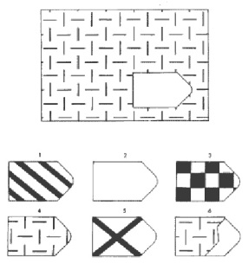 |  | Q4102a 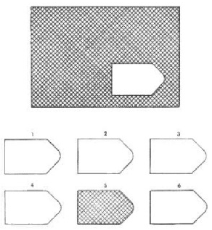 |  | Q4103a 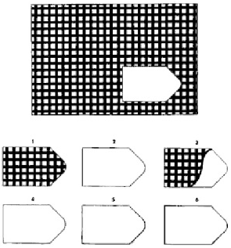
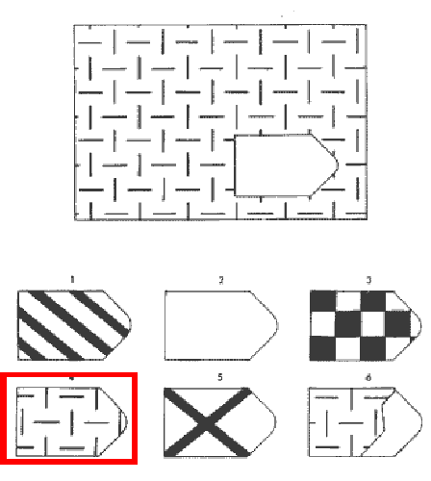 |  | 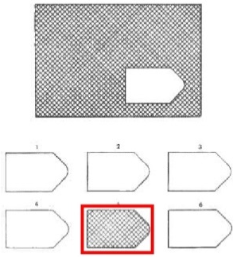 |  | 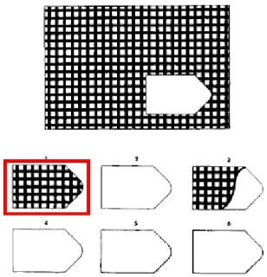
Q4104a 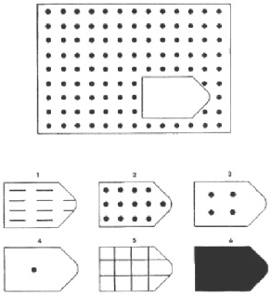 |  | Q4105a 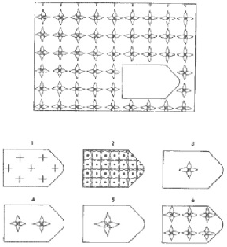 |  | Q4106a 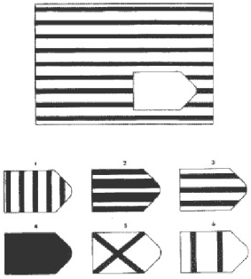
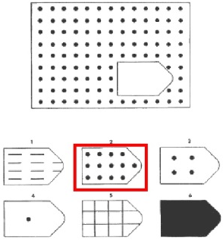 |  | 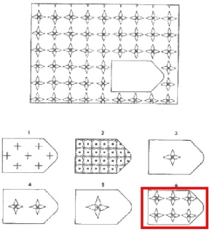 |  | 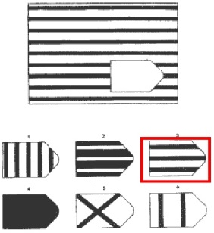
Q4107a 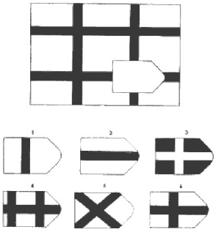 |  | Q4108a 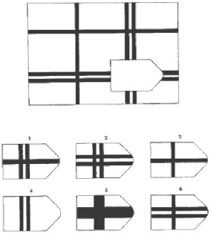 |  | Q4109a 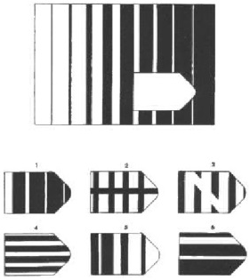
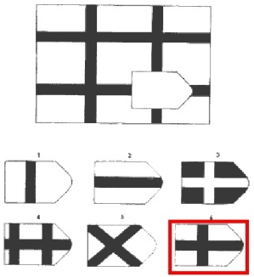 |  | 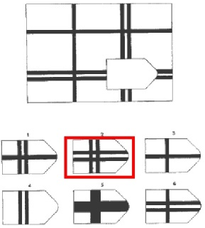 |  | 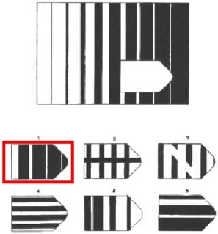
Q4110a 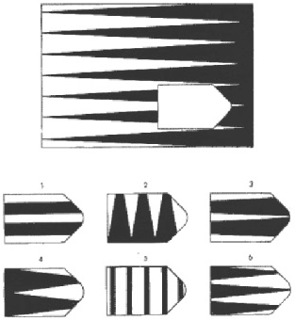 |  | Q4111a 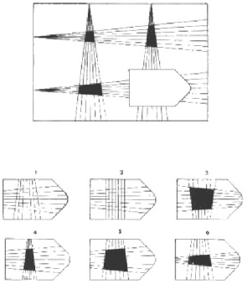 |  | Q4112a 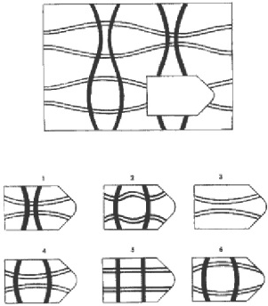
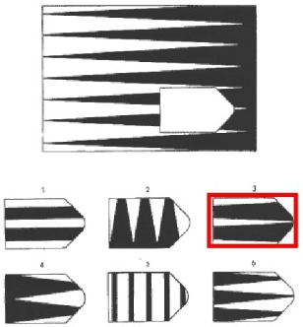 |  | 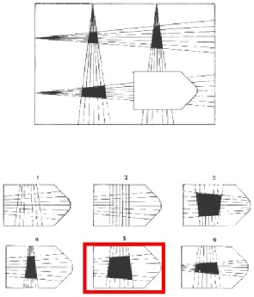 |  | 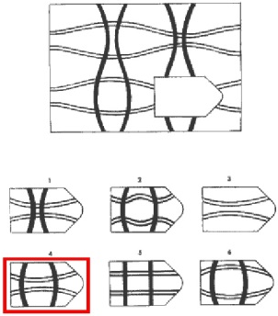
Q4101b 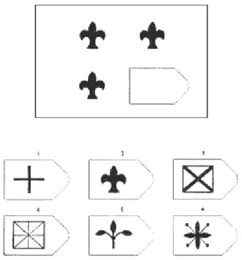 |  | Q4102b 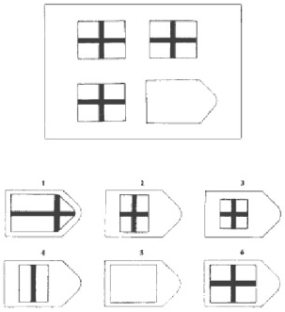 |  | Q4103b 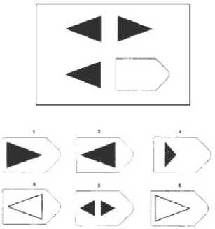
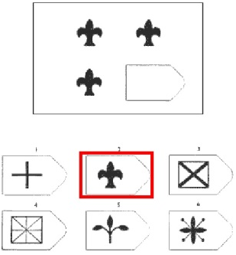 |  | 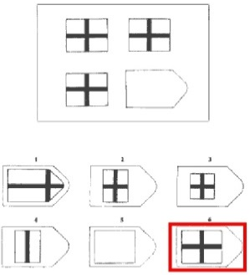 |  | 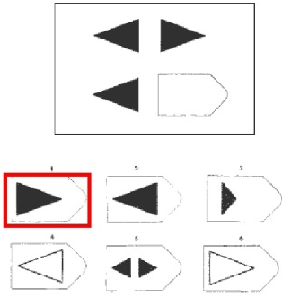
Q4104b 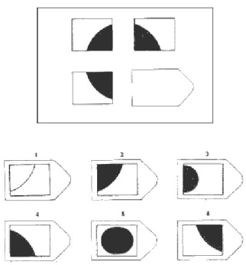 |  | Q4105b 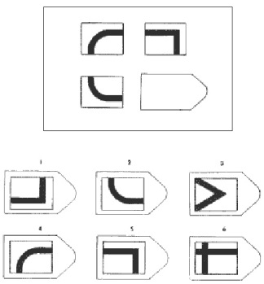 |  | Q4106b 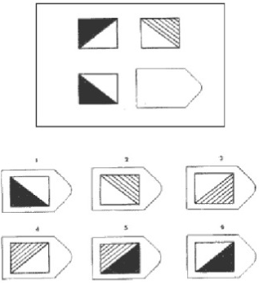
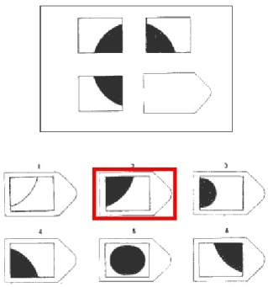 |  | 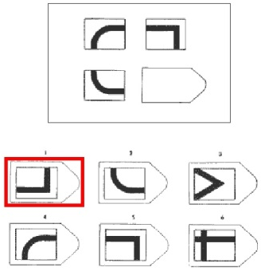 |  | 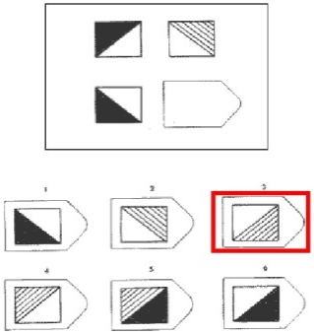
Q4107b 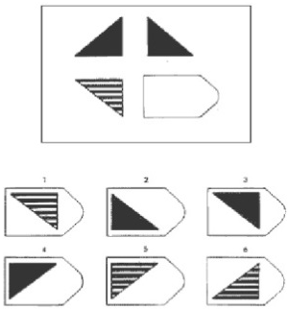 |  | Q4108b 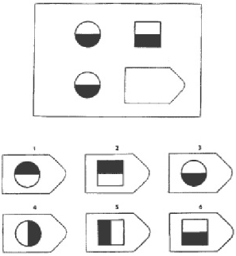 |  | Q4109b 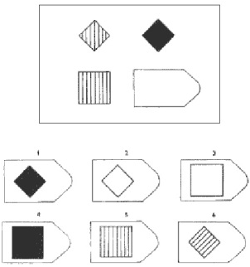
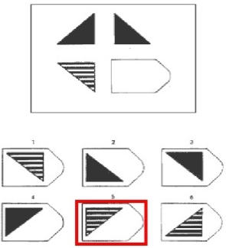 |  | 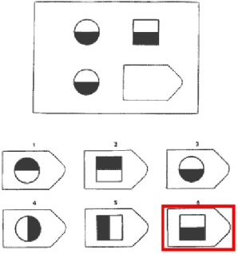 |  | 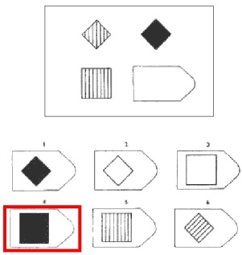
Q4110b 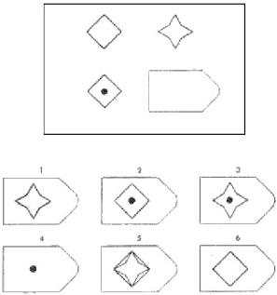 |  | Q4111b 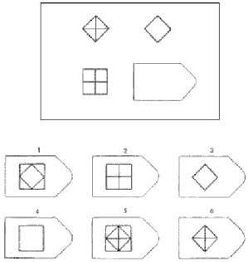 |  | Q4112b 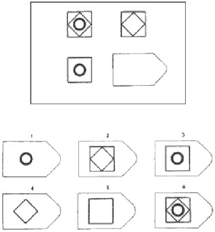
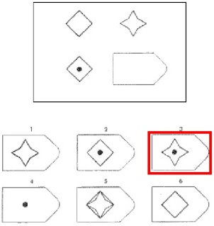 |  | 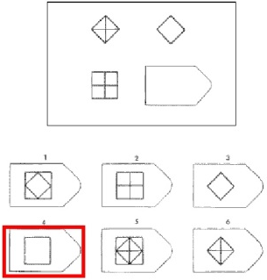 |  | 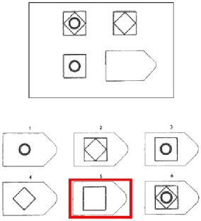
Q4101c 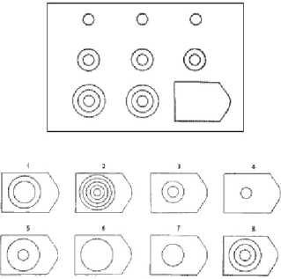 |  | Q4102c 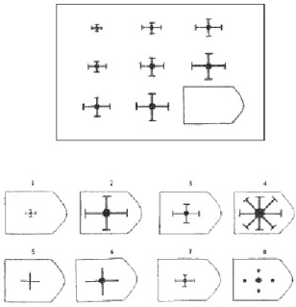 |  | Q4103c 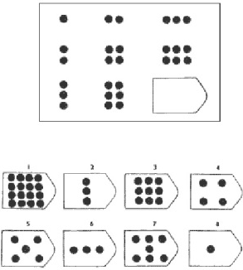
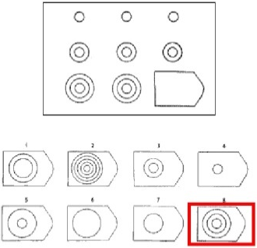 |  | 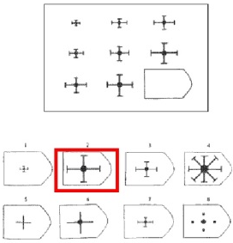 |  | 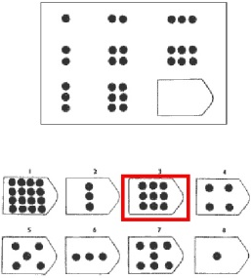
Q4104c 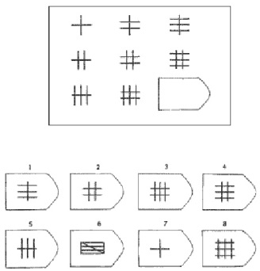 |  | Q4105c 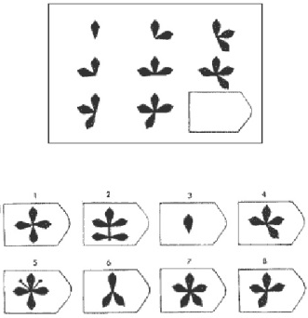 |  | Q4106c 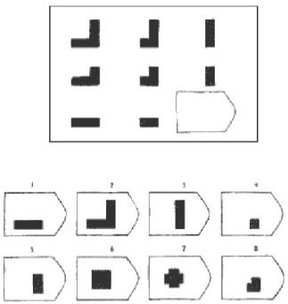
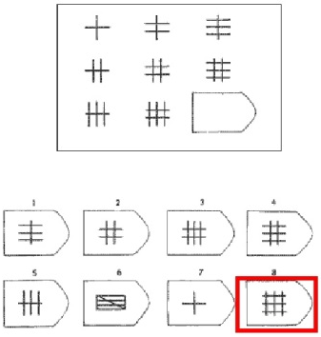 |  | 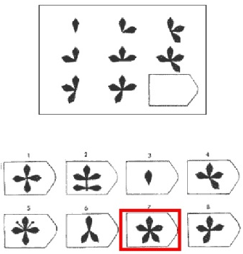 |  | 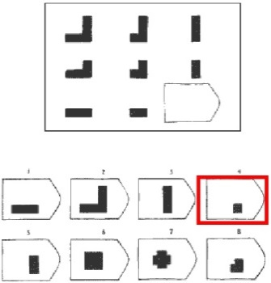
Q4107c 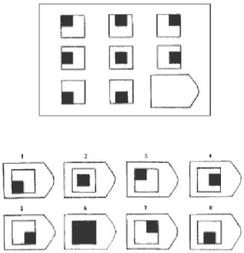 |  | Q4108c 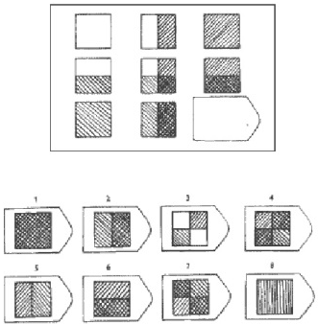 |  | Q4109c 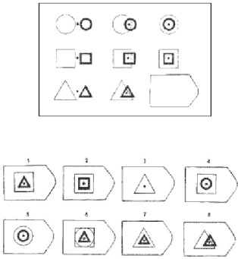
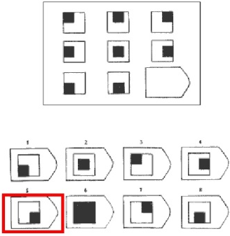 |  | 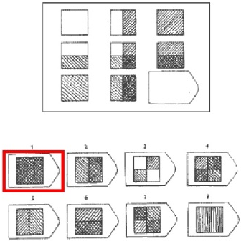 |  | 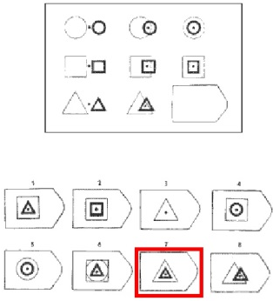
4110c 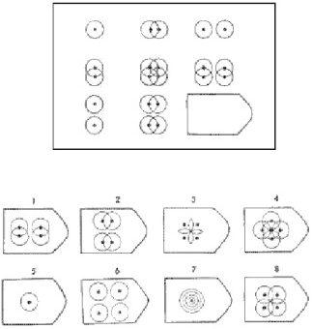 |  | Q4111c 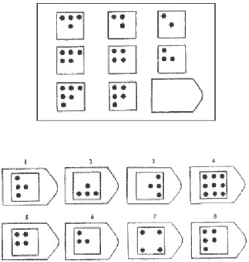 |  | Q4112c 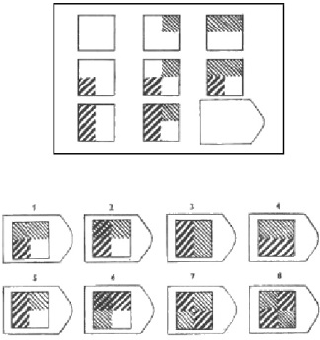
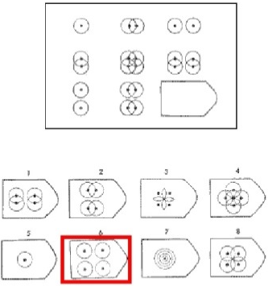 |  | 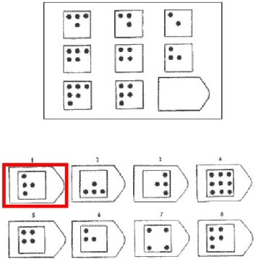 |  | 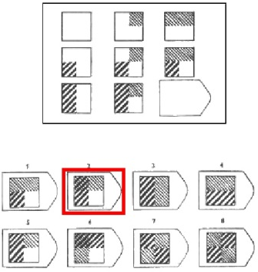

http://us.talentlens.com/wp-content/uploads/Ravens_SPM_Development.pdf
http://us.talentlens.com/wp-content/uploads/pdf/Ravens_SPM_Manual.pdf
https://www.scribd.com/doc/268865266/RAVEN-PROGRESSIVE-MATRICES-TEST-ANSWERS-PDF-FREE-DOWNLOAD-EBOOK

MODULE 4.2: COGNITIVE SKILL: Digit Span Forward And Backward
Digit Span: Digits Forward (Oral)
Note to enumerators: For the following tests, digits forward and backward, say the digits at the rate of one per second, not grouped. Let the pitch of your voice drop with the last digit of each series. In any series if the subject fails Trial 1 - give Trial 2 of the same series, then proceed to the next series if the respondent responds correctly. Trial 2 is only given if Trial 1 is failed. Note that the respondents are not allowed to use anything for the next section
Read out-loud the following instructions: Now I would like to play a game called 'Digits Game'. Listen carefully when I say the number, and once I am finished, you must repeat the numbers right after me. I want you to repeat each set of numbers exactly in the same order I say them to you. For example, if I said "3-8-6", you would say3-8-6. Or if I say "1-6-2" , you say …?
Enumerator: Wait for correct response "1-6-2". If correct, start with Series Q4201. If response is incorrect, provide the correct response and attempt once more with another example. Okay, let's try another example, repeat after me, "5-3". If correct, continue. If not correct - mark "0" in Q4208 and skip to Cognitive skill: Math Fluency (Module 4.3).

Okay, good. Let us start with the numbers.
Enumerator: Stop when respondent fails both trials.
Series | Trial 1 | Trial 1 correct?  (a)  1=Yes Next Series  2=No Trial 2 | Trial 2 | Trial 2 correct?  (b)  1=Yes Next Series  2=No Module 4.3
Q4201 | 5-8-2 |  | 6-9-4
Q4202 | 6-4-3-9 |  | 7-2-8-6
Q4203 | 4-2-7-3-1 |  | 7-5-8-3-6
Q4204 | 6-1-9-4-7-3 |  | 3-9-2-4-8-7
Q4205 | 5-9-1-7-4-2-8 |  | 4-1-7-9-3-8-6
Q4206 | 5-8-1-9-2-6-4-7 |  | 3-8-2-9-5-1-7-4
Q4207 | 2-7-5-8-6-2-5-8-4 |  | 7-1-3-9-4-2-5-6-8
Okay good. Enumerator: mark the score in Q4210
Q4208 | Total score (enter the series number in the longest series repeated without error in Trial 1 or 2) (Maximum = 7 points)

MODULE 4.2: COGNITIVE SKILL: Digit Span Forward And Backward
Digit Span: Digits Backward
Note to enumerators: Note that the respondents are not allowed to use anything for the next section
Read out-loud the following instructions:- Now I would like to play the same game, but this time when I stop, I want you to repeat the numbers I say backwards. For example, if I said "1-2-3", you say 321. Indicate backwards logic with your hands . Or if I say "3-5", what would you say?
Enumerator: Wait for subject to say 5-3. If response is correct, start with Series 2. If respondent does not reply correctly or fails to understand, give the correct answer and another example, saying Remember, you are to say them backwards. Try this, "3-8". If response is correct, continue. If fails second example, mark "0" in Q4218and skip to Cognitive skill: Math Fluency (Module 4.3).

Okay, let's start.
Enumerator: Stop when respondent fails both trials.
Series | Trial 1 | Trial 1 correct?  (a)  1=Yes Next Series  2=No Trial 2 | Trial 2 | Trial 2 correct?  (b)  1=Yes Next Series  2=No Module 4.3
Q4211 | 2-4 |  | 5-8
Q4212 | 6-2-9 |  | 4-1-5
Q4213 | 3-2-7-9 |  | 4-9-6-8
Q4214 | 1-5-2-8-6 |  | 6-1-8-4-3
Q4215 | 5-3-9-4-1-8 |  | 7-2-4-8-5-6
Q4216 | 8-1-2-9-3-6-5 |  | 4-7-3-9-1-2-8
Q4217 | 9-4-3-7-6-2-5-8 |  | 7-2-8-1-9-6-5-3
Okay good. Enumerator: mark the score in Q4218
Q4218 | Total score (enter the series number in the longest series repeated without error in Trial 1 or 2) (Maximum = 7 points)

MODULE 4.3: COGNITIVE SKILL: Math Fluency
Note to enumerators: Hold the Fluency in Mathematics Exercise Sheet in vertical position in front of you. Make sure the respondent cannot analyze the exercises before you indicate.
Read out-loud the following instructions exactly as they are written:
- I will now ask you to work on some math exercises. Begin here (Slide your finger along the first row from left to right.)
- The exercises must be completed from left to right and row by row. When you are done with the first line, continue on the one below (Indicate the direction in which it should be completed).
- Pay careful attention to the signs in the operations: Some are sums, others subtractions and others are multiplications (Point to the signs)
- Work on each exercise until you finish the page. Then, continue at the top of the following page (Show the second page). You won’t necessarily be able to complete all the exercises. You may skip the ones you find too difficult. You should complete as many operations as you can in 3 minutes. (Return to the front page)
- If you make a mistake, erase it and correct it. If you finish before time, let me know so that I stop the watch. Hand the sheet and the pencil to the interviewee. If after 1 minute the person has not begun or has answered 1 item or less, stop the test and record 1 minute.

After they have completed the questions, please review their answers, and ask for clarification on any of their numbers that are difficult to read because of handwriting. Make sure that the respondent has filled in all necessary identification forms.

Take the page back. Please record the total time spent on this section: put first minutes in the first case, and then seconds in the second case. (For example, if the respondent took 3 minutes and 02 seconds, you would first fill in 3 for the minutes case (M1), and then fill in 2 for the second case(M2)).

Q4301 | How much time did the respondent spend on this section? | M1 | M2
Q4302 | If the respondent spent in total less than 3 minutes on this module, why did the respondent finish early?  1=Respondent refused to take the test  2=Test was interrupted because the respondent could not answer more questions  3=Respondent finished all of the questions earlier  96=Other, specify

1 | 5 | 8 | 5 | 2 | 1 | 1 | 1 | 2 | 3
+7 | -2 | +1 | -0 | +7 | +5 | -1 | +4 | -2 | -1
4 | 1 | 6 | 3 | 3 | 4 | 1 | 6 | 0 | 4
-3 | +1 | -3 | +0 | -2 | -4 | +2 | -1 | +0 | +2
3 | 6 | 5 | 3 | 4 | 4 | 2 | 2 | 4 | 0
-3 | +1 | +3 | -0 | -2 | +3 | -1 | +2 | -1 | +5
9 | 7 | 10 | 3 | 6 | 7 | 5 | 8 | 0 | 5
-3 | +7 | -6 | +9 | +2 | -4 | +5 | -3 | +8 | -1
8 | 9 | 8 | 7 | 10 | 4 | 5 | 4 | 8 | 6
+6 | -4 | +2 | -2 | -2 | +4 | -3 | +8 | -1 | +6
1 | 10 | 5 | 5 | 6 | 8 | 9 | 6 | 3 | 5
+3 | -10 | -4 | +7 | -2 | -6 | +1 | -6 | +3 | +2
7 | 1 | 2 | 10 | 8 | 4 | 7 | 1 | 0 | 6
+3 | ×3 | ×2 | -5 | -8 | ×1 | +8 | ×5 | ×1 | -5
3 | 6 | 9 | 2 | 3 | 5 | 0 | 9 | 6 | 1
×0 | +4 | -2 | ×1 | ×2 | +9 | ×4 | -9 | +3 | ×1
9 | 6 | 10 | 4 | 1 | 9 | 2 | 5 | 3 | 8
+7 | ×0 | -0 | ×3 | ×7 | -5 | ×4 | +6 | ×5 | -7
5 | 9 | 1 | 2 | 7 | 9 | 5 | 3 | 10 | 6
×2 | -6 | ×8 | +3 | -7 | ×1 | +4 | ×3 | -7 | ×2
7 | 5 | 10 | 9 | 8 | 6 | 4 | 10 | 5 | 1
×4 | +8 | -1 | ×3 | -2 | +9 | ×4 | -3 | ×8 | ×6
7 | 9 | 7 | 8 | 9 | 8 | 7 | 6 | 9 | 10
+6 | ×2 | ×5 | -4 | ×5 | ×9 | -0 | ×4 | +2 | -8
6 | 10 | 9 | 7 | 5 | 9 | 8 | 5 | 6 | 4
×7 | -4 | ×9 | -1 | ×6 | -7 | ×2 | -5 | ×8 | +9
10 | 8 | 4 | 6 | 8 | 7 | 3 | 9 | 8 | 7
-9 | ×4 | -0 | ×9 | +8 | -6 | ×8 | ×4 | +3 | ×7
7 | 8 | 3 | 9 | 8 | 4 | 9 | 8 | 6 | 0
-3 | ×0 | ×6 | +9 | ×7 | ×5 | -8 | -5 | ×6 | +4
9 | 4 | 5 | 7 | 6 | 7 | 8 | 7 | 9 | 8
×7 | +7 | ×5 | ×3 | -4 | -5 | +9 | ×2 | -1 | ×8

MODULE 4.4: COGNITIVE SKILL: Numeracy
Note to enumerators: Read the following instructions and questions in a slow regular pace to the respondent. Provide pencil and paper to the respondent to make calculations. No other material may be used.
Read out-loud the following instructions: Now I am going to ask you some mathematical questions regarding hypothetical scenarios. They will vary in difficulty. Try to answer the ones you can. Please listen carefully.

Q4401 | Imagine you have 3 bags of maize and your father has 8 bags. How many bags do you have in total between the two of you?
Q4402 | Imagine there were 3 children and they have 6 avocados each, how many do they have in total?
Q4403 | Suppose you want to buy a bag of rice that costs 370 Tshs. If you pay with a 1,000 Tshs note, how much change would you get back?"
Q4404 | Imagine you have 4,200 Tshs and a friend gives you another 5,300 Tshs. How many Tshs would you have in total?"
Q4405 | Suppose 5 people had to share equally a prize of 18,000 Tshs. How much money would each person get?
Q4406 | There are 2 fertilizers available in the market for the same price. Imagine you had tried both fertilizers on two plots of maize. When you applied Fertilizer 1, the number of bags you harvested increased from 2 bags to 6 bags. When you applied Fertilizer 2, the number of bags you harvested increased from 5 to 7 bags. Which fertilizer is more profitable:
Q4407 | There are 2 fertilizers available in the market for different prices. Imagine you had tried both fertilizers in similar conditions. Fertilizer A costed 1,000 Tshs and increased your sales by 2,000 Tshs. Fertilizer B costed 1,500 Tshs and increased your sales by 2,200 Tshs. Which fertilizer was more profitable?
Q4408 | If there are 1,000 people, and the chance of getting a disease is 23 percent, how many out of 1,000 people would be expected to get the disease?"

MODULE 4.5: COGNITIVE SKILL: Reading (subjective)
Read out-loud the following instructions: Please answer the following questions about your reading level on a scale of 1 to 5. (Show the scale, and indicate with your finger as you explain), where 1 indicates you cannot perform the exercise at all and 5 indicates you can perform it perfectly on your own without any help and without making any mistakes.

Q4501 | To what extent can you read a newspaper in Swahili?  1=I cannot perform the exercise at all  2= I can barely perform the exercise  3=I can more or less perform the exercise  4= I can perform the exercise well  5=I can perform the exercise perfectly
Q4502 | To what extent can you write a letter to a relative in Swahili?"  1=I cannot perform the exercise at all  2= I can barely perform the exercise  3=I can more or less perform the exercise  4= I can perform the exercise well  5=I can perform the exercise perfectly
Q4503 | To what extent can you read a newspaper in English?  1=I cannot perform the exercise at all  2= I can barely perform the exercise  3=I can more or less perform the exercise  4= I can perform the exercise well  5=I can perform the exercise perfectly
Q4504 | To what extent can you write a letter to a relative in English?  1=I cannot perform the exercise at all  2= I can barely perform the exercise  3=I can more or less perform the exercise  4= I can perform the exercise well  5=I can perform the exercise perfectly
1 | 2 | 3 | 4 | 5

1 =  I cannot perform the exercise at all | 5=  I can perform the exercise perfectly

MODULE 4.5: COGNITIVE SKILL: Reading (Exercise)
Read out-loud the following instructions: I am going to ask you to read the following text silently. I would like to ask you some questions about it afterwards. I will read the questions out to you when you finish reading the text. Give reading sheet with exercise 1 on top to respondent. Let me know when you are done."

Exercise 1
Fingo is a new product to protect cotton from insects. This product is safe for the farmers’ health to use it and it is friendly with the environment. Fingo should be used during flowering of the plant.
Q4505 | True or false: According to the text, Fingo is a product that protect plants against rats.  "ukweli ama hapana: Kulingana na arafa, Fingo ni dawa ambayo hulinda mmea kwa panya"  1=True  2=False
Q4506 | True or false: According to the text, the product called Fingo may damage the environment.  "ukweli ama hapana: Kulingana na arafa, Fingo ni dawa ambayo inaweza haribu mazingira"  1=True  2=False
Q4507 | According to the text, Fingo protects which crop?  " Kulingana na arafa, Fingo hulinda mmea gani?"  1=Cotton  96=Others
Q4508 | According to the text, when should Fingo be used?  "Kulinga na arafa, ni wakati gani fingo inafaa kutumika?"  1= During the flowering of the plant  96=Others

Exercise 2

Application instructions: RL-4 is a biological pesticide. To apply this pesticide you must spray it on the plant. You must wait at least 6 hours before putting water on the plant after applying the pesticide. You must wear protective clothing when using RL-4 to avoid contact with your eyes and skin. Storage: You should store RL-4 in a cool, dry place.
Q4509 | True or false: According to the text, RL-4 is a product that kills pests.  "ukweli ama hapana: Kulingana na arafa,RL-4 ni dawa ambayo huuwa wadudu"  1=True  2=False
Q4510 | True or false: According to the text, you should avoid contact of RL-4 with your eyes and skin.  "ukweli ama hapana: Kulingana na arafa, inafaa uzuie RL-4 isikuingilie kwa macho ama iguze mwili."  1=True  2=False
Q4511 | According to the text, how long should you wait before watering the plant after applying RL-4 on it?  "ulingana na arafa,kwa muda gani unafaa kungoja kabla kunyunyuza maji baada ya kuinyunyuzia RL-4"  1= at least 6 hours  96=Others
Q4512 | According to the text, where should you store RL-4?  "Kulingana na arafa,ni wapi unafaa kuhifadhi RL-4?"  1=In a cool, dry place  96=Others

Exercise 3

Goodgrowth is a fertilizer that provides sulfur to the plant and should be used only for the cultivation of cereals. It is recommended to combine Goodgrowth with a basal fertilizer such as Goodroots, to be applied at planting. Farmers should apply two teaspoons of Goodgrowth per plant, four weeks after planting. Apply it at 10 centimeters from the plant. Goodgrowth also performs best when the crop is irrigated.
Q4513 | True or false: According to the text, Goodgrowth should be applied at planting.  "ukweli ama hapana: Kulingana na arafa, Goodgrowth inafaa kutumika wakati wa kupanda."  1=True  2=False
Q4514 | True or false: According to the text, Goodgrowth should be used for vegetables.  "ukweli ama hapana: Kulingana na arafa, Goodgrowth inafaa kutumika kwa mboga."  1=True  2=False
Q4515 | According to the text, what nutrient can you find in Goodgrowth?  "Kulingana na arafa, ni madini gani inaweza kupatikana kwa Goodgrowth?"  1=Sulfur  96=Others
Q4516 | According to the text, where should Goodgrowth be applied?  "Kulingana na arafa, ni wapi Goodgrowth inafaa kuwekwa?"  1=10 centimeters from the plant  96=Others

MODULE 16: FFS
How many FFS did you participate in?  Unit (count)  This answer needs to be identical with the answer in Q115 (module 1, household identification cover sheet).  Ask the following questions for each FFS where this person attended trainings until the end of the module 14. | Who in your household has attended a Farmer Field School ?  SELECT UP TO THREE MEBERS FROM HOUSEHOLD ROSTER |  |  | Name of the FFS or name of facilitator?  FFS Name or Name of facilitator to link this module to the data in the enumeration  Multiple answers allowed (as there might have been a change in the FFS facilitator in a FFS) | Type of FFS facilitators?  1=Extension Worker  2=Lead Farmer  3=Others, please specify | Sex of FFS facilitators?  1=Female  2=Male | What was the activity of the FFS?  Enter Code  Multiple answers possible | When did this FFS start?  Month (MM)  Year (YYYY)  Earliest date possible is 09 2007. | When did this FFS end?  Month (MM)  Year (YYYY)  The end dates cannot be before the start date.  Latest date possible is today's date. The earliest date possible is 09 2008. | What was the main reason which pushed you to attend these FFS?  1=Access to input markets  2=Receive extension services  3=Access to market for crops  4=Access to credit  5=Social functions / networking  6=Curiosity  96=Other, please specify |  |  | How far did you have to travel to reach the FFS meeting point?  Travel time in minutes (both ways) | Did you attend all the FFS training?  1= Yes  2=No | How many days per week did you attained FFS trainings  sessions  ?  Unit (count)  Minimum 0. | How many FFS trainings did you miss or were not able to attend?  Unit (count) | Are you aware of that there is a DFF in your district?  1= Yes  2=No -> Q1701 | Did the DFF's activities affect you?  1= Yes  2=No | How did the DFF's activities affect you?  1= Increased crop yield or livestock production  2= Improved access to production inputs and services  3= Reduced cost of production inputs and services  4= Increased income from crop or livestock production  5= Improved technical capacity  6=Better access to information and linkages to the market  96=Other, please specify | How would you rate the technical competency of the DFF in fulfilling his or her role?  1=Very low  2=Low  3=Moderate  4=High  5=Very high
Q1601 | Q1602a | Q1602b | Q1602c | Q1603 | Q1604 | Q1605 | Q1606 | Q1607 | Q1608 | Q1698a | Q1609b | Q1609c | Q1610 | Q1611 | Q1612 | Q1613 | Q1614 | Q1615 | Q1616 | Q1617
1
2
3
4
5
Note: Module 16 to 18 should only be administered to FFS beneficiaries and the respondent should be the participants themselves.
Q1603 FFS activity
1= Vegetables, 2= Cassava, 3= Goat, 4= Chicken, 5= Banana, 6= Rice, 7= Cow

MODULE 17a: FFS Vegetables
Ask these questions if the respondent answered 1 in Q1603 for Direct Beneficiary (FFS participant) and .in Q122 for Non-beneficiaries (control farmers).
Are you familiar with the following improved practices?  1= Yes >> Next question  2=No >> Next item | Is this a new practice in your community?  1= Yes >> Next question  2=No 99=Not applicable >>Next item  Some of these practices may not be applicable in all environments. | Where did you hear about this practice?  1= FFS, 2=Friends , 3= Neighbors, 4= News, 5= Other, please specify | Have you ever adopted or used these practices on your farm?  0=No >> Next item  1= Yes partially >> Next question  2= Yes fully >> Next question  99=Not applicable >>Next item | If no, why have you not adopted the practices on your farm?  1=Insufficient information on them  2=Too expensive  3=Labor constraint  4=Capital constraint  5=No technical support  6=Lack of inputs/expensive inputs  7= not interested  in topics  covered  8=do not believe  information given  is reliable  96=Others, please specify | Are you currently using this practice on your farm?  0= Yes partially  1= Yes fully  2=No | How useful was the advice received on [TOPIC] at the Farmer Field School?  1=Very useful  2=Somewhat useful  3=Not useful
Q1701 | Q1702 | Q1703 | Q1704 | Q1705 | Q1706 | Q1707
LAND PREPARATION
- Clearing and burning the wild trees and grass
- Plowing
- Forming terraces of 6 cm of length of 3 cm of width
- Having the terraces on mounds to ensure that the terraces are not destroyed by water floods.
- Using manure when preparing the land from cows, goats, chickens, other animals and dead plants as natural fertilizer
- Using the ashes from burning of wild trees and grass as fertilizer
KEEPING TRACK OF PRODUCTION
- Keeping track of all expenditures such as seeds, ropes or other equipment and their prices.
- Keeping track of the amount of time spent on each crop
- Keeping track of plan for each crop e.g. when you ploughed the land, when you planted etc.
- Keeping track of each activity performed on the crops. The farmers were trained to track the dates of planting and the dates of appliance and quantity of inputs. For example, farmers were recommended to keep track of the dates and quantity of fertilizer they applied or water they used.
- Keeping track of crop diseases.
- Keeping track of weather patterns
- Keeping track of the harvesting (dates and quantities)
- Keeping track of the sales (prices, quantity and revenue)
- Keeping track of profits or losses
PLANTING OF CROP
- Planting during the rainy season is the best time to plant vegetable to achieve the highest production. Planting in the other season will not generate the highest production but will gain the highest prices.
- Buying expensive seeds as they are the best ones.
- Planting of seeds should only take place when the seeds are not mixed with dust or dirt
- The space between plants should be more than 30 centimeters apart.
- Digging shallow holes for planting the vegetables
- Put the fertilizers in the holes and watering the holes. Water the hole morning and evening.
- Placing fertilizer at the top of the hole
- Water the ground after planting so that the fertilizer goes to the bottom of the hole.
INTERCROPPING
- Planting spinach if farming watermelon
METHODS FOR EFFICIENT HANDLING OF FIELD
- Cleaning every day the farm and not having or be near weeds.
- Spraying weed killer which helps prevent the weeds from growing.
- Using natural inputs such as leaves from the neem tree (crushing and soaking the leaves in water for 7 to 21 days and subsequently applying the leaves on the vegetables) to kill the diseases and pests.
- Removing all worms from the plant
- Placing animal droppings in a hole, covering with grass, watering, waiting for fermentation and after it has decomposed, using it as fertilizer.
- Preparing fertilizer from grasses, old trees, decomposed dry leaves or coconut dust.
CROP PESTS AND DISEASES CONTROL
- Using traps to get rid of pests
- Spraying the plants against pests
- Using fungicides as a preventative measure against pests
- Soon after planting, uprooting, removing and destroying the vegetable crops with pests and diseases (if these crops are not destroyed then the pests will simply migrate to another healthy vegetable crop).
- Separating the plot in 2 to deal with pests more efficiently
AGRIBUSINESS
- Planting at a specific time to harvest when the demand for the product is high in the market.
- Trying to lower costs
- Identifying the market to sell the production (where to sell the production)
- Making the produce look appealing for customers
CLIMATE CHANGE
- Stopping deforestation or land clearing for farming
HARVESTING OF CROP
- Harvesting when the plant starts to have the right color.(red for tomatoes for example)
- Harvesting the vegetable with the stem attached
- Spreading the harvested vegetables on the ground in a room to allow them to ripen.
STORAGE OF CROP
- Storing the harvested vegetables in a safe well ventilated room without any pest like rats which would destroy them.
- Covering the vegetables at nights to protect the vegetables from pest and uncovering them during the day so that the vegetables can get some air.
- If the harvest is very large, drying the vegetables can be a good way to preserve them
CONSUMPTION OF CROP
- Tomatoes can be used as juice or jam
BASIC KNOWLEDGE OF NUTRITION:
- Drinking milk has many healthy nutrients.
- The need for a balanced diet with carbohydrates, fat, protein, vitamin and vegetables.

MODULE 17b: FFS Cassava
Ask these questions if the respondent answered 2 in Q1603 for Direct Beneficiary (FFS participant) and .in Q122 for Non-beneficiaries (control farmers).
Are you familiar with the following improved practices?  1= Yes >> Next question  2=No >> Next item | Is this a new practice in your community?  1= Yes >> Next question  2=No >> Next item  99=Not applicable >>Next item  Some of these practices may not be applicable in all environments. | Where did you hear about this practice?  1= FFS, 2=Friends  3= Neighbors  4= News  5= Other, please specify | Have you ever adopted or used these practices on your farm?  0= Yes partially  1= Yes fully  2=No | If no, why have you not adopted the practices on your farm?  1=Insufficient information on them  2=Too expensive  3=Labor constraint  4=Capital constraint  5=No technical support  6=Lack of inputs/expensive inputs  7= not interested  in topics  covered  8=do not believe  information given  is reliable  96=Others, please specify | Are you currently using this practice on your farm?  0= Yes partially  1= Yes fully  2=No | How useful was the advice received on [TOPIC] at the Farmer Field School?  1=Very useful  2=Somewhat useful  3=Not useful
Q1701 | Q1702 | Q1703 | Q1704 | Q1705 | Q1706 | Q1707
LAND PREPARATION
- Clearing and burning the wild trees and grass
- Selecting suitable soil ensuring the slope of the ground is not very steep.
- Measuring the length of the plot with rope and sticks
- Plowing
- Forming terraces
- Having the terraces on mounds to ensure that the terraces are not destroyed by water floods.
- Using manure when preparing the land from cows, goats, chickens, other animals and dead plants as natural fertilizer
- Using the ashes from burning of wild trees and grass as fertilizer
KEEPING TRACK OF PRODUCTION
- Keeping track of all expenditures such as seeds, ropes or other equipment and their prices.
- Keeping track of the amount of time spent on each crop
- Keeping track of plan for each crop e.g. when you ploughed the land, when you planted etc.
- Keeping track of each activity performed on the crops. The farmers were trained to track the dates of planting and the dates of appliance and quantity of inputs. For example, farmers were recommended to keep track of the dates and quantity of fertilizer they applied or water they used.
- Keeping track of crop diseases.
- Keeping track of weather patterns
- Keeping track of the harvesting (dates and quantities)
- Keeping track of the sales (prices, quantity and revenue)
- Keeping track of profits or losses
PLANTING OF CROP
- Digging hole of 30 cm deep for the cassava seeds
- Creating hump of soil of about 1 meter (from the lowest to the highest point) and having humps of soils about 1 meter apart.
- Planting the seed Mwari (it was the best seed to plant at that time)
- Planting the seeds Sepije, Kizimbani, Machui, Michirizi
- Planting during the rainy season
- Buying expensive seeds as they are the best ones.
METHODS FOR EFFICIENT HANDLING OF FIELD
- Cleaning every day the farm and not having or be near weeds.
- Spraying weed killer which helps prevent the weeds from growing.
- Using natural inputs such as leaves from the neem tree (crushing and soaking the leaves in water for 7 to 21 days and subsequently applying the leaves on the vegetables) to kill the diseases and pests. (organic)
- Removing all worms from the plant
- Placing animal droppings in a hole, covering with grass, watering, waiting for fermentation and after it has decomposed, using it as fertilizer.
- Preparing fertilizer from grasses, old trees, decomposed dry leaves or coconut dust.
- Using natural inputs such as leaves from the neem tree (crushing and soaking the leaves in water for 7 to 21 days and subsequently applying the leaves on the vegetables) to kill the diseases and pests.
CROP PESTS AND DISEASES CONTROL
- Using traps to get rid of pests
- Spraying the plants against pests
- Using fungicides as a preventative measure against pests
- Soon after planting, uprooting, removing and destroying the cassava crop with pests and diseases (if these crops are not destroyed then the pests will simply migrate to another healthy cassava crop).
- Separating the plot in 2 to deal with pests more efficiently
AGRIBUSINESS
- Identifying the market to sell the production (where to sell the production)
- Making the produce look appealing for customers
- Using the flour to make porridge and chips.
- Planting at a specific time to harvest when the demand for the product is high in the market.
- Trying to lower costs
CLIMATE CHANGE
- Stopping deforestation or land clearing for farming
HARVESTING OF CROP
- Standing in the right position and area to pull out the cassava from the terrace to not damage the roots
- Cutting the cassava and holding the cassava in the right way.
STORAGE OF CROP
- Drying the plant using hanging lines before peeling the skin
- Storing the cassava in sacks, plastic bags or crates.
- Digging holes and storing the cassava in the ground
- Using wax from bees to store the cassava
PROCESSING OF CROP
- Making pilau, bake cakes, and even bites
- Grinding it for flour and having it as ugali
- Using the flour to make porridge
- Eating cassava raw
- Makopa
- Mandazi (donuts)
- Makwaru (cassava chips in packets)
BASIC KNOWLEDGE OF NUTRITION:
- Drinking milk has many healthy nutrients.
- The need for a balanced diet with carbohydrates, fat, protein, vitamin and vegetables.

MODULE 17c: FFS Banana
Ask these questions if the respondent answered 5 in Q1603 for Direct Beneficiary (FFS participant) and .in Q122 for Non-beneficiaries (control farmers).
Are you familiar with the following improved practices?  1= Yes >> Next question  2=No >> Next item | Is this a new practice in your community?  1= Yes >> Next question  2=No >> Next item  99=Not applicable >>Next item  Some of these practices may not be applicable in all environments. | Where did you hear about this practice?  1= FFS, 2=Friends , 3= Neighbors  4= News  5= Other, please specify | Have you ever adopted or used these practices on your farm?  0= Yes partially  1= Yes fully  2=No | If no, why have you not adopted the practices on your farm?  1=Insufficient information on them  2=Too expensive  3=Labor constraint  4=Capital constraint  5=No technical support  6=Lack of inputs/expensive inputs  7= not interested  in topics  covered  8=do not believe  information given  is reliable96=Others, please specify | Are you currently using this practice on your farm?  0= Yes partially  1= Yes fully  2=No | How useful was the advice received on [TOPIC] at the Farmer Field School?  1=Very useful  2=Somewhat useful  3=Not useful
Q1701 | Q1702 | Q1703 | Q1704 | Q1705 | Q1706 | Q1707
LAND PREPARATION
- Clearing and burning the wild trees and grass
- Having the terraces on mounds to ensure that the terraces are not destroyed by water floods.
- Plowing
- Using manure when preparing the land from cows, goats, chickens, other animals and dead plants as natural fertilizer
- Using the ashes from burning of wild trees and grass as fertilizer
KEEPING TRACK OF PRODUCTION
- Keeping track of all expenditures such as seeds, ropes or other equipment and their prices.
- Keeping track of the amount of time spent on each crop
- Keeping track of plan for each crop e.g. when you ploughed the land, when you planted etc.
- Keeping track of each activity performed on the crops. The farmers were trained to track the dates of planting and the dates of appliance and quantity of inputs. For example, farmers were recommended to keep track of the dates and quantity of fertilizer they applied or water they used.
- Keeping track of crop diseases.
- Keeping track of weather patterns
- Keeping track of the harvesting (dates and quantities)
- Keeping track of the sales (prices, quantity and revenue)
- Keeping track of profits or losses
PLANTING OF CROP
- Putting the fertilizers in the holes and watering the holes
- Planting banana seedling which are disease and pest free
- Identifying diseased seedling by looking at the leaves (droopy leaves, leaves with changing colors from yellow to brown and leaves with dots)
- Sterilizing the seedling by boiling them in hot water or by trimming them.
- Spacing the lines 2 to 4 meters apart
- Placing the stems 2 to 4 meters apart
- Digging holes of 12 to 100 centimeters deep and 60 centimeters wide
- Planting in the end of the dry season.
- Planting Pukusa seeds
- Planting Makoroboi seed if planting for own consumption
- Buying expensive seeds as they are the best ones.
INTERCROPPING
- Planting mango trees or coconut trees with banana trees
METHODS FOR EFFICIENT HANDLING OF FIELD
- Cleaning every day the farm and not having or be near weeds.
- Spraying weed killer which helps prevent the weeds from growing.
- Using natural inputs such as leaves from the neem tree (crushing and soaking the leaves in water for 7 to 21 days and subsequently applying the leaves on the vegetables) to kill the diseases and pests.
- Removing all worms from the plant
- Placing animal droppings in a hole, covering with grass, watering, waiting for fermentation and after it has decomposed, using it as fertilizer.
- Preparing fertilizer from grasses, old trees, decomposed dry leaves or coconut dust.
CROP PESTS AND DISEASES CONTROL
- Using traps to get rid of pests
- Spraying the plants against pests
- Using fungicides as a preventative measure against pests
- Trimming the stems of affected banana tree and burning them
- Separating the plot in 2 to deal with pests more efficiently
- Soon after planting, uprooting, removing and destroying the banana crop with pests and diseases (if these crops are not destroyed then the pests will simply migrate to another healthy banana crop).
AGRIBUSINESS
- Planting at a specific time to harvest when the demand for the product is high in the market.
- Identifying the market to sell the production (where to sell the production)
- Making the produce look appealing for customers
- Trying to lower costs
CLIMATE CHANGE
- Stopping deforestation or land clearing for farming
HARVESTING OF CROP
- Harvesting the banana with the stem attached
- Spreading the harvested bananas on the ground in a room to allow them to ripen.
- Harvesting with care when handling the crop to ensure the best quality of the banana (such as having two people harvesting big bananas: one person for holding the bunch as the other one for cutting it)
- Harvesting when you see the lines on the banana forming a ring like shape.
STORAGE OF CROP
- Packing the harvested bananas using dry leaves
PROCESSING OF CROP
- Making banana flour and using it for cooking
CONSUMPTION OF CROP
- Boiling banana in salty water
- Frying banana in coconut oil
BASIC KNOWLEDGE OF NUTRITION:
- Drinking milk has many healthy nutrients.
- The need for a balanced diet with carbohydrates, fat, protein, vitamin and vegetables.

MODULE 17d: FFS Rice
Ask these questions if the respondent answered 6 in Q1603 for Direct Beneficiary (FFS participant) and .in Q122 for Non-beneficiaries (control farmers).
Are you familiar with the following improved practices?  1= Yes >> Next question  2=No >> Next item | Is this a new practice in your community?  1= Yes >> Next question  2=No >> Next item  99=Not applicable >>Next item  Some of these practices may not be applicable in all environments. | Where did you hear about this practice?  1= FFS, 2=Friends , 3= Neighbors  4= News  5= Other, please specify | Have you ever adopted or used these practices on your farm?  0= Yes partially  1= Yes fully  2=No | If no, why have you not adopted the practices on your farm?  1=Insufficient information on them  2=Too expensive  3=Labor constraint  4=Capital constraint  5=No technical support  6=Lack of inputs/expensive inputs  7= not interested  in topics  covered  8=do not believe  information given  is reliable  96=Others, please specify | Are you currently using this practice on your farm?  0= Yes partially  1= Yes fully  2=No | How useful was the advice received on [TOPIC] at the Farmer Field School?  1=Very useful  2=Somewhat useful  3=Not useful
Q1701 | Q1702 | Q1703 | Q1704 | Q1705 | Q1706 | Q1707
LAND PREPARATION
- Clearing and burning the wild trees and grass
- Plowing
- Waiting 1 week to 2 months before tilling the land or watering the land before tilling.
- Using manure when preparing the land from cows, goats, chickens, other animals and dead plants as natural fertilizer
- Using the ashes from burning of wild trees and grass as fertilizer
KEEPING TRACK OF PRODUCTION
- Keeping track of all expenditures such as seeds, ropes or other equipment and their prices.
- Keeping track of the amount of time spent on each crop
- Keeping track of plan for each crop e.g. when you ploughed the land, when you planted etc.
- Keeping track of each activity performed on the crops. The farmers were trained to track the dates of planting and the dates of appliance and quantity of inputs. For example, farmers were recommended to keep track of the dates and quantity of fertilizer they applied or water they used.
- Keeping track of crop diseases.
- Keeping track of weather patterns
- Keeping track of the harvesting (dates and quantities)
- Keeping track of the sales (prices, quantity and revenue)
- Keeping track of profits or losses
PLANTING OF CROP
- Identifying good quality seeds
- Spacing rice seedlings 25 centimeters apart.
- Planting at the end of the dry season
- Planting seed TXD88
- Planting seed Super BK
- Buying expensive seeds as they are the best ones.
INTERCROPPING
- Avoiding intercropping
METHODS FOR EFFICIENT HANDLING OF FIELD
- Placing animal droppings in a hole, covering with grass, watering, waiting for fermentation and after it has decomposed, using it as fertilizer.
- Preparing fertilizer from grasses, old trees, decomposed dry leaves or coconut dust.
- Cleaning every day the farm and not having or be near weeds.
- Spraying weed killer which helps prevent the weeds from growing.
- Using natural inputs such as leaves from the neem tree (crushing and soaking the leaves in water for 7 to 21 days and subsequently applying the leaves on the vegetables) to kill the diseases and pests.
- Removing all worms from the plant
- Separating the plot in 2 to deal with pests more efficiently
CROP PESTS AND DISEASES CONTROL
- Using traps to get rid of pests
- Spraying the plants against pests
- Using fungicides as a preventative measure against pests
- Soon after planting, uprooting, removing and destroying the rice crop with pests and diseases (if these crops are not destroyed then the pests will simply migrate to another healthy rice crop).
AGRIBUSINESS
- Planting at a specific time to harvest when the demand for the product is high in the market.
- Identifying the market to sell the production (where to sell the production)
- Making the produce look appealing for customers
- Trying to lower costs
CLIMATE CHANGE
- Stopping deforestation or land clearing for farming
HARVESTING OF CROP
- Harvesting when the color of the crop changes from green to yellow
- Harvesting by cutting the crop from the bottom or at the top
STORAGE OF CROP
- Placing the harvested rice in sacks
- Letting the sacks of the harvested crop dry in the sun between noon and 3 pm to eliminate the moisture which would damage the quality of the harvested rice
- Piling sacks up in a heap of about 5 m in height and keep turning it and every two hours so that the rice that is at the top goes to the bottom and the one that was in the bottom comes up.
- Ensuring that the storing equipment is clean, dry and breathable in order to store the rice for a long time.
- Taking some dry woods/tree branches and placing them on the ground in the storage room and arranging the bags on top of them while avoiding to squeeze them into the wall.
PROCESSING OF CROP
- Making rice flour
BASIC KNOWLEDGE OF NUTRITION:
- Drinking milk has many healthy nutrients.
- The need for a balanced diet with carbohydrates, fat, protein, vitamin and vegetables.

MODULE 17e: FFS Goat
Ask these questions if the respondent answered 3 in Q1603 for Direct Beneficiary (FFS participant) and .in Q122 for Non-beneficiaries (control farmers).
Are you familiar with the following improved practices?  1= Yes >> Next question  2=No >> Next item | Is this a new practice in your community?  1= Yes >> Next question  2=No >> Next item  99=Not applicable >>Next item  Some of these practices may not be applicable in all environments. | Where did you hear about this practice?  1= FFS, 2=Friends , 3= Neighbors  4= News  5= Other, please specify | Have you ever adopted or used these practices on your farm?  0= Yes partially  1= Yes fully  2=No | If no, why have you not adopted the practices on your farm?  1=Insufficient information on them  2=Too expensive  3=Labor constraint  4=Capital constraint  5=No technical support  6=Lack of inputs/expensive inputs  7= not interested  in topics  covered  8=do not believe  information given  is reliable  96=Others, please specify | Are you currently using this practice on your farm?  0= Yes partially  1= Yes fully  2=No | How useful was the advice received on [TOPIC] at the Farmer Field School?  1=Very useful  2=Somewhat useful  3=Not useful
Q1701 | Q1702 | Q1703 | Q1704 | Q1705 | Q1706 | Q1707
PREPARATION OF THE AREA FOR THE LIVESTOCK AREA
- Planting grass or trees as source of goat feed
- Planting elephant grass (gongomuwa)
- Planting hay bean (brine cidia/mijenga)
- Clearing the land
- Lining and planting of grass or hay bean seeds
- Building the goat pens
KEEPING TRACK OF LIVESTOCK ACTIVITIES
- Keeping track of expenditures on shed constructions and other costs
- Keeping track of costs on the goat treatment
- Keeping track of water use for each goat
- Keeping track of plan
- Keeping track of each activity performed
- Keeping track of labour
- Keeping track of pasturing
- Keeping track of feed
- Keeping track of vaccinations and other drugs
- Keeping track of costs
- Keeping track of milk and other products production
- Keeping track of milk and other products sales
- Keeping track of profits or losses
AGRIBUSINESS
- Putting forward the nutritional benefits of goat milk for its nutritional value, for people suffering from ulcers and for digestion.
- Milking properly
- Selling milk to their neighbors or on the market
- Taking the milk to a collection centre
- Selling the milk through a cooperative unions (for farmers who are part of these groups)
LIVESTOCK PEST AND DISSEASE CONTROL
- Mixing grass with hay and beans in the feed of the animal as grass lacks some nutrients.
- Purchasing or using residue from maize, sunflower, animal salts and sardines and mix them with the animal goat to increase the nutritional value of the feed.
- Feeding the cows with food rich in protein, carbohydrates, minerals and vitamins
- Protecting the goats from pneumonia
- Protecting the goats from worm infestation with drugs
- Keeping the mother goat with her offspring together
- Contacting the nearest veterinary officer if the goat experienced complications during labor.
- Cleaning the area where do the milking
- Washing hands when milking
- Giving goats higher quality grass.
- Trimming goats hooves during the rainy season
- Identifying when a goat has reach puberty (around the 3 month mark)
- Identifying when it is appropriate to feed a goat when it is in heat.
- Identifying the signs a goat is in labor.
- Storing hay or silage so that feeding is not missing in periods of scarcity of pastures and green grasses
CONSERVATION AND PROCESSING
- Cleaning milking equipment
- Not using plastic tools and instruments
- Storing the milk in a freezer or fridge
- Boiling the milk and the refrigerating it
- Boiling the milk if there is no fridge to store the milk.
- Making cream from the milk
- Making butter or ghee from the milk
- Making yoghurt from the milk
- Making cheese from the milk
CLIMATE CHANGE
- Stopping deforestation due to ranching and land clearing for livestock production
BASIC KNOWLEDGE OF NUTRITION:
- Drinking milk has many healthy nutrients.
- The need for a balanced diet with carbohydrates, fat, protein, vitamin and vegetables.

MODULE 17f: FFS Chicken
Ask these questions if the respondent answered 4 in Q1603 for Direct Beneficiary (FFS participant) and .in Q122 for Non-beneficiaries (control farmers).
Are you familiar with the following improved practices?  1= Yes >> Next question  2=No >> Next item | Is this a new practice in your community?  1= Yes >> Next question  2=No >> Next item  99=Not applicable >>Next item  Some of these practices may not be applicable in all environments. | Where did you hear about this practice?  1= FFS, 2=Friends  3= Neighbors  4= News  5= Other, please specify | Have you ever adopted or used these practices on your farm?  0= Yes partially  1= Yes fully  2=No | If no, why have you not adopted the practices on your farm?  1=Insufficient information on them  2=Too expensive  3=Labor constraint  4=Capital constraint  5=No technical support  6=Lack of inputs/expensive inputs  7= not interested  in topics  covered  8=do not believe  information given  is reliable  96=Others, please specify | Are you currently using this practice on your farm?  0= Yes partially  1= Yes fully  2=No | How useful was the advice received on [TOPIC] at the Farmer Field School?  1=Very useful  2=Somewhat useful  3=Not useful
Q1701 | Q1702 | Q1703 | Q1704 | Q1705 | Q1706 | Q1707
PREPARATION OF THE AREA FOR THE LIVESTOCK
Clearing the land
Building the chicken coop with hardboard
Having a coop 1 meter long to hold at most a 100 chicks
Having several rooms in the coop
Providing the coop with a source of heat
Placing newspaper on the ground
Putting the food on the newspaper before using the feeding apparatus
Building the chicken coop close to the dwelling to be able to check on the coop frequently to ensure that the chickens do not escape, are in good health (keep away pests for example) and are secure.
Keeping the coop well ventilated.
Cleaning the coop regularly
Enclosing the area with wire fence
Finding a friendly environment, disease free.
KEEPING TRACK OF PRODUCTION
Keeping track of all expenditures and their prices.
Keeping track of the amount of time spent on each activity.
Keeping track of plan.
Keeping track of each activity performed.
Keeping track of frequency and dates you vaccinated your chicken.
Keeping track of expenditure to build the hut or the barn (expenditure on cement, etc )
Keeping track of costs of rearing and feeding the chicken
Keeping track of egg and other products production
Keeping track of sale of egg and other products production
Keeping track of the price and revenue from sale of products from chickens.
Keeping track of profits or losses
BUSINESS
Creating contacts with special brokers in the market to sell the chicken meat
Finding the good prices
Identifying chicks that are good for rearing
Selling eggs
Selling meat
Selling manure
Ensuring that chickens are not laying eggs in the coop as these eggs might be damaged in the coop.
Slaughtering broilers for the meat after they have reached 2 months
Using broilers instead of local chicken as local chicken take twice as much time to grow for the meat and local chicken need more space than broilers.
LIVESTOCK PEST AND DISSEASE CONTROL
Allowing the chicks to walk freely and get some exercise
Vaccinating the chicken one month before the period of disease prevalence.
Vaccinate the chickens for mahepe/kideli/gombolo (herpes virus) to prevent the disease which can occur anywhere between 2-3 months
Vaccinate the chickens for small pox (variola) and worms
Dealing with coccidiosis (bloody diarrhea disease)
Dealing with viruses
Changing feeding habit when the chickens are older.
Using feed with residue from local cereals like maize, rice and sardines to reduce the cost of feeding.
Ensuring that the chicks are with their mothers
COLLECTION AND STORAGE EGGS
Using clean trays to collect and store the eggs
Storing the eggs in a safe place away from pests like rats and other insects
Not leaving eggs in the laying box/nests for too long as they may be broken by other chicken
Separating cracked and small sized eggs from the other eggs
CLIMATE CHANGE
Stopping deforestation due to land clearing for livestock production
BASIC KNOWLEDGE OF NUTRITION:
Drinking milk has many healthy nutrients.
The need for a balanced diet with carbohydrates, fat, protein, vitamin and vegetables.

MODULE 17g: FFS Cows
Ask these questions if the respondent answered 7 in Q1603 for Direct Beneficiary (FFS participant) and .in Q122 for Non-beneficiaries (control farmers).
Are you familiar with the following improved practices?  1= Yes >> Next question  2=No >> Next item | Is this a new practice in your community?  1= Yes >> Next question  2=No >> Next item  99=Not applicable >>Next item  Some of these practices may not be applicable in all environments. | Where did you hear about this practice?  1= FFS, 2=Friends  3= Neighbors  4= News  5= Other, please specify | Have you ever adopted or used these practices on your farm?  0= Yes partially  1= Yes fully  2=No | If no, why have you not adopted the practices on your farm?  1=Insufficient information on them  2=Too expensive  3=Labor constraint  4=Capital constraint  5=No technical support  6=Lack of inputs/expensive inputs  7= not interested  in topics  covered  8=do not believe  information given  is reliable  96=Others, please specify | Are you currently using this practice on your farm?  0= Yes partially  1= Yes fully  2=No | How useful was the advice received on [TOPIC] at the Farmer Field School?  1=Very useful  2=Somewhat useful  3=Not useful
Q1701 | Q1702 | Q1703 | Q1704 | Q1705 | Q1706 | Q1707
PREPARATION OF THE AREA FOR THE LIVESTOCK AREA
- Planting grass or trees as source of goat feed
- Planting elephant grass (gongomuwa)
- Planting hay bean (brine cidia/mijenga)
- Clearing the land
- Lining and planting of grass or hay bean seeds
- Building cow sheds which are 1 meters in width and 1.5 meters in length
- Building the cow shed on slightly raised land and not on concrete land.
- Keeping the cow shed area clean
- Building a small hut near the cow sheds to store the manure which will be used for fertilizer in the future.
- Building a small hut to store the water tanks for the cows' drinking water.
KEEPING TRACK OF LIVESTOCK ACTIVITIES
- Keeping track of expenditures on shed constructions and other costs
- Keeping track of costs on the cow treatment
- Keeping track of water use for each cow
- Keeping track of plan
- Keeping track of each activity performed
- Keeping track of labour
- Keeping track of pasturing
- Keeping track of feed
- Keeping track of vaccinations and other drugs
- Keeping track of costs
- Keeping track of milk and other products production
- Keeping track of milk and other products sales
- Keeping track of profits or losses
AGRIBUSINESS
- Having hybrid cows, such as Jersey type cows as they give more milk and they require less feeding.
- Milking properly
- Selling milk to their neighbors or on the market
- Taking the milk to a collection centre
- Selling the milk through a cooperative unions (for farmers who are part of these groups)
LIVESTOCK PEST AND DISSEASE CONTROL
- Washing hands when milking
- Cleaning the area where do the milking
- Mixing grass with hay and beans in the feed of the animal as grass lacks some nutrients.
- Purchasing or using residue from maize, sunflower, animal salts and sardines and mix them with the animal goat to increase the nutritional value of the feed.
- Protecting the cows from pneumonia
- Protecting the cows from worm infestation with drugs
- Contacting the nearest veterinary officer if the cow experienced complications during labor.
- Storing hay or silage so that feeding is not missing in periods of scarcity of pastures and green grasses
- Protecting animal from discuose fever (DCF), FMD, lapas, plasmiosis, and all diseases are caused by ticks and bugs
- Regularly washing by spraying the animal near the ears, skin and hips to remove all ticks and bucks
- Vaccinate the cows
- Preparing the animal for pregnancy
- Keeping the cows in 4 groups (the pregnant cows together, calves with their mothers, males with males, females with females)
- Feeding the cows with food rich in protein, carbohydrates, minerals and vitamins
CONSERVATION AND PROCESSING
- Cleaning milking equipment
- Not using plastic tools and instruments
- Storing the milk in a freezer or fridge
- Boiling the milk and the refrigerating it
- Boiling the milk if there is no fridge to store the milk.
- Making cream from the milk
- Making butter or ghee from the milk
- Making yoghurt from the milk
- Making cheese from the milk
CLIMATE CHANGE
- Stopping deforestation due to cattle ranching and land clearing for livestock production
BASIC KNOWLEDGE OF NUTRITION:
- Drinking milk has many healthy nutrients.
- The need for a balanced diet with carbohydrates, fat, protein, vitamin and vegetables.

MODULE 18: SPILLOVERS
Please provide the names of the people you shared knowledge you learned from the FFS within the last three years. | What is your relationship with this person? | Where does this person live? | Which knowledge or practice you learned from the FFS did you share with this person? |  |  | How did you share the knowledge you learned during the FFS with this person? | What is the average length of these discussions with this person on the knowledge or practice you learned from the FFS? | How often did you have these discussions with this person to share the knowledge or practice you learned from the FFS? |  | Did this person pay you for sharing this knowledge or practice you learned from the FFS? | How much did this person pay you for sharing this knowledge or practice learned from the FFS?
Maximum 20 names  Ask the following questions for person mentioned attended trainings until the end of the module 18. | Enter codes from list | Enter codes from list | Enter codes from list |  |  | 1= By talking about it  2= By writing it on paper  3= By showing it on a crop or an animal | Average length of the training  In minutes  Minimum 0. | Frequency of the training  Minimum 0. | Time unit  1=Weekly  2=Monthly  3=Yearly | 1= Yes  2= No | Total amount paid  If in-kind convert to Tshs  Minimum 0. | Total amount paid  In cash  Tshs  Minimum 0.
Q1801 | Q1802 | Q1803 | Q1804A | Q1804B | Q1804C | Q1805 | Q1806 | Q1807 | Q1808 | Q1809 | Q1810 | Q1811

Q1804A/Q1804B/Q1804C
Practice thought
1= | Land preparation for crop production
2= | Keeping track of production
3= | Planting of crop
4= | Methods for efficient handling of field
5= | Crop pests and diseases control
6= | Agribusiness for crop production
7= | Stopping deforestation or land clearing for crop production
8= | Harvesting of crop
9= | Storage of crop
10= | Processing of crop
11= | Land preparation for livestock production
12= | Keeping track of livestock activities
13= | Agribusiness for livestock production
14= | Stopping deforestation due to ranching and land clearing for livestock production
15= | Livestock pests and diseases control
16= | Storage and processing of livestock products
17= | Basic knowledge of nutrition
96= | Other, please specify

Q1802
Relationship
1= | Do not know this person
2= | Son/daughter of head and spouse
3= | Son /daughter of head
4= | Son/daughter of spouse
5= | Mother/father of head/ spouse
6= | Sister/brother of head/spouse
7= | Foster child
8= | God child
9= | Grandchild
10= | Other relatives
11= | Neighbor
12= | Friend
13= | Partner in a sharecropping or land renting arrangement
14= | Partner in an oxen-sharing or similar arrangement
15= | Partner in a labour-sharing arrangement
16= | Belongs to the same farming, livestock or fishing group or association
17= | Belongs to the same non-agriculture group or association
96= | Other, please specify

Q1803
Location
1= | In the same village
2= | In the same shehia
3= | In the same district
4= | In another district
96= | Other, please specify

